**My Favourite Part**

The Enormous Turnip

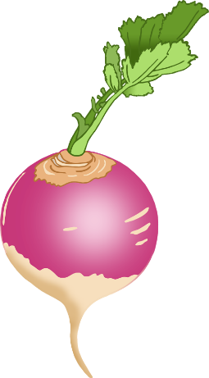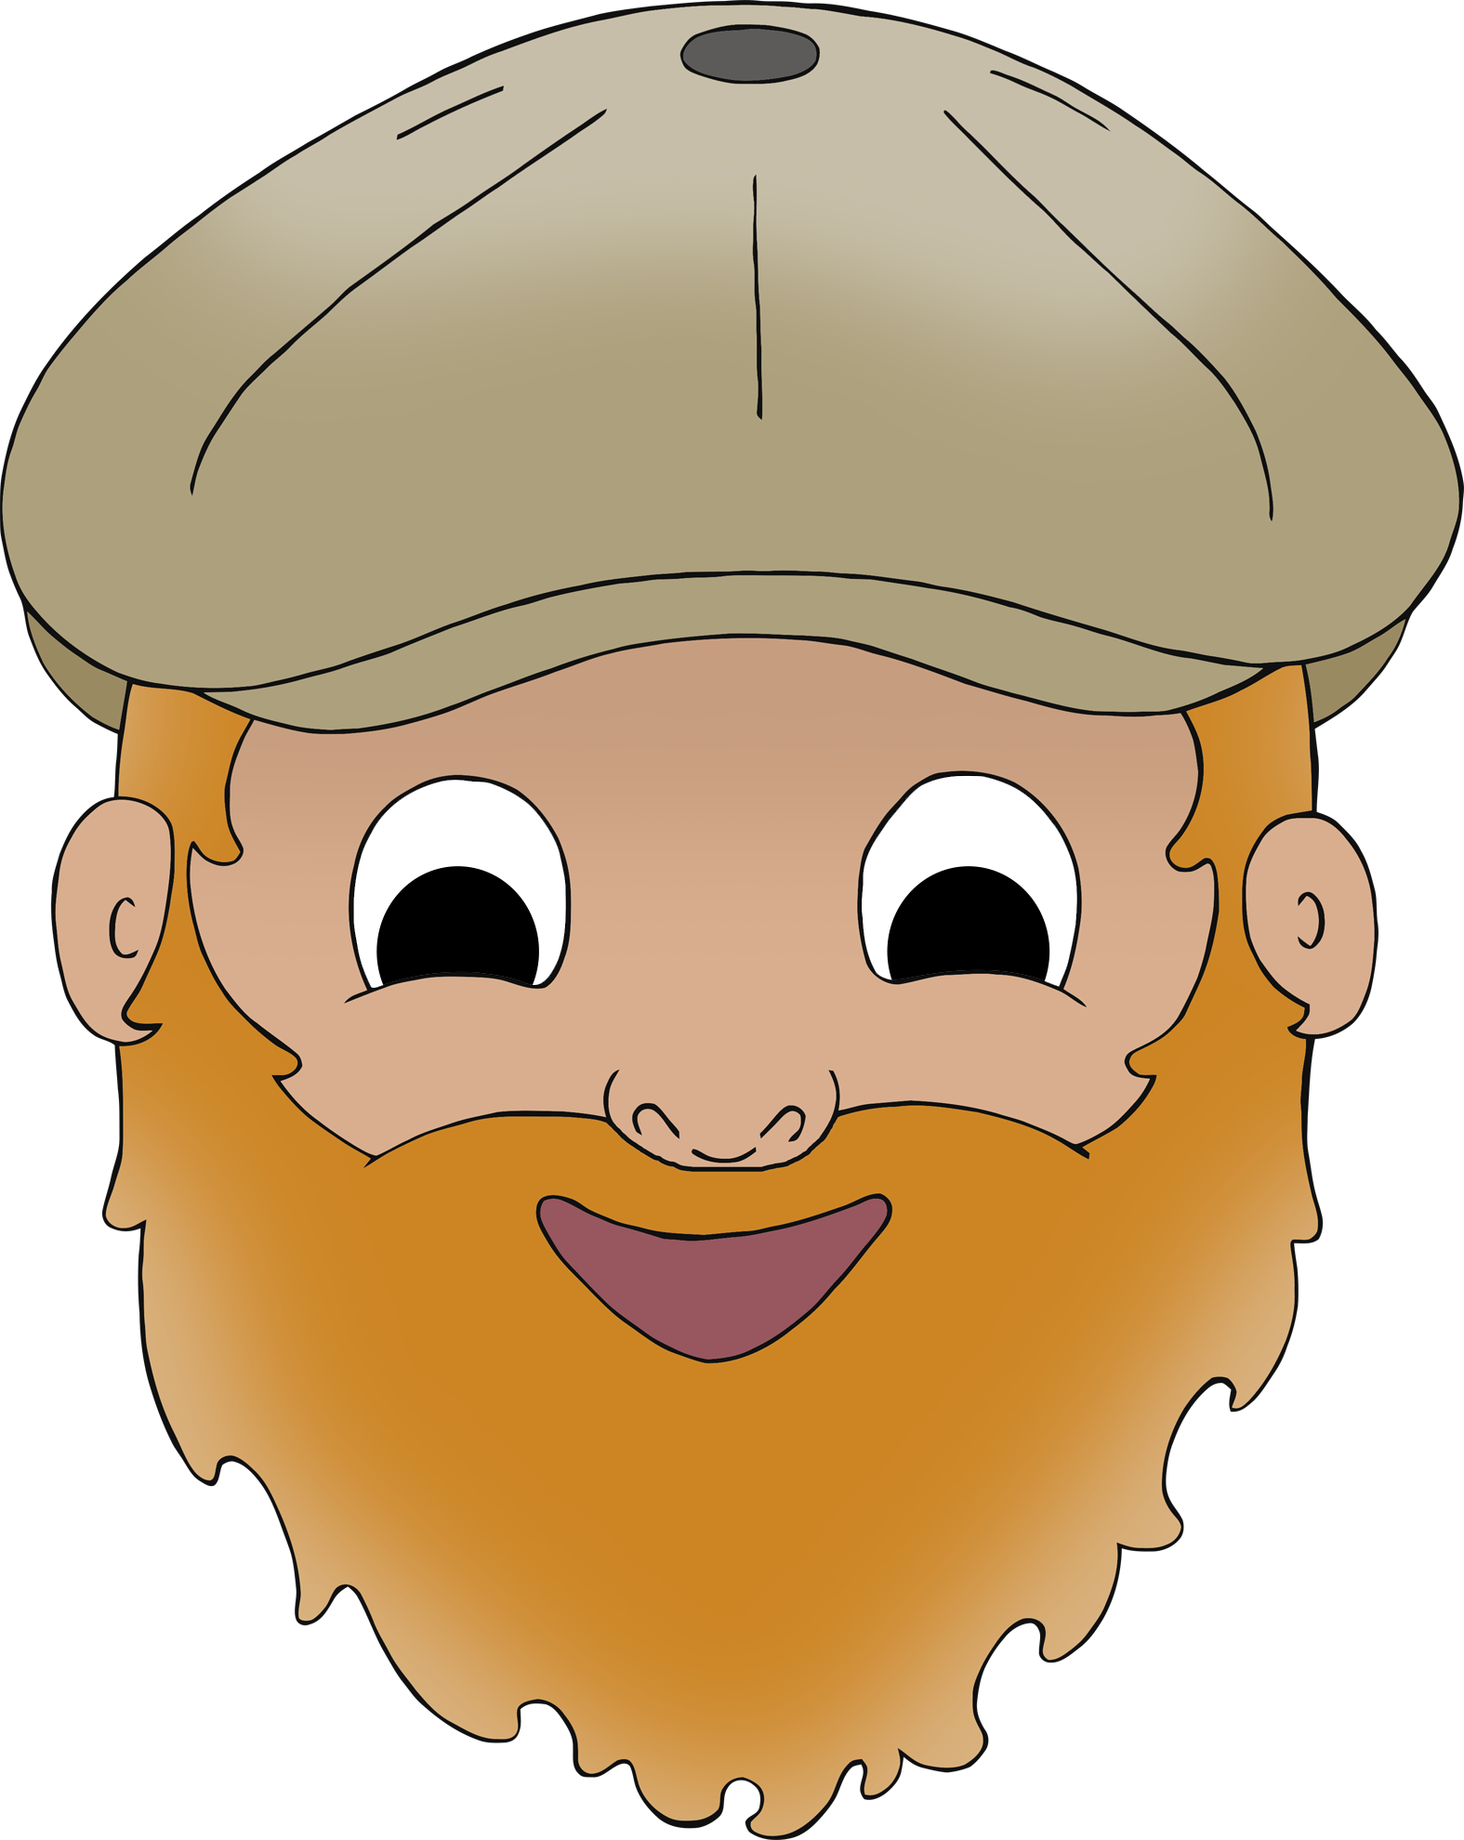

© 2023 Little Owls Resources

**My Favourite Part**

The Enormous Turnip



© 2023 Little Owls Resources

____________________________________________________________________________________

**My Favourite Part**

The Enormous Turnip



© 2023 Little Owls Resources

________________________________________________________________________________________________________________________________________________________________________________________________

**My Favorite Part**

The Enormous Turnip



© 2023 Little Owls Resources

**My Favorite Part**

The Enormous Turnip



© 2023 Little Owls Resources

____________________________________________________________________________________

**My Favorite Part**

The Enormous Turnip



© 2023 Little Owls Resources

________________________________________________________________________________________________________________________________________________________________________________________________