**turnip**

© 2023 Little Owls Resources

**man**

© 2023 Little Owls Resources

**woman**

© 2023 Little Owls Resources

**girl**

© 2023 Little Owls Resources

**boy**

© 2023 Little Owls Resources

**dog**

© 2023 Little Owls Resources

**cat**

© 2023 Little Owls Resources

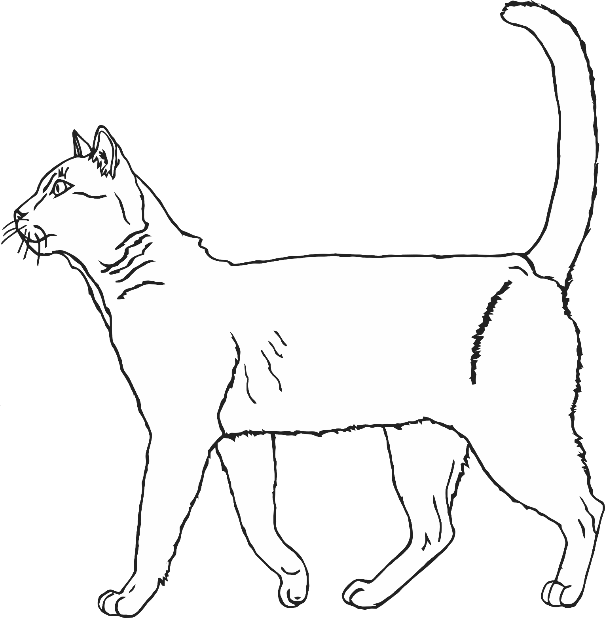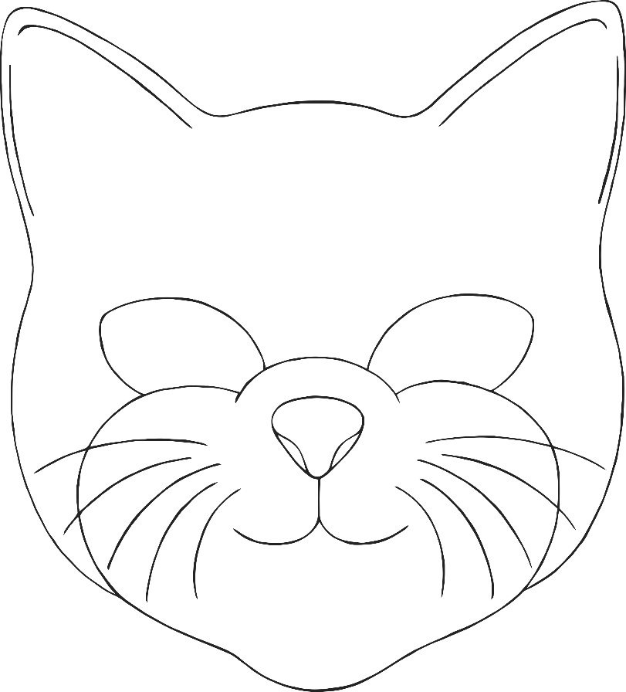

**mouse**

© 2023 Little Owls Resources

**The Enormous Turnip**

© 2023 Little Owls Resources