**Enormous**

**The**

**Turnip**

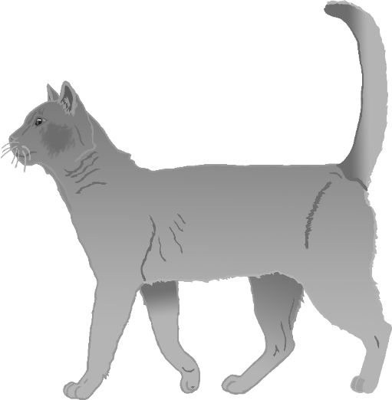

© 2023 Little Owls Resources

