Pack includes:

*(Number in brackets shows how many A4 pages)*

* Themed bunting (4)
* Blank bunting (1)
* Themed certificate (1)
* End of Year certificate (1)
* Graduation certificate (1)
* End of year posters (3)
* Themed colouring placemats (3)
* Blank placemat (1)
* Themed targets for beanbag throwing game (4)
* Colouring ‘thank-you’ cards (5)
* ‘Memories’ sheets – Heart and Star (2)
* Colouring party tickets (1)
* Blank party tickets (1)
* Balloon colouring/mindfulness sheets (3)
* Themed party invitation writing templates (3)
* Themed party time drawing sheet (1)

Balloons

Party Pack

**End of Year**

© 2020 Little Owls Resources

c

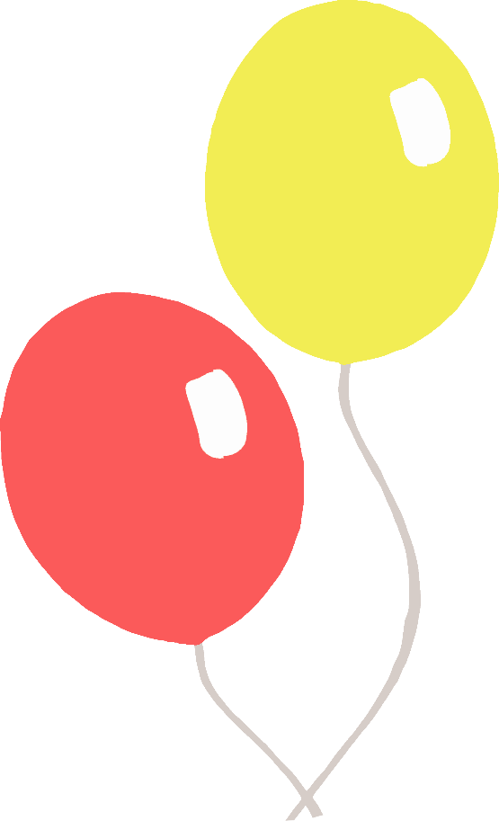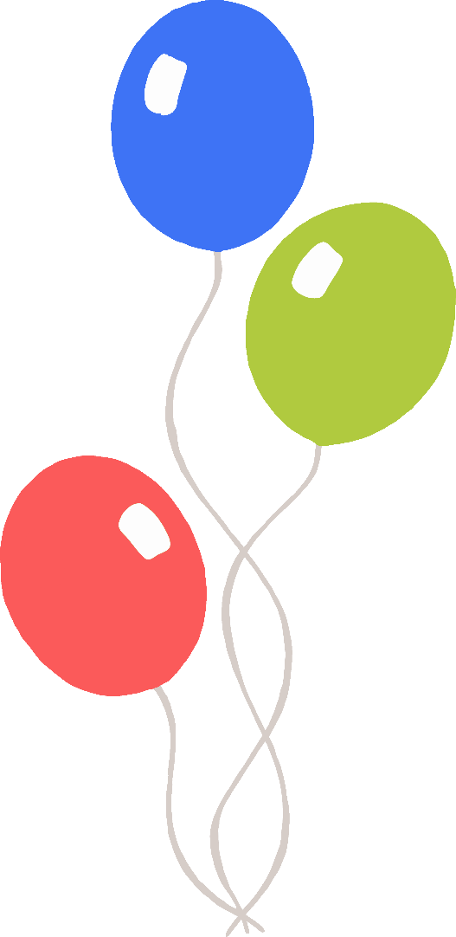

© 2021 Little Owls Resources

c

© 2021 Little Owls Resources

c

© 2020 Little Owls Resources

c

© 2021 Little Owls Resources

c

© 2021 Little Owls Resources

c



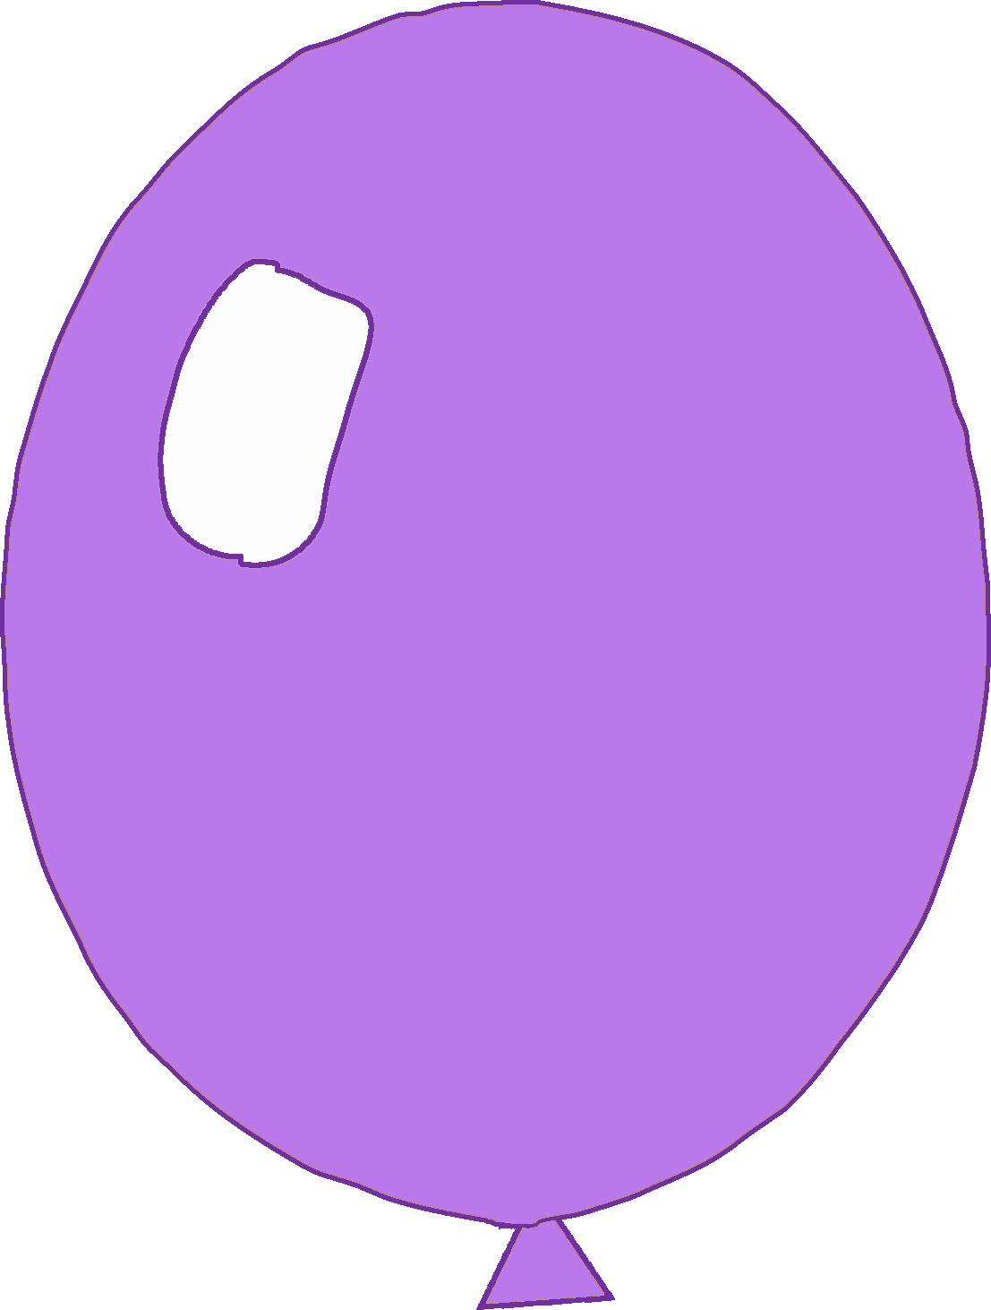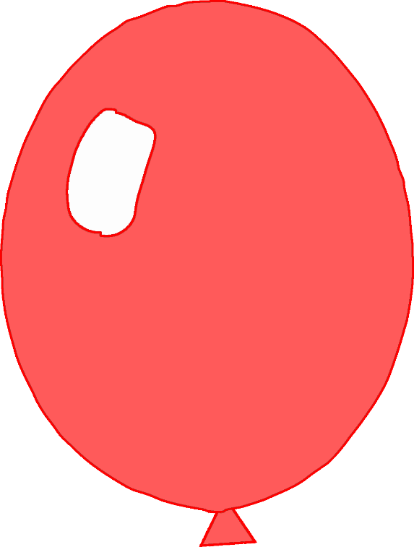

© 2021 Little Owls Resources

c

© 2021 Little Owls Resources

c

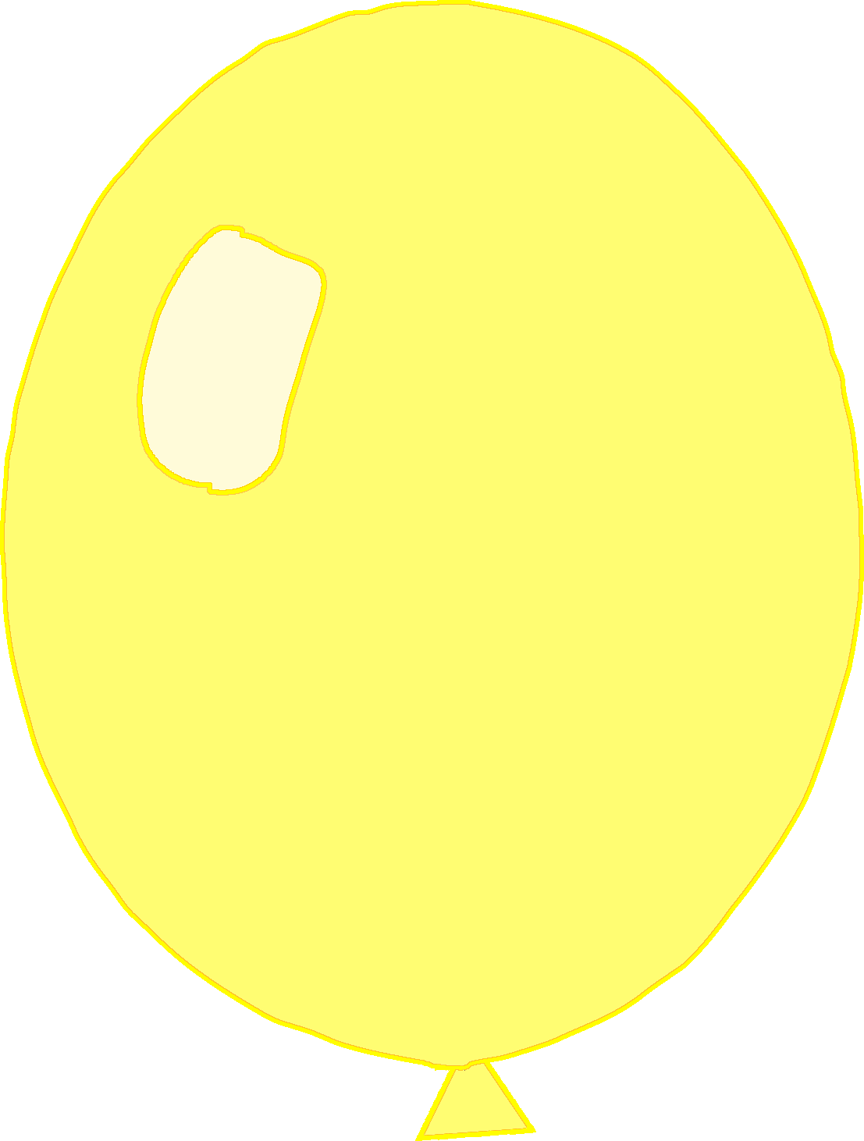

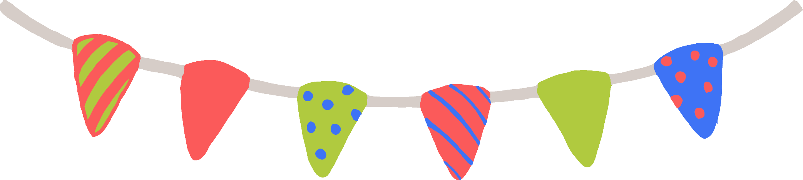

Name: ……………………………………………………………………………………………………………………

Date: …………………………………………………………

**Well Done!**

© 2021 Little Owls Resources

c

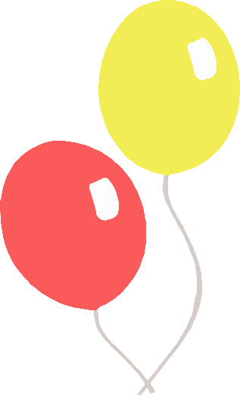

Congratulations!

Congratulations to

End of Year Certificate

___________________________________

___________________________________

Signed: _____________________ Date: ______________

for being a SUPERSTAR this year at

© 2021 Little Owls Resources

c

Congratulations to

Graduation Certificate

___________________________________

___________________________________

Signed: _____________________ Date: ______________

for being a SUPERSTAR at

© 2021 Little Owls Resources

c

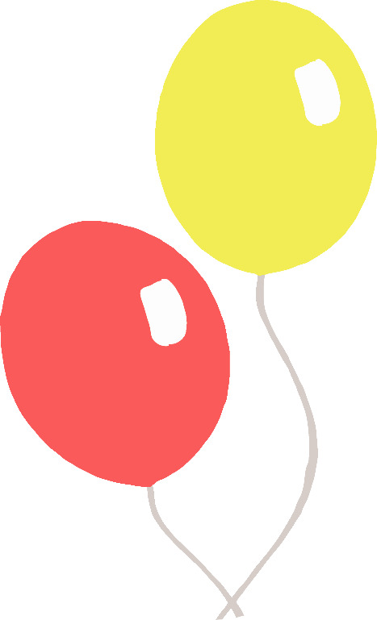

Enjoy your next adventure!

Good Luck!

© 2021 Little Owls Resources

c

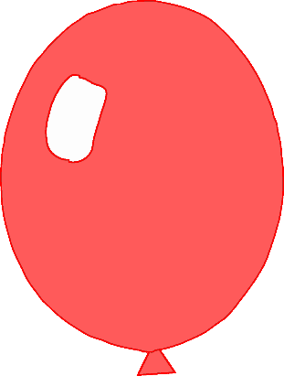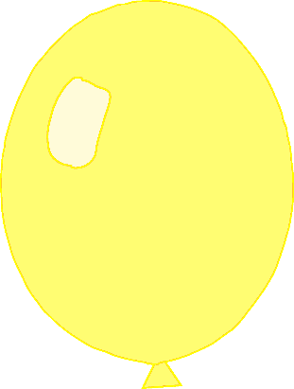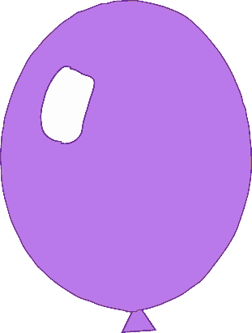

Goodbye!

© 2021 Little Owls Resources

c

© 2021 Little Owls Resources

c

Party Time!

© 2021 Little Owls Resources

© 2021 Little Owls Resources

© 2021 Little Owls Resources

© 2021 Little Owls Resources

1

© 2021 Little Owls Resources

2

© 2021 Little Owls Resources

\

3

© 2021 Little Owls Resources



\

4

© 2021 Little Owls Resources

Thank you!

©2021 Little Owls Resources

Goodbye!

©2021 Little Owls Resources

©2021 Little Owls Resources

Thanks!

Good Luck!

©2021 Little Owls Resources

Thanks to you!

©2021 Little Owls Resources

memories

© 2021 Little Owls Resources

My

© 2021 Little Owls Resources

Memories

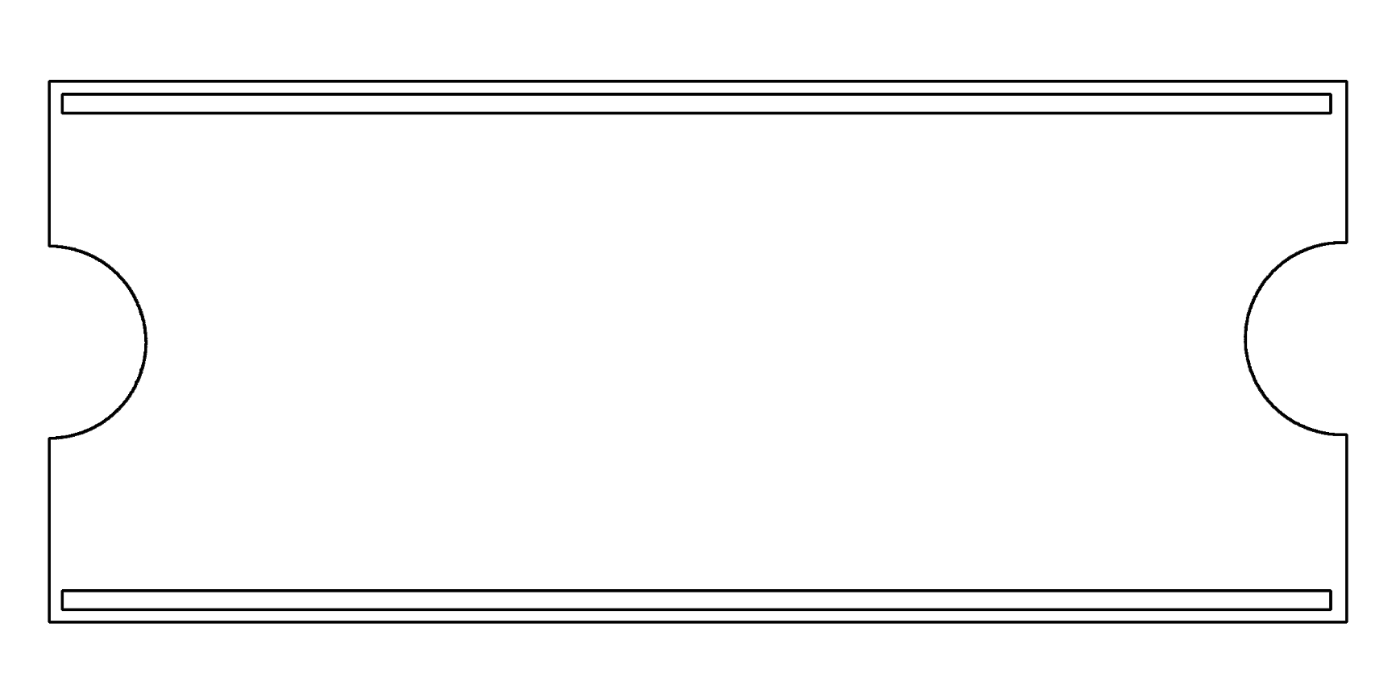

**My Party Ticket**



**My Party Ticket**



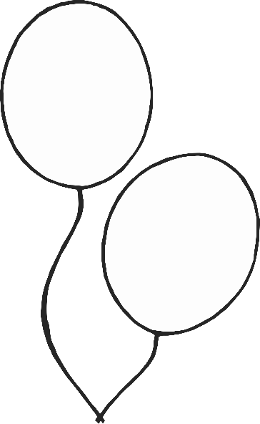

©2021 Little Owls Resources

©2021 Little Owls Resources

©2021 Little Owls Resources

Party Invitation

© 2021 Little Owls Resources

Dear_____________

You are invited to the ‘End of Year’ Party!

Love from

__________________

Party Invitation

© 2021 Little Owls Resources

Dear_____________

________________________________________________________________________

Love from __________________

Party Invitation

© 2021 Little Owls Resources

______________________________________________________________________________________________________________________________

Party Time

© 2021 Little Owls Resources