**Emperor Penguin body parts**

© 2020 Little Owls Resources

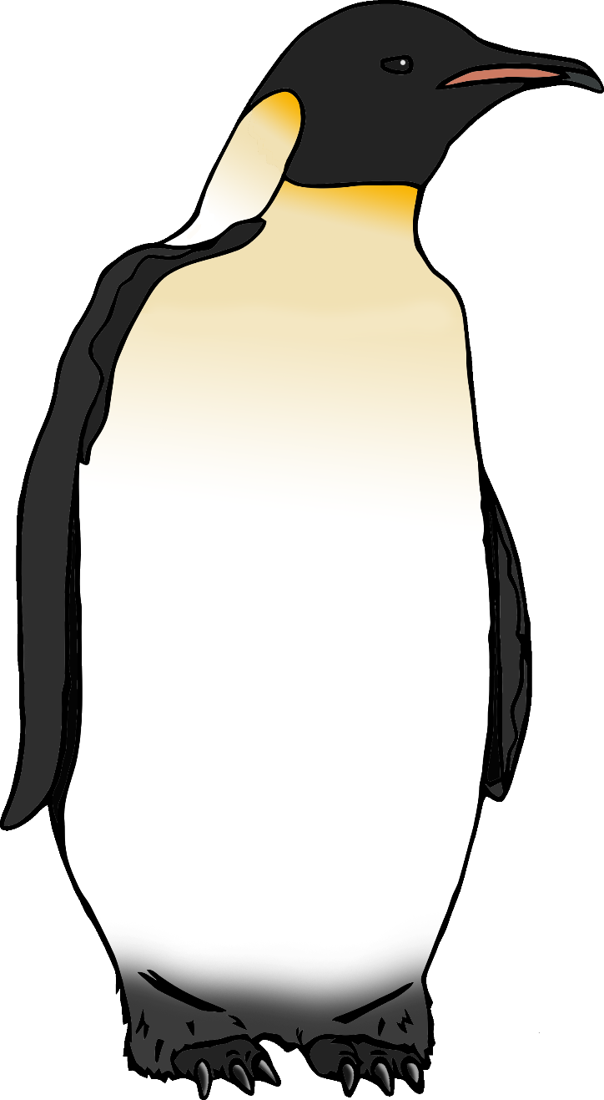

e

b

f

f

f

**Emperor Penguin body parts**

© 2020 Little Owls Resources



feathers

foot

bill

flipper

eye

**Emperor Penguin body parts**

© 2020 Little Owls Resources

