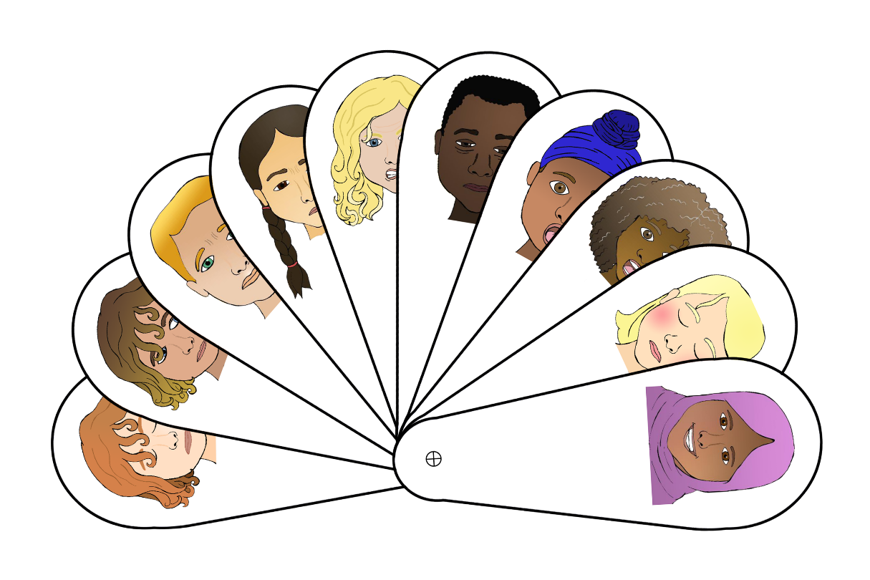

Emotion Fans

Emotion fans with:

Happy, Angry, Confused, Embarrassed, Worried, Sad, Scared, Shocked, Shy and Tired.

*Designed to be cut out, laminated and then joined with a split pin or short treasury tag.*

Children can use to voluntarily express feelings or in response to questions by an adult whether 1:1 or in a group input.

e.g.

“In the story, Jane’s toy was broken by her friend.

How do you think she feels? Show me with the fans…”



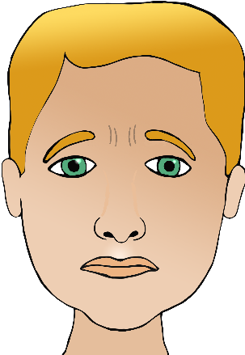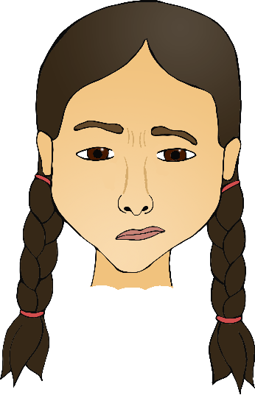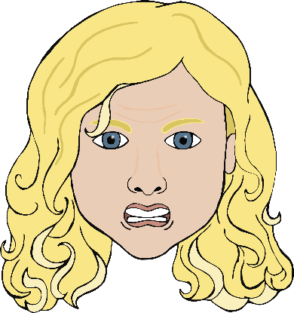

© 2019 Little Owls Resources

© 2019 Little Owls Resources

© 2019 Little Owls Resources

© 2019 Little Owls Resources

© 2019 Little Owls Resources

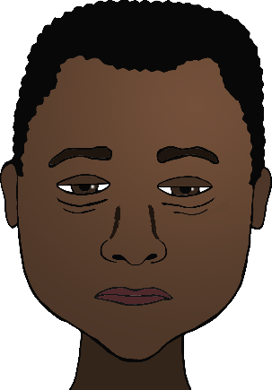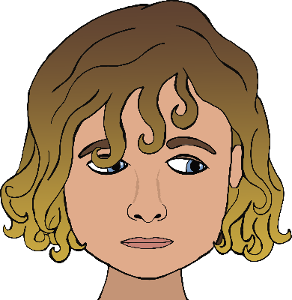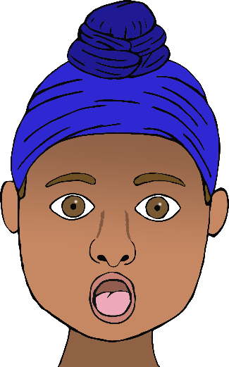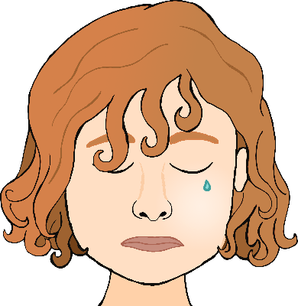

© 2019 Little Owls Resources

© 2019 Little Owls Resources

© 2019 Little Owls Resources

© 2019 Little Owls Resources

© 2019 Little Owls Resources