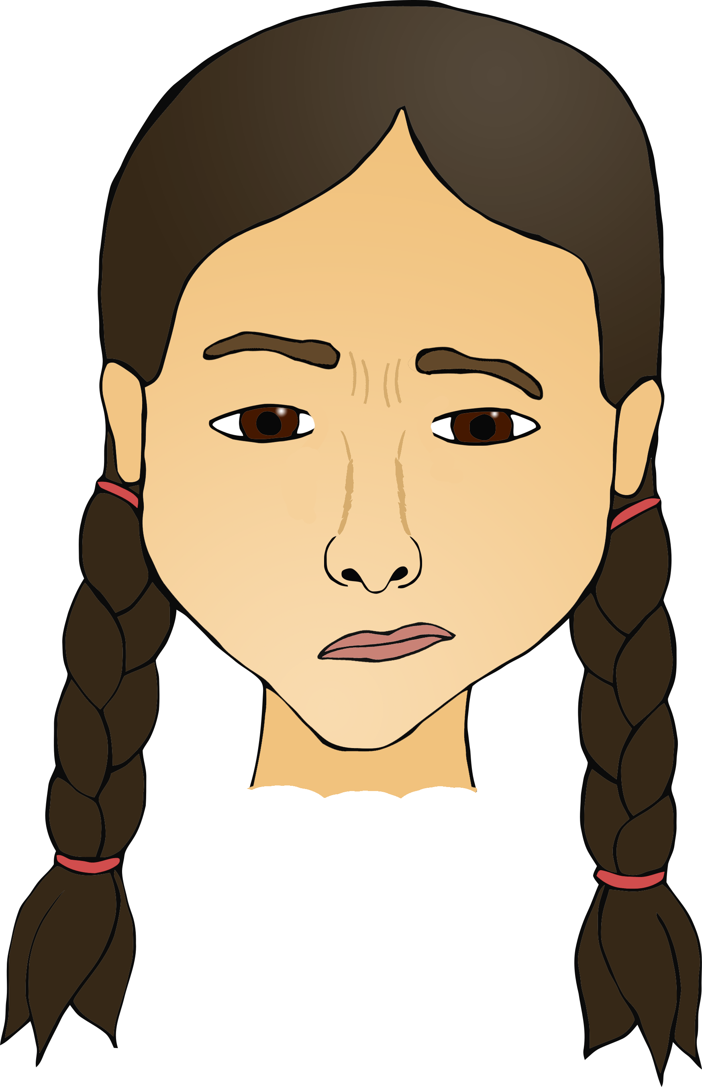

© 2018 Little Owls Resources

© 2018 Little Owls Resources

Confused

Happy

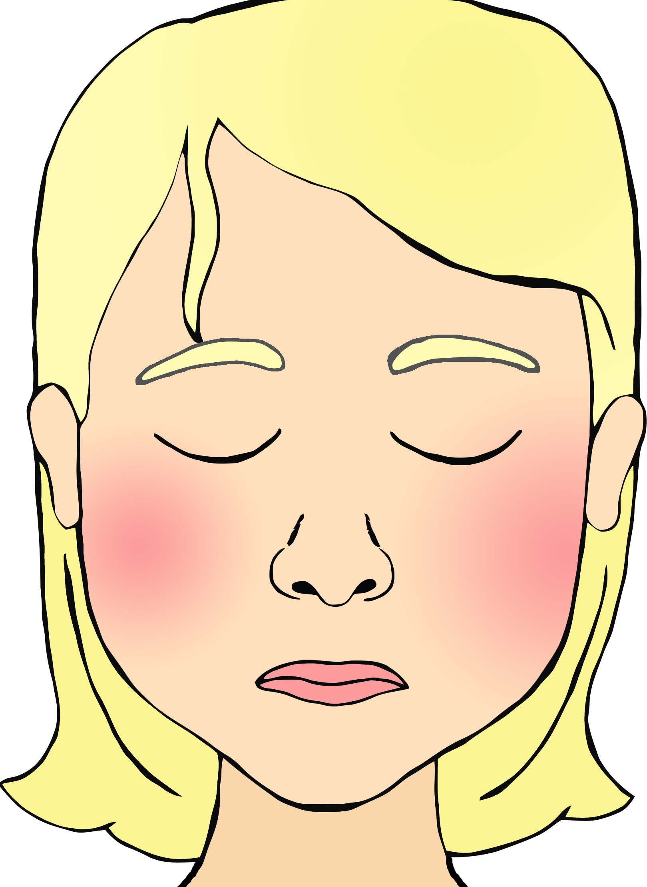

© 2018 Little Owls Resources

© 2018 Little Owls Resources

Sad

Embarrassed

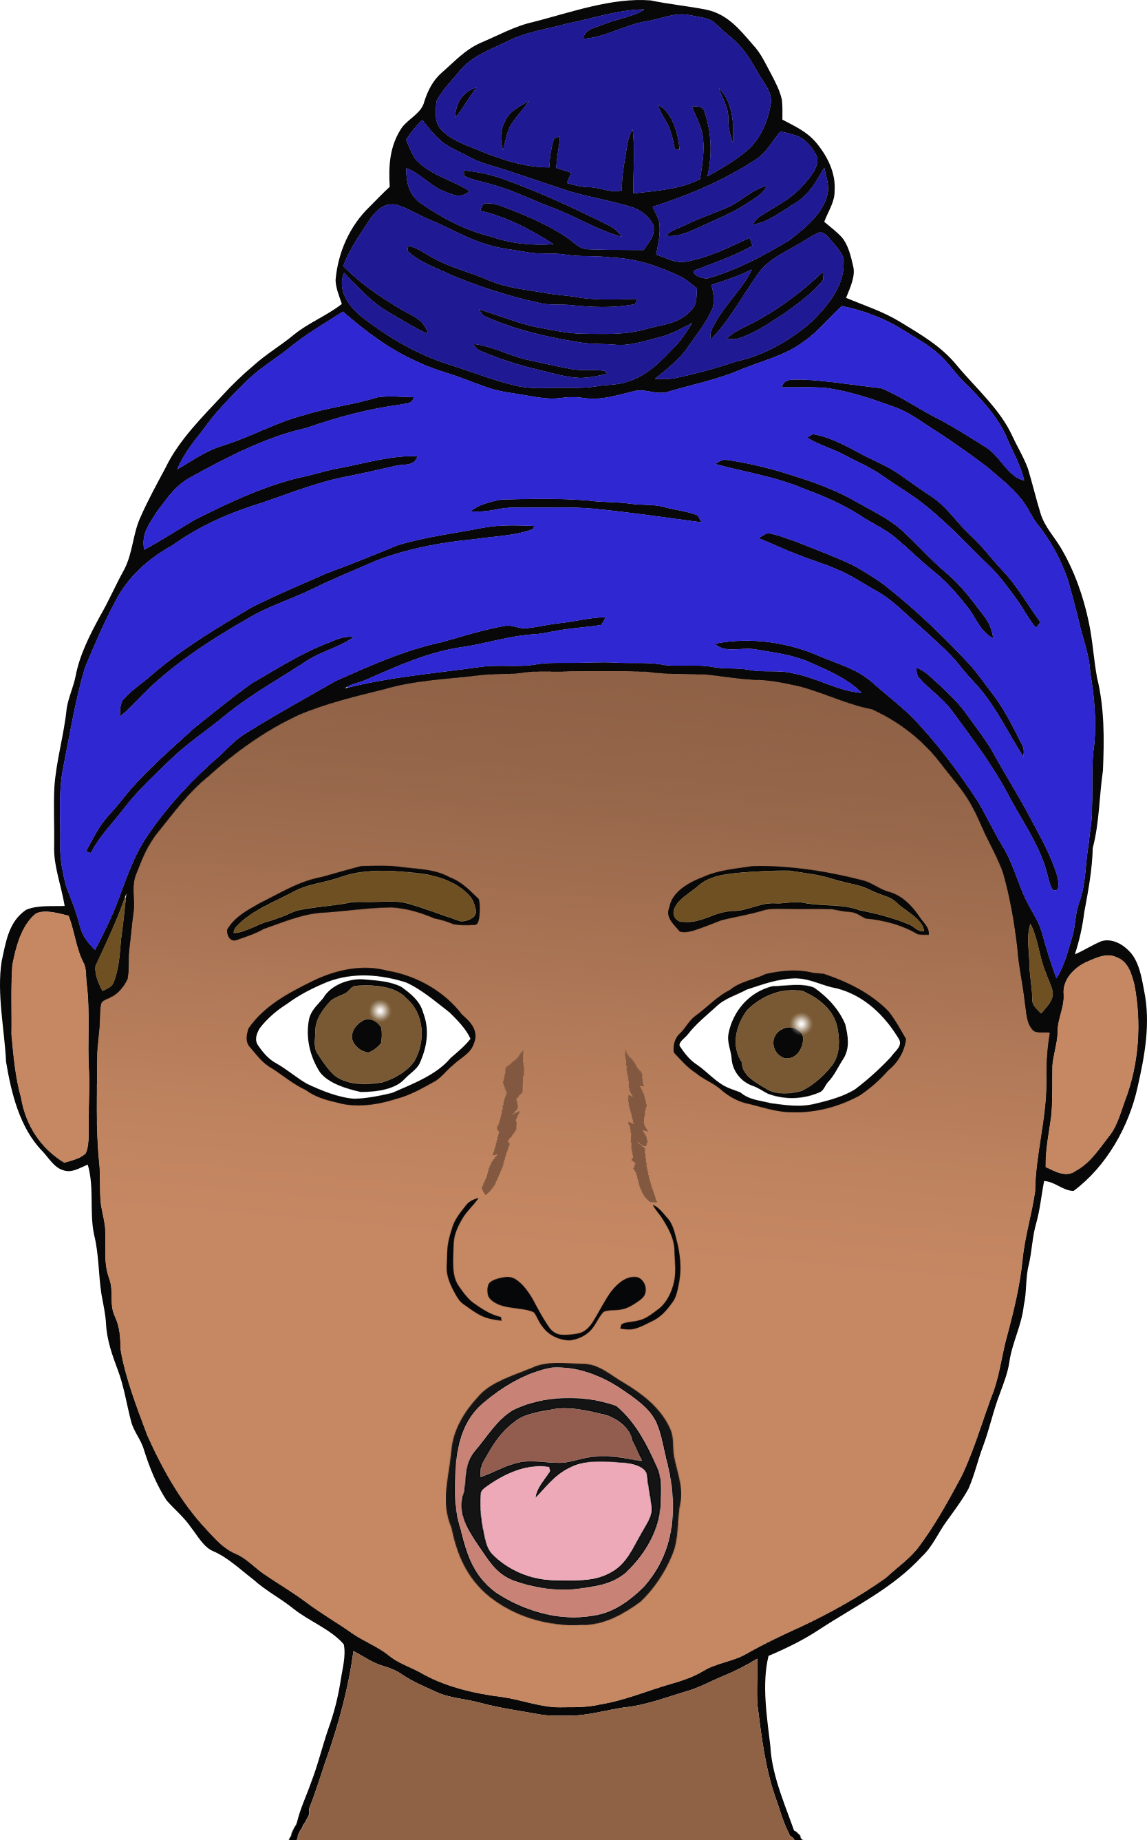

© 2018 Little Owls Resources

© 2018 Little Owls Resources

Shocked

Scared

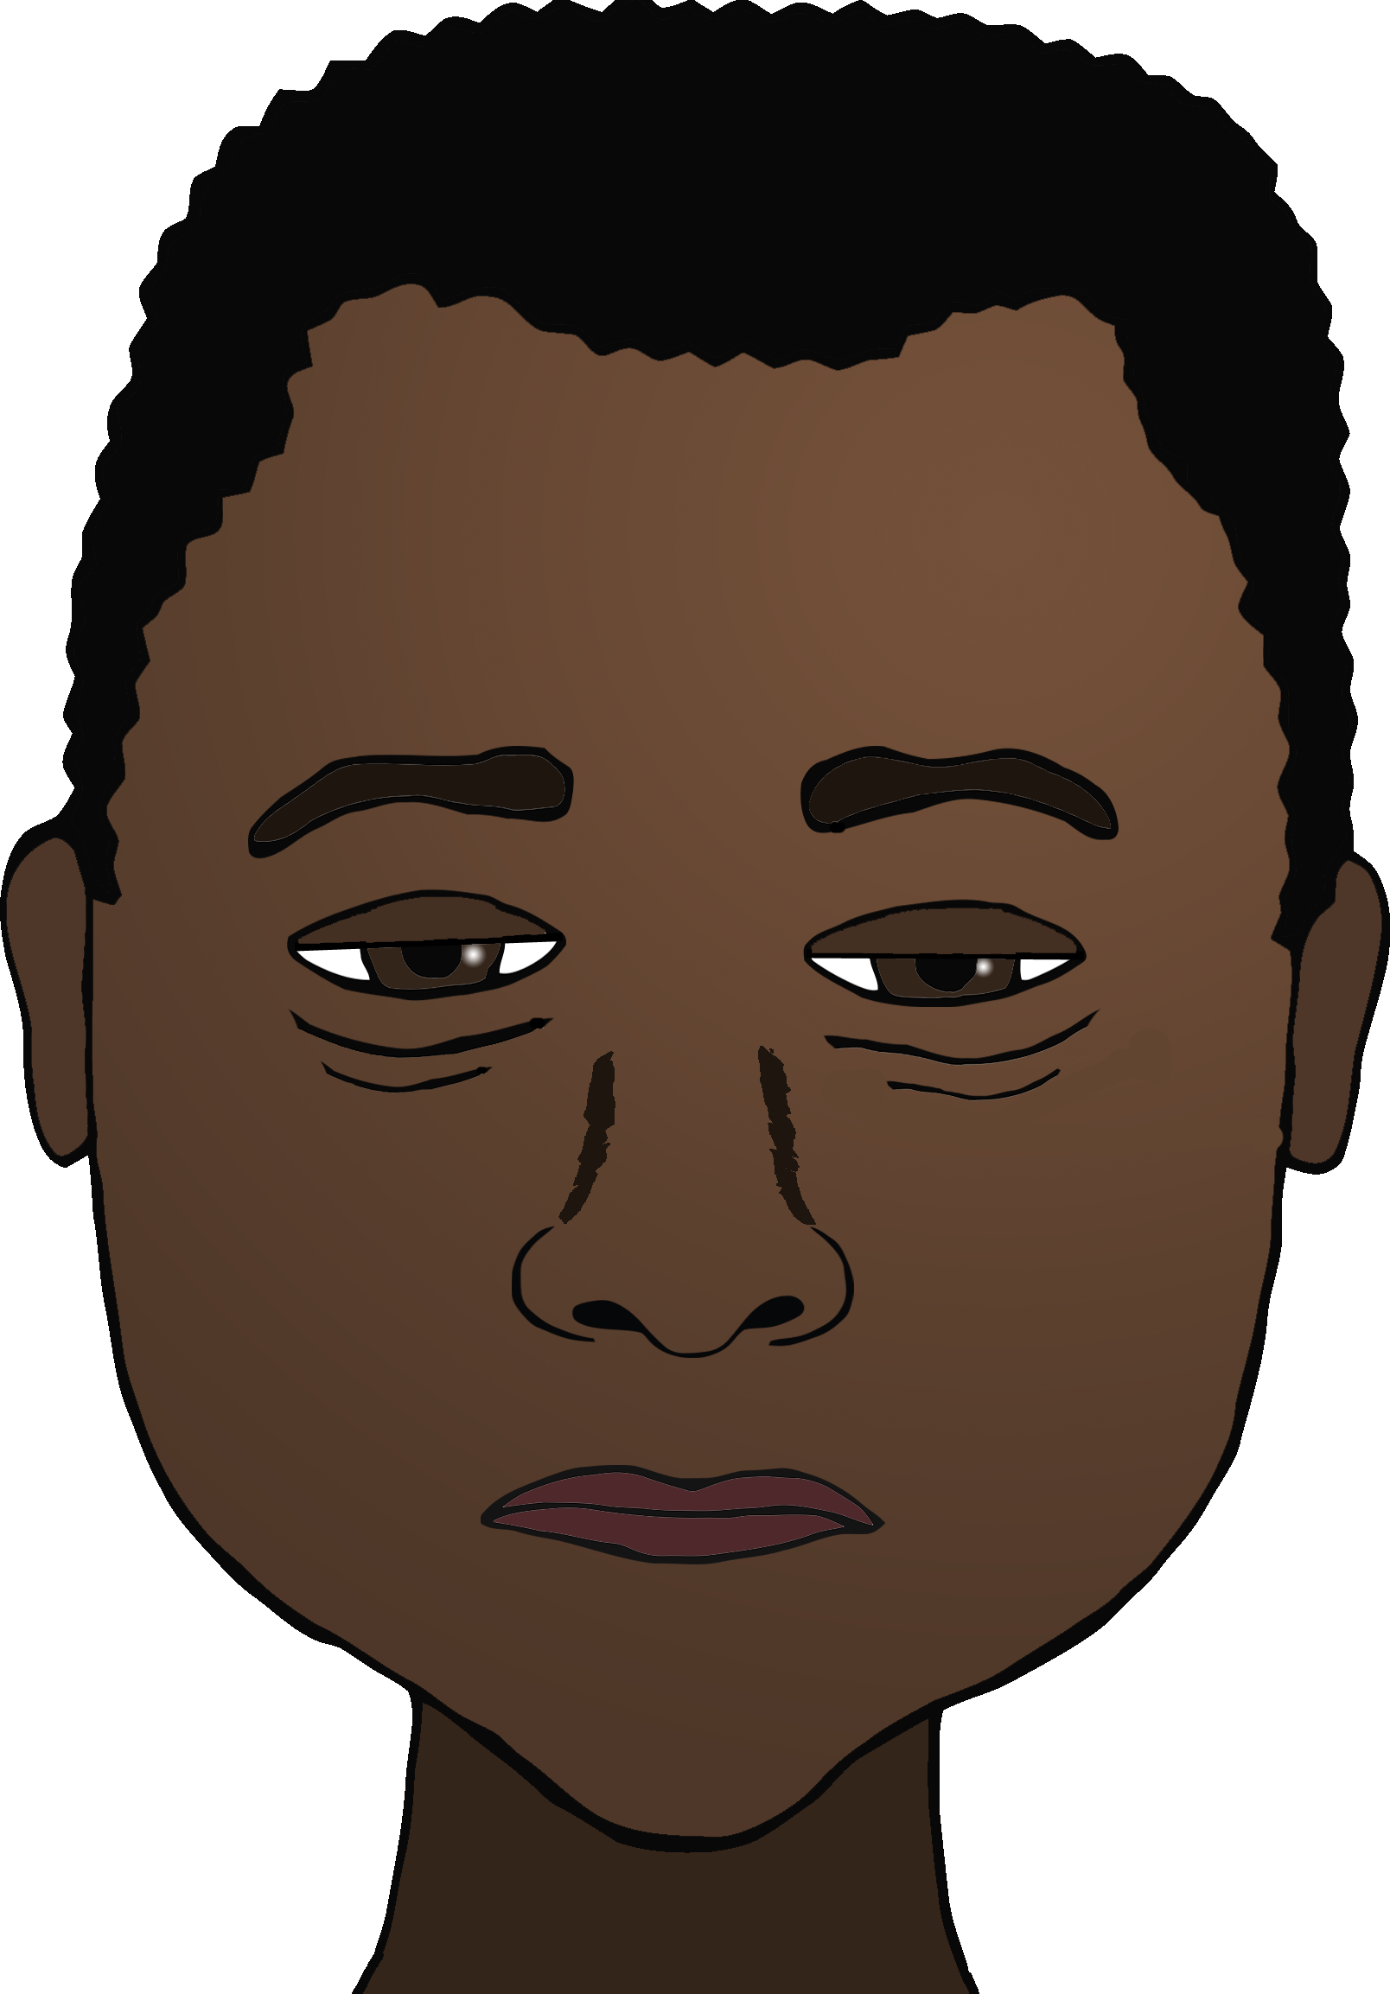

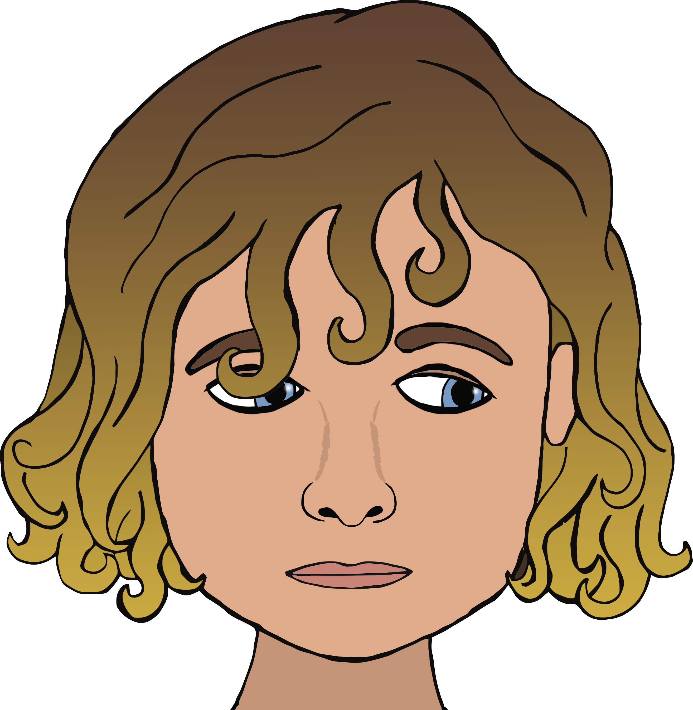

Tired

© 2018 Little Owls Resources

© 2018 Little Owls Resources

Shy

© 2018 Little Owls Resources

© 2018 Little Owls Resources

Angry

Worried

