Confused

Happy

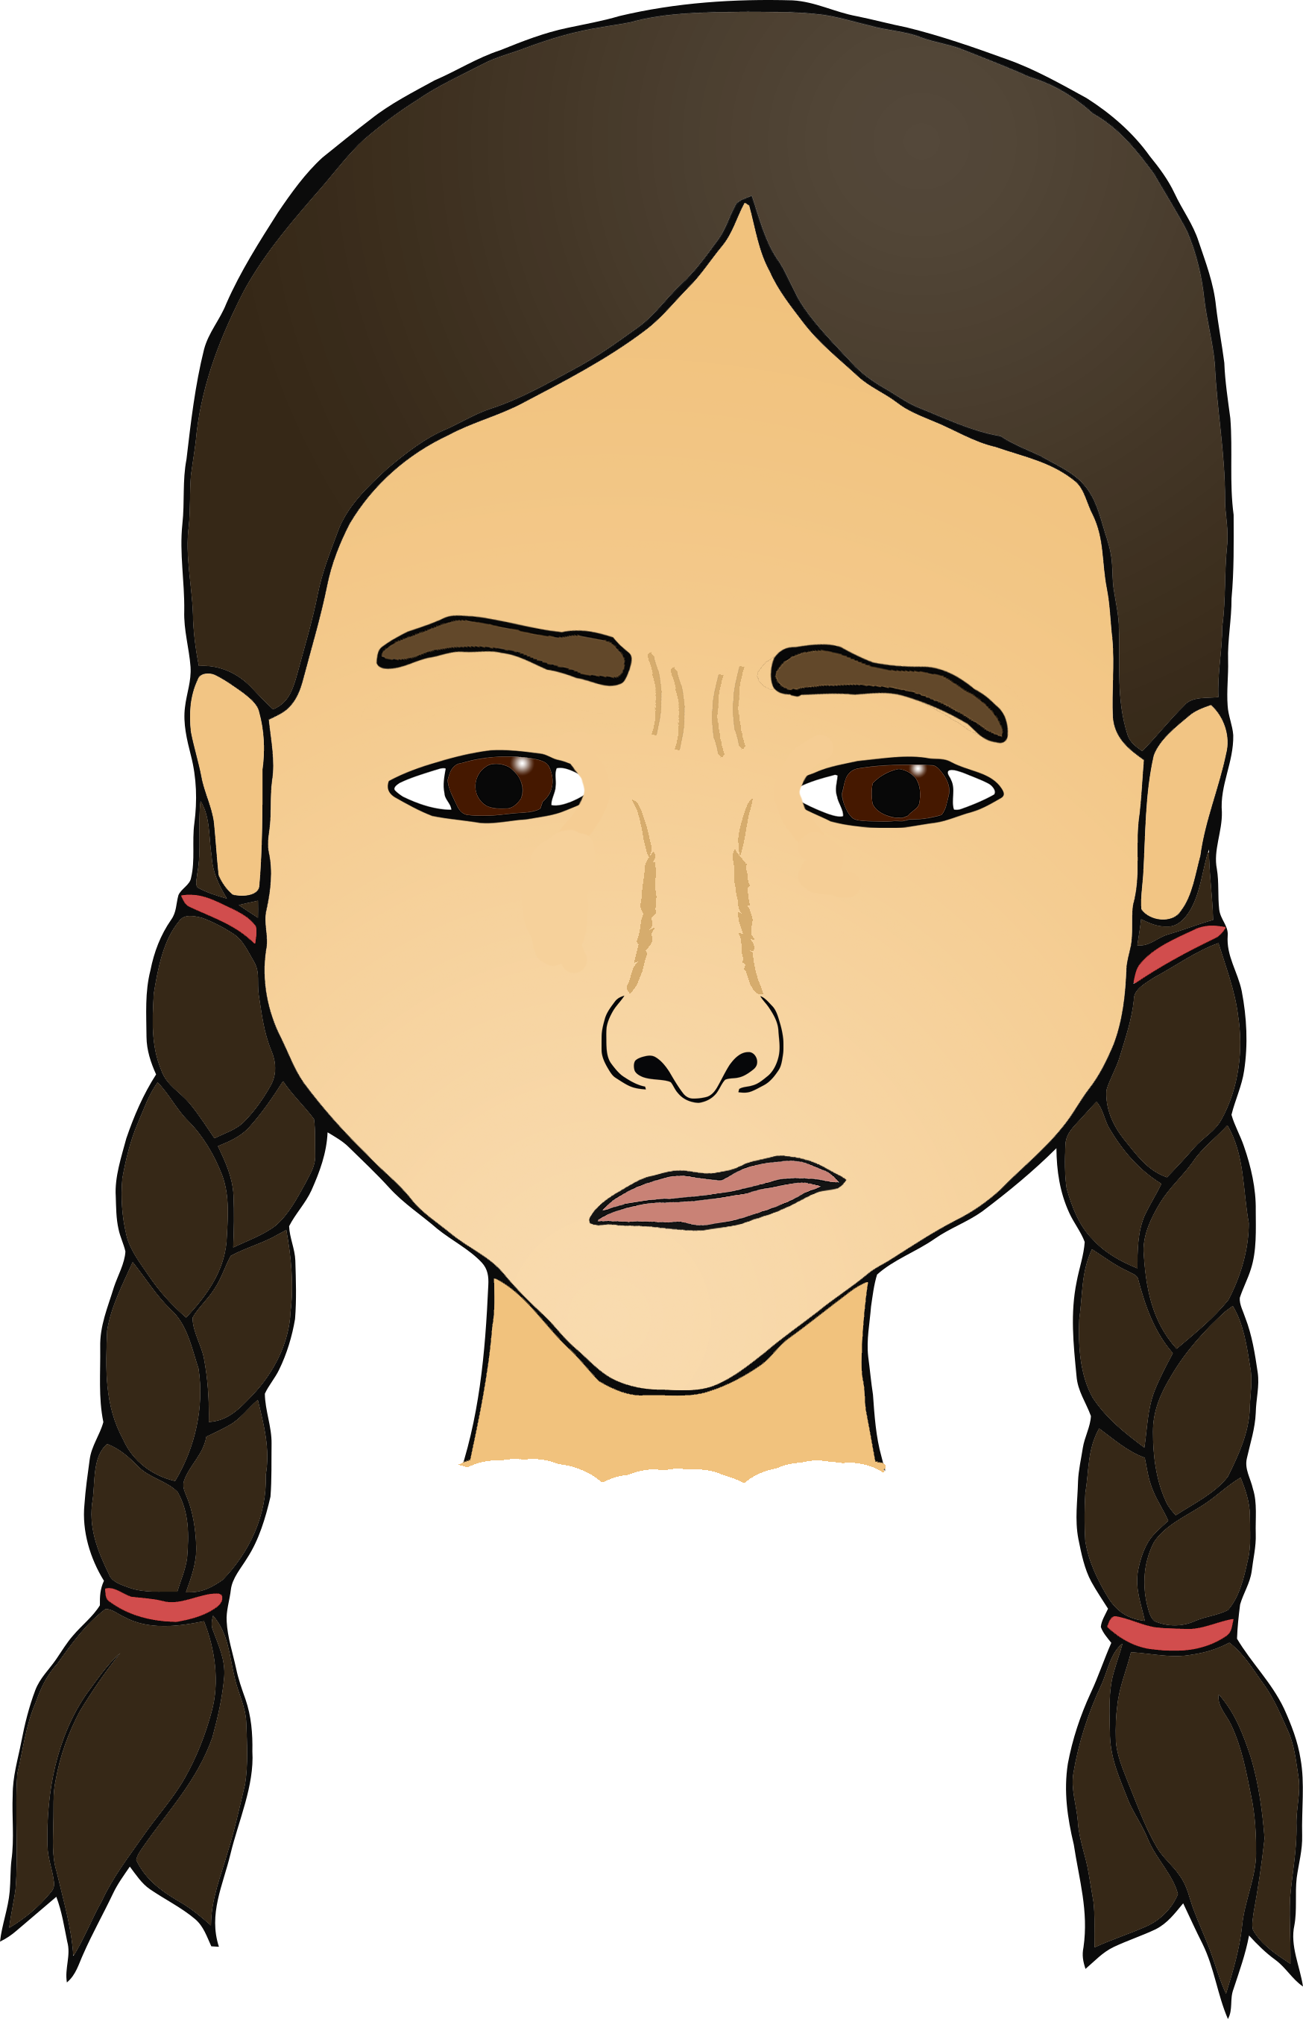

© 2018 Little Owls Resources

© 2018 Little Owls Resources

Sad

Embarrassed

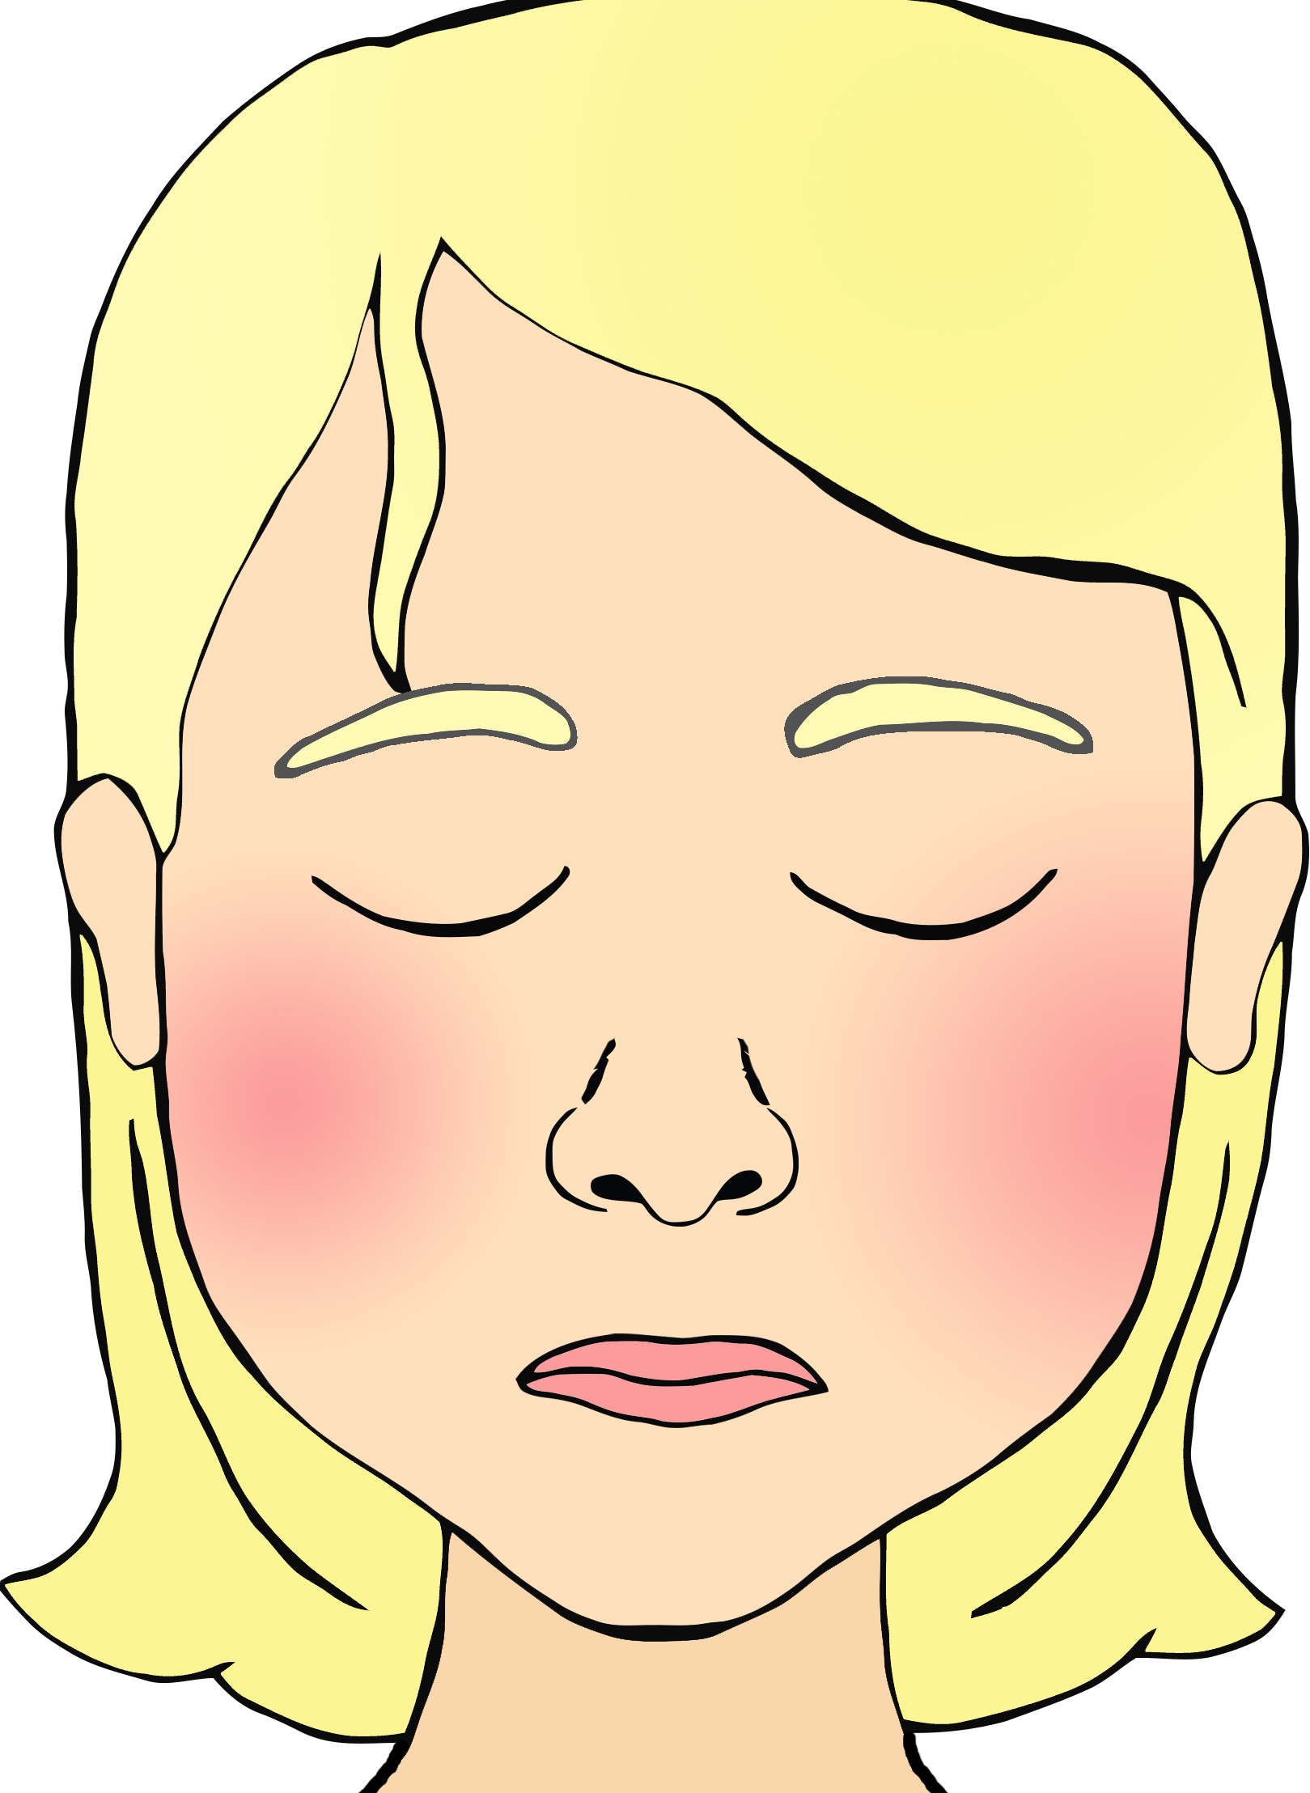

© 2018 Little Owls Resources

© 2018 Little Owls Resources

Shocked

Scared

© 2018 Little Owls Resources

© 2018 Little Owls Resources

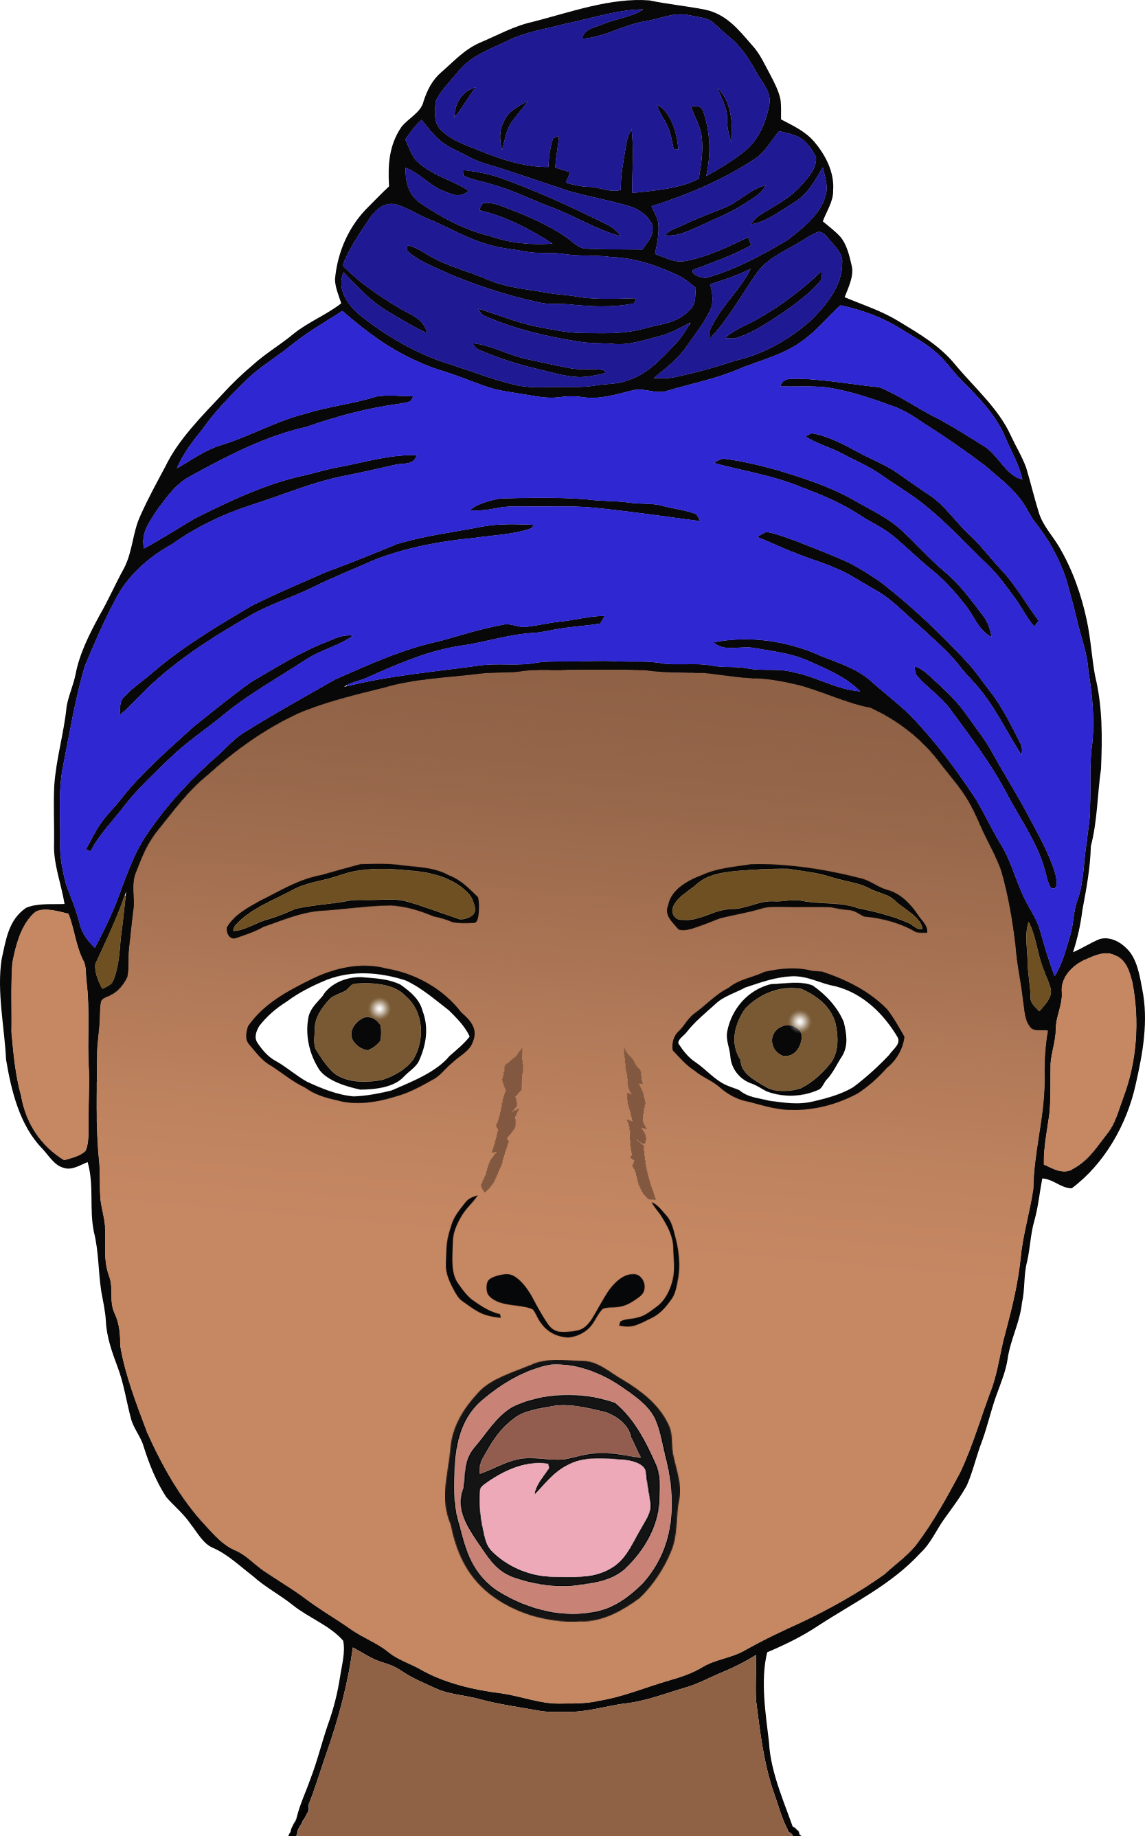

Shy

Tired

© 2018 Little Owls Resources

© 2018 Little Owls Resources

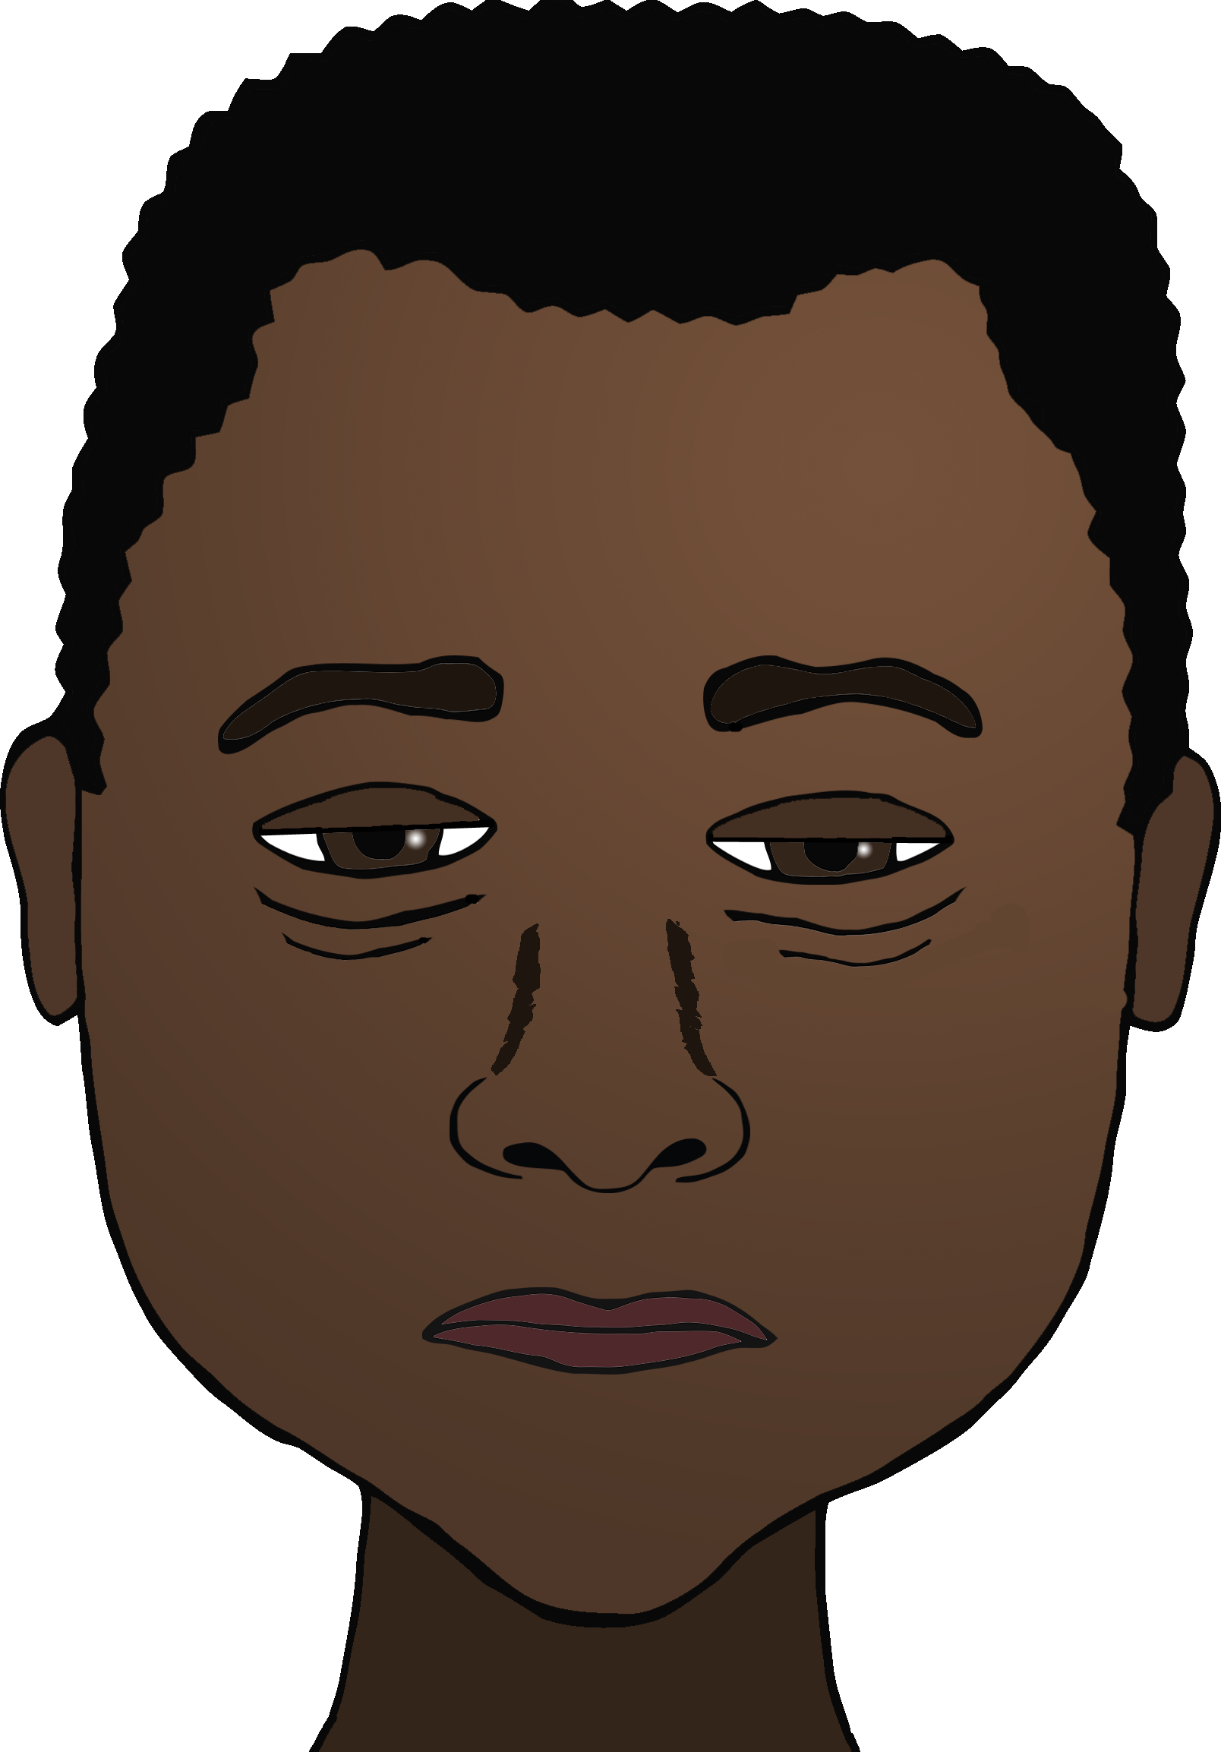

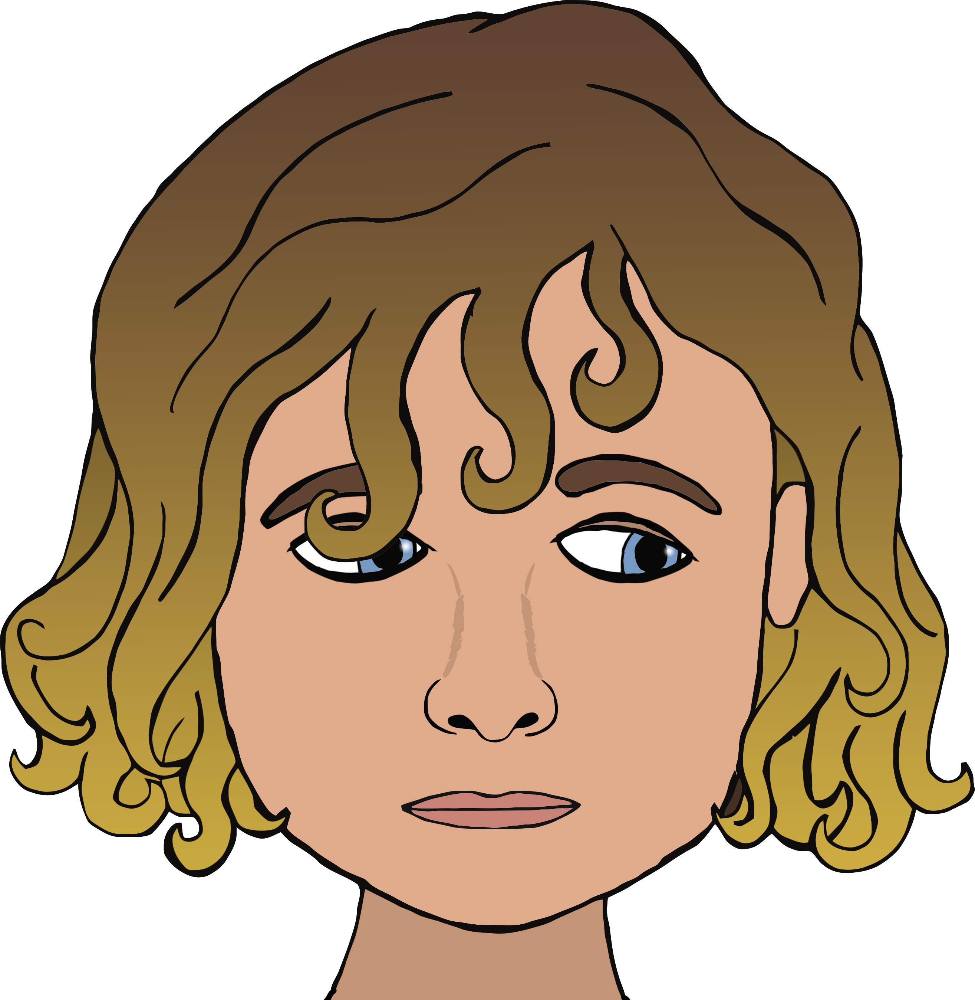

© 2018 Little Owls Resources

© 2018 Little Owls Resources

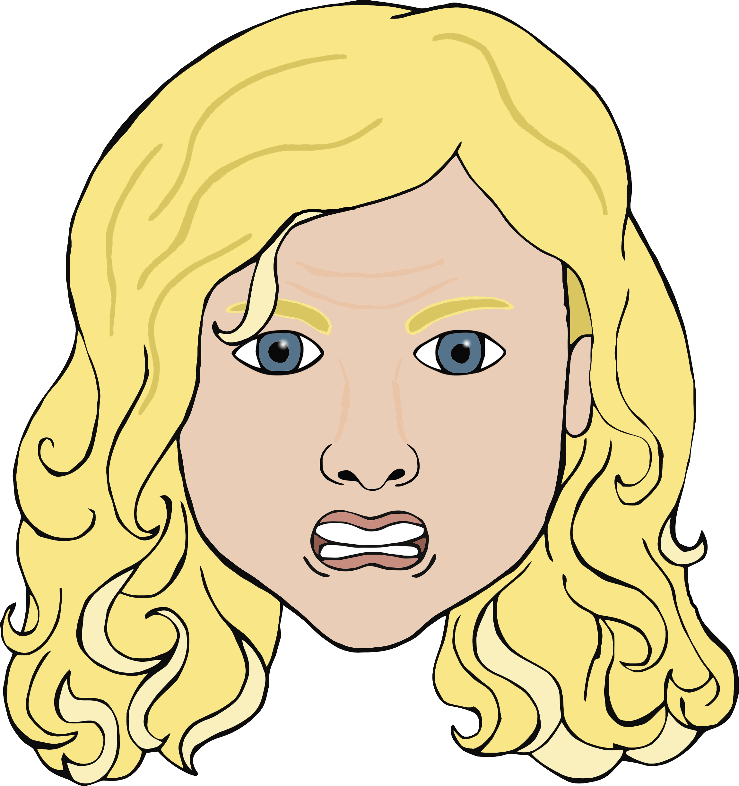

Angry

Worried