The pages of this pack give some general information about elephants and some fun and engaging activities to foster and develop children’s interest in them.

**Elephant**

**This pack includes:**

* Fact posters x3 (Could be used as stimuli for a lesson input)
* Number slice activity (1-10) (Can be pre-cut for a pure number ordering activity or left to be cut by child to add scissor practice)
* Number slice activity - colouring version (1-10) (As above but to be coloured before cutting)
* Description sheet (Can be used as an independent writing activity or with an adult scribing the ideas of a younger child)
* A4 poster
* A4 poster - colouring version
* ‘Body Parts’ x3 (fully labelled, initial sounds only, blank)
* Draw and write sheets x3 (blank sheet, wide lines and narrow lines)
* 1x 4-piece puzzle
* Multimats x4 (for Colouring/Art & Craft/Loose Parts/Playdough)

© 2021 Little Owls Resources

This pack includes:

The pages of this pack give some general information about the role of a paramedic and some fun and engaging activities to foster and develop children’s interest in this role in society.

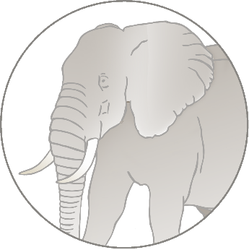

**biggest**

Elephants are the land animals in the world!

© 2021 Little Owls Resources

**Elephant Facts**

Wild elephants can live for

years.

**70**

Elephants eat **grasses** and **leaves**.

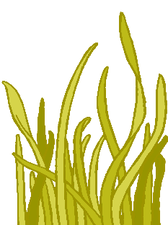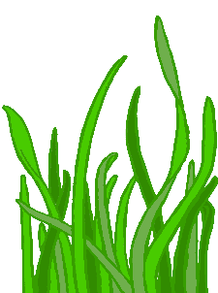

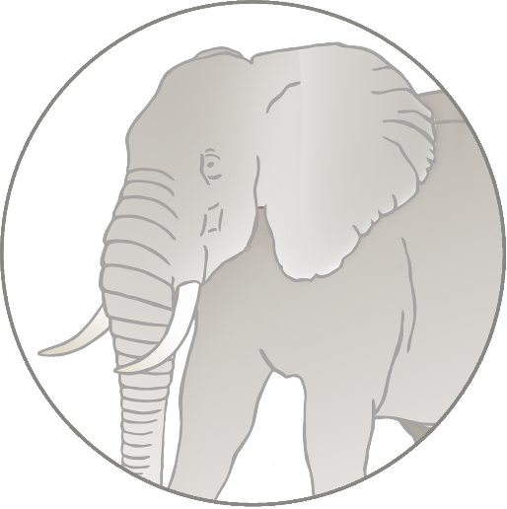

This means there is a very high risk that they may become extinct.

Humans have hunted and killed many elephants.

Humans have destroyed lots of places that elephants used to live.

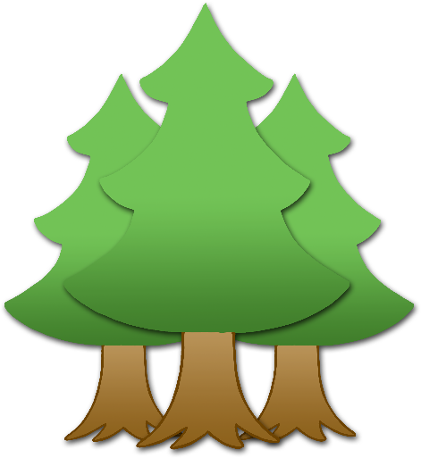

**Elephants are** Endangered.

© 2021 Little Owls Resources

**How big is an Elephant?**

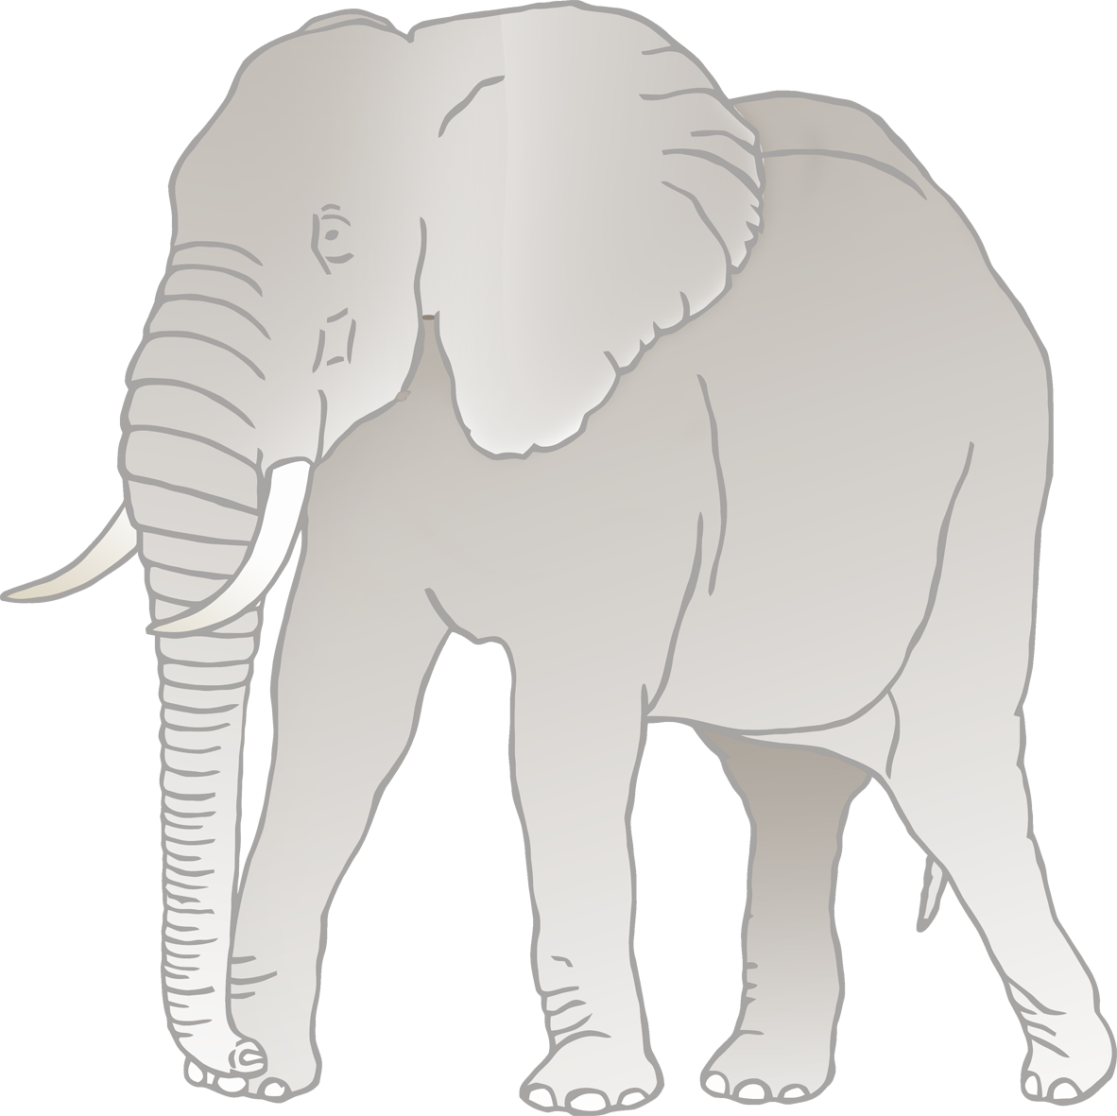

320cm / 3.2m

© 2021 Little Owls Resources



1

2

3

4

5

6

7

8

9

10



© 2021 Little Owls Resources

© 2021 Little Owls Resources

1

2

3

4

5

6

7

8

9

10

© 2021 Little Owls Resources

**What words would you use to describe an elephant?**

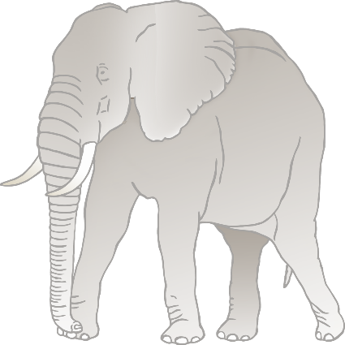

**Elephant**



© 2021 Little Owls Resources

**Elephant**

© 2021 Little Owls Resources

**Elephant body parts**

© 2021 Little Owls Resources

back

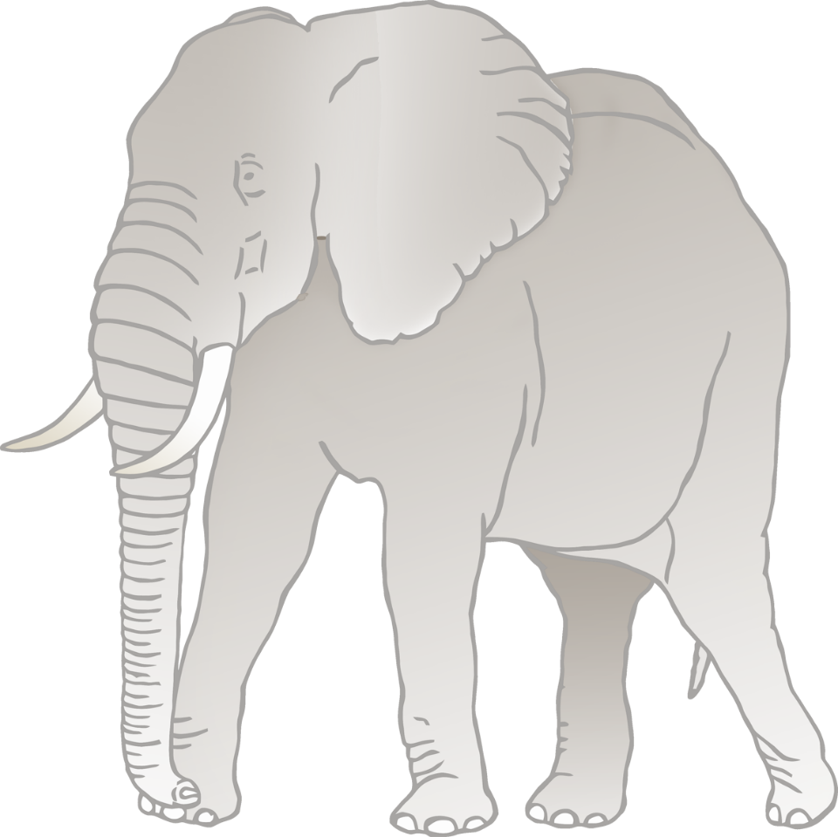

ear

tusk

trunk

foot

leg



f

l

b

e

t

t

**Elephant body parts**

© 2021 Little Owls Resources

**Elephant body parts**



© 2021 Little Owls Resources

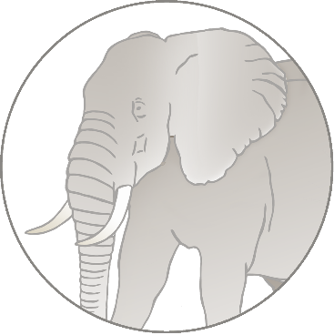

© 2021 Little Owls Resources

**Draw an Elephant!**



© 2021 Little Owls Resources

**Draw and write about an Elephant!**

____________________________________________________



© 2021 Little Owls Resources

**Draw and write about an Elephant!**

______________________________________________________________________________________________________

**Elephant**



© 2021 Little Owls Resources



© 2021 Little Owls Resources

**Elephant Multimat – Elephant**



© 2021 Little Owls Resources

**Elephant Multimat – Elephants**



© 2021 Little Owls Resources

**Elephant Multimat – Footprint**

© 2021 Little Owls Resources

**Elephant Multimat – Footprints**