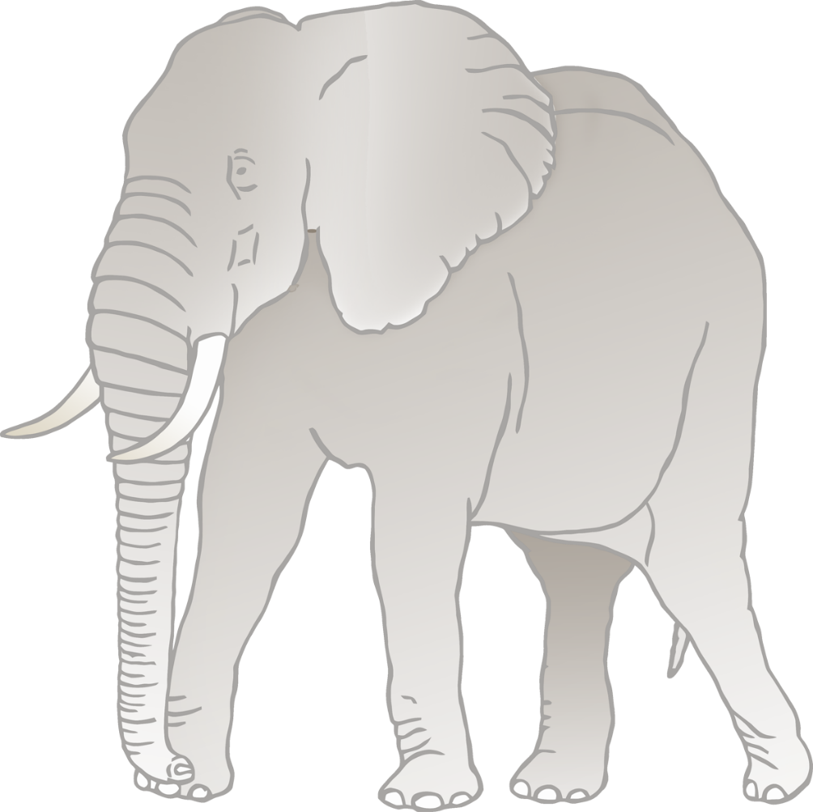

**Elephant body parts**

© 2020 Little Owls Resources

f

s

e

t

t

h



**Elephant body parts**

© 2020 Little Owls Resources

foot

skin

ear

trunk

tusk

head



**Elephant body parts**

© 2020 Little Owls Resources