© 2020 Little Owls Resources

**Create your own**

**Eid henna designs!**

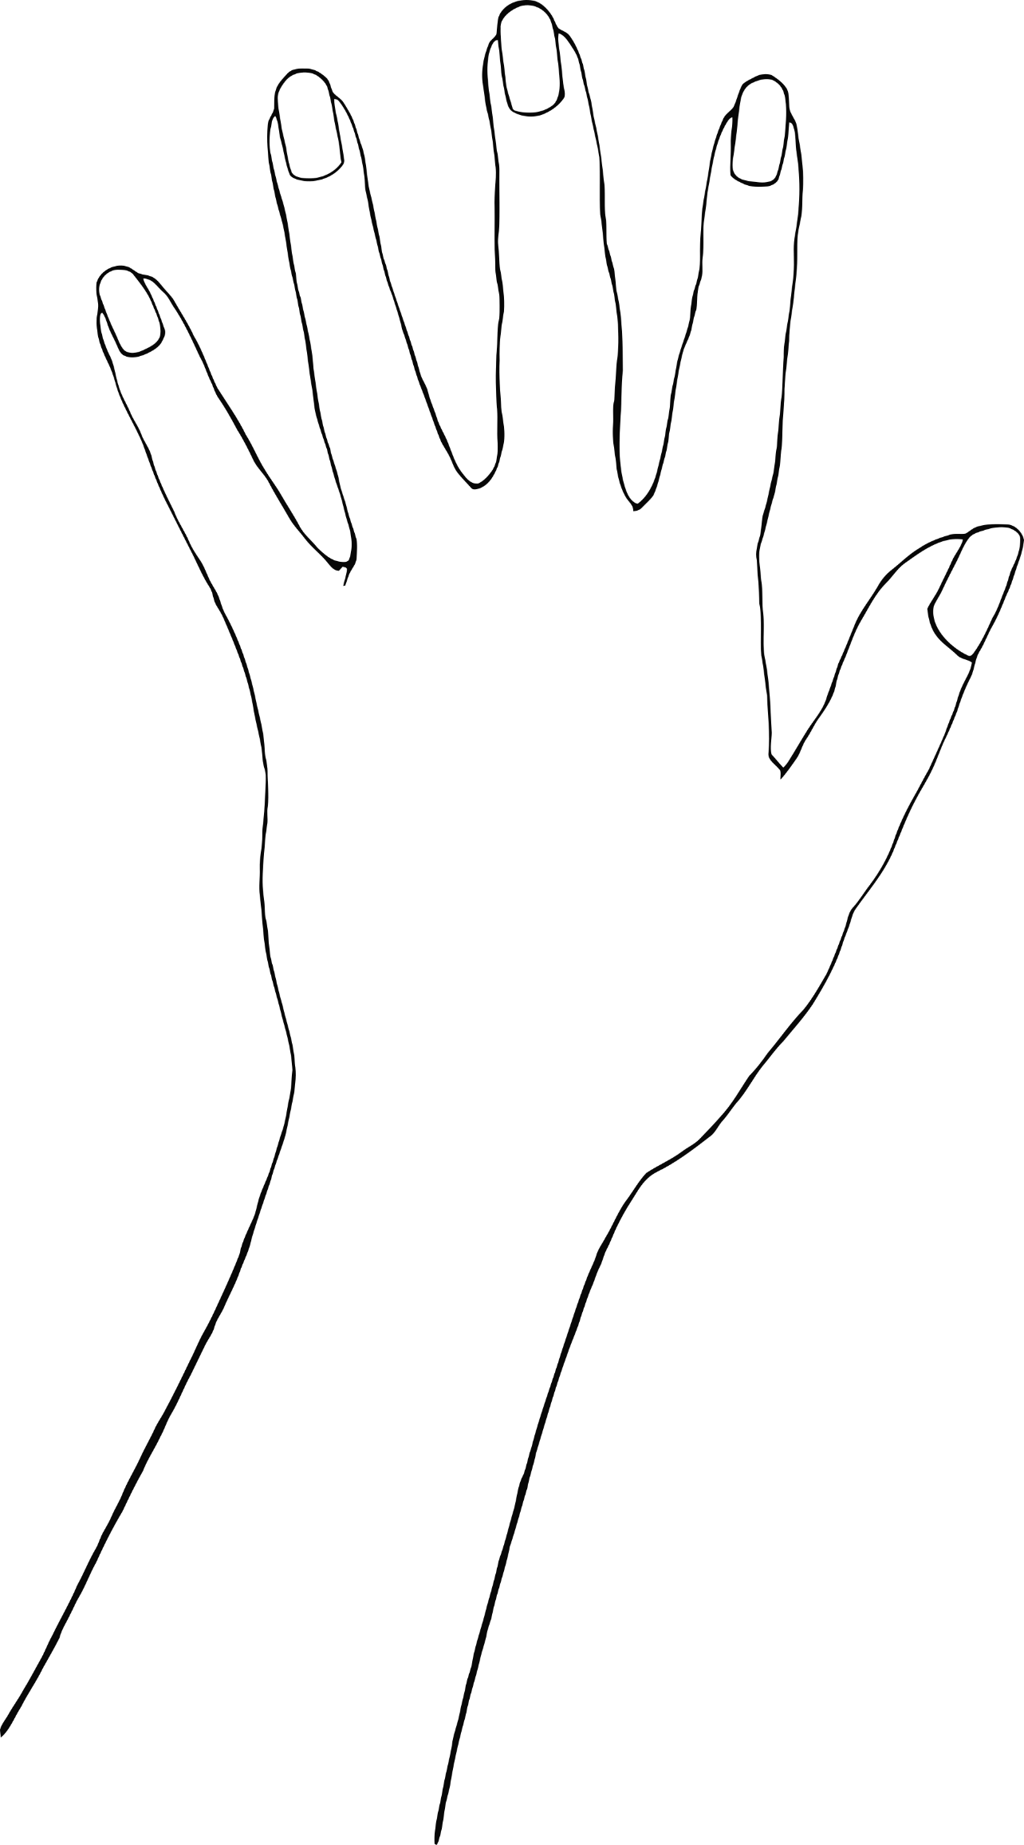

© 2020 Little Owls Resources



© 2020 Little Owls Resources