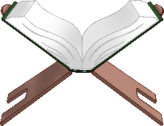

**عيد الفطر**

**Eid Al-Fitr**



**Eid Al-Fitr**

**عيد الفطر**

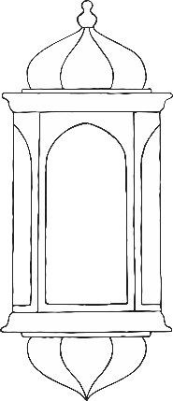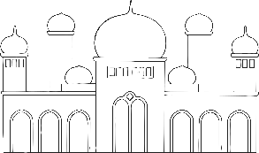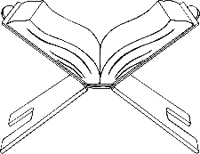

**عيد الفطر**

**Eid Al-Fitr**



____________________________________________________________________________________________________________________________________________



**Eid Al-Fitr**

**عيد الفطر**



____________________________________________________________________________________________________________________________________________



**عيد الفطر**

**Eid Al-Fitr**



_________________________________________________________



**Eid Al-Fitr**

**عيد الفطر**



_________________________________________________________