© 2021 Little Owls Resources

**Egg Fine Motor Control**

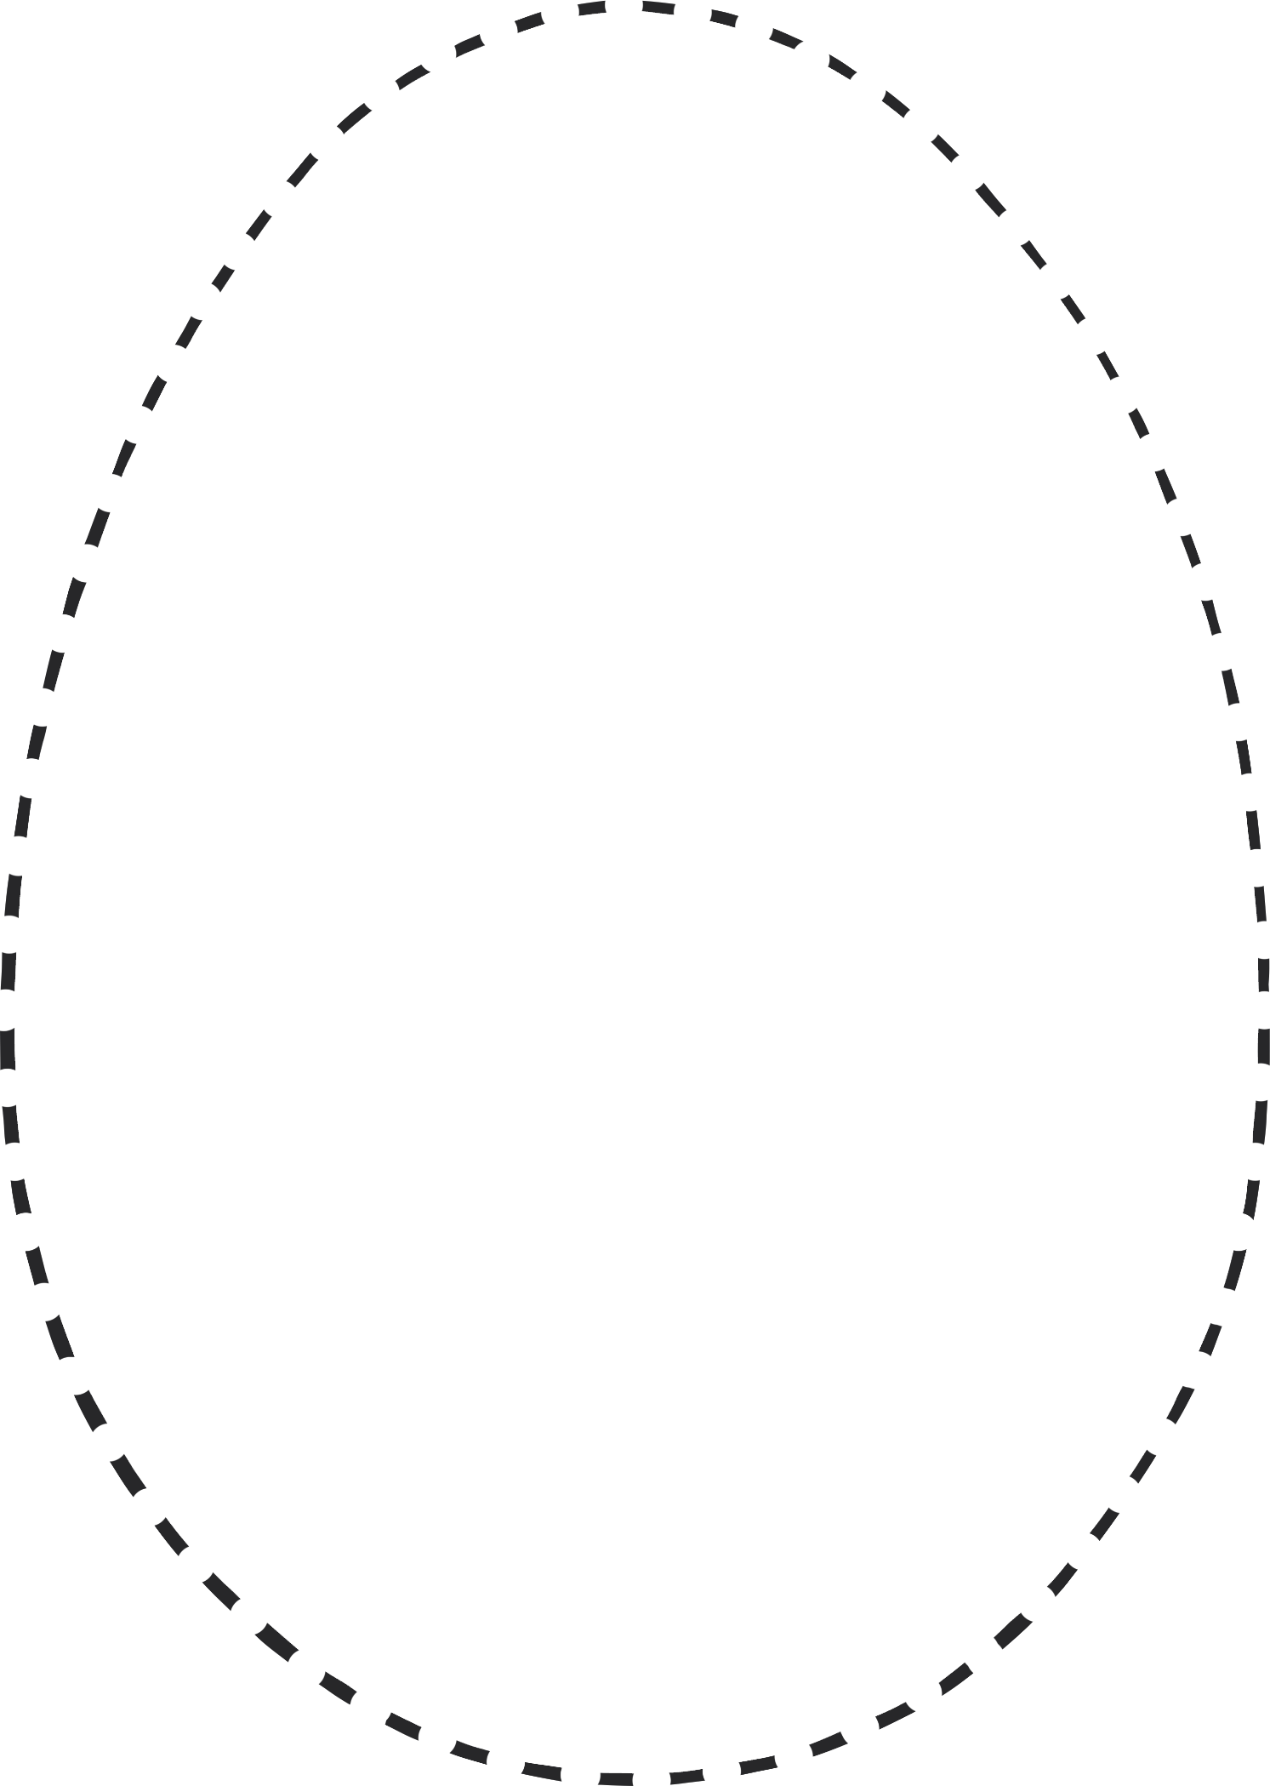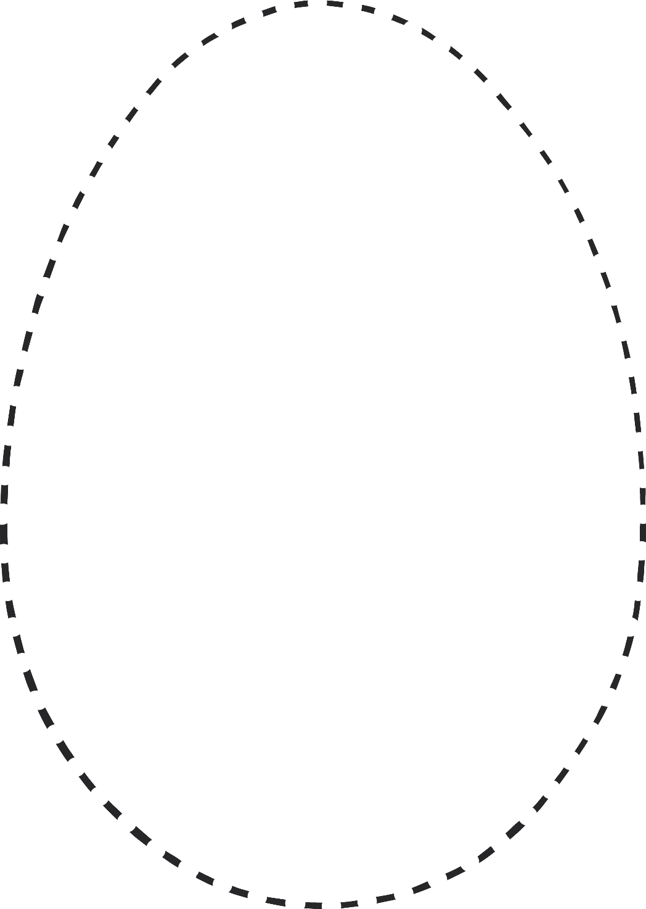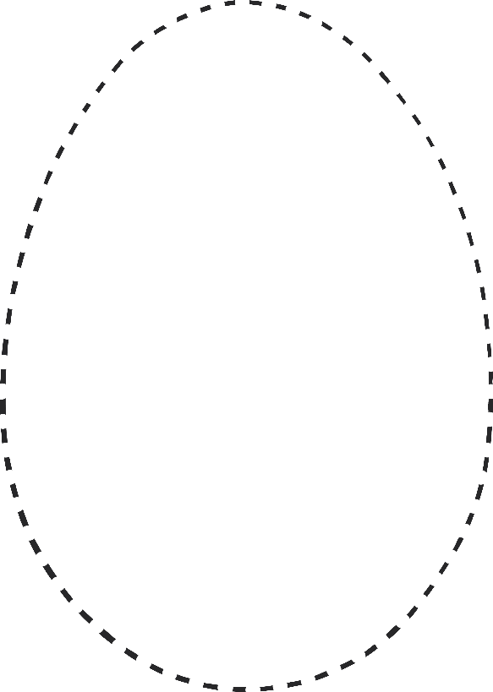

© 2021 Little Owls Resources

**Egg Fine Motor Control**