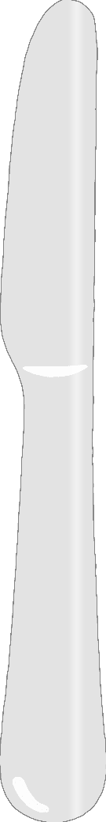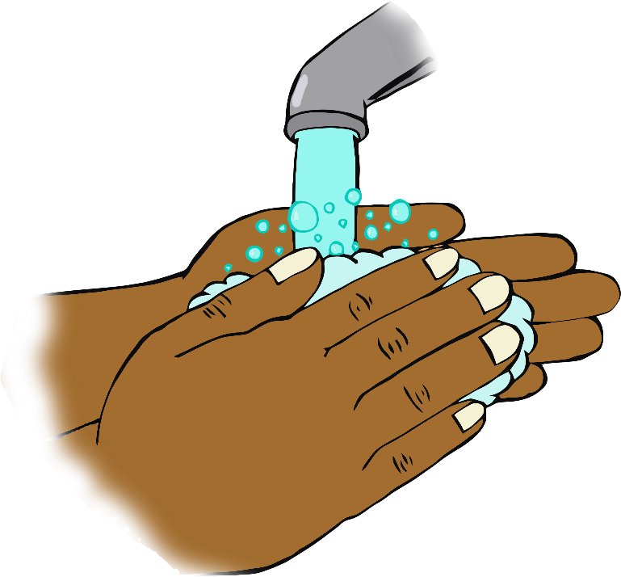

**Before eating…**

**Wash your hands!**