

chocolate egg

chocolate egg

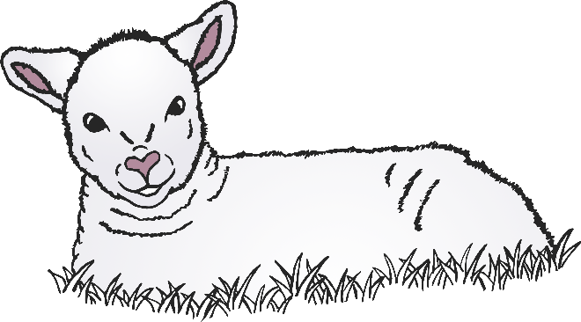

chocolate egg

lamb

lamb

lamb



chick

chick

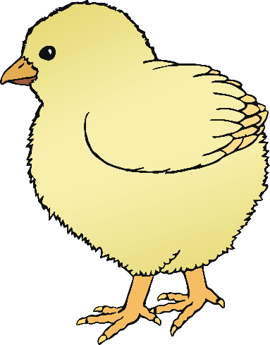

chick

Easter basket

www.littleowlsresources.com

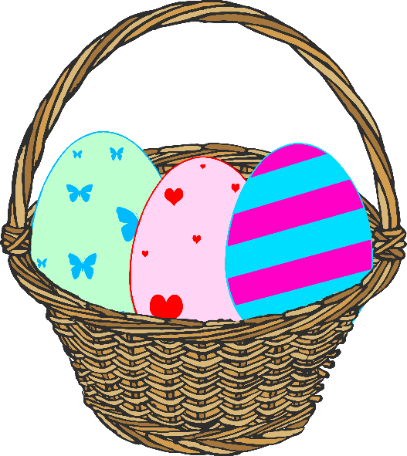

Easter basket

Easter basket

www.littleowlsresources.com



daffodils

daffodils

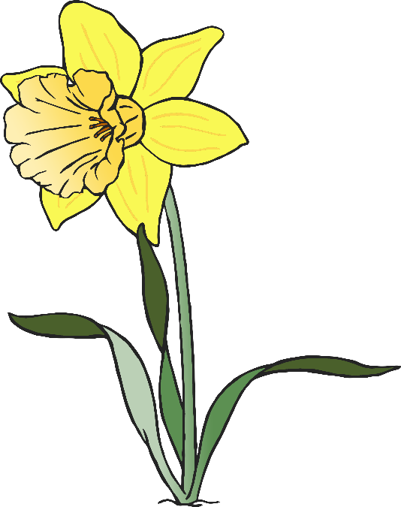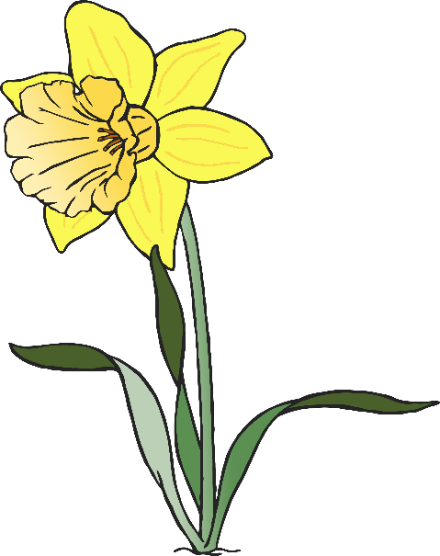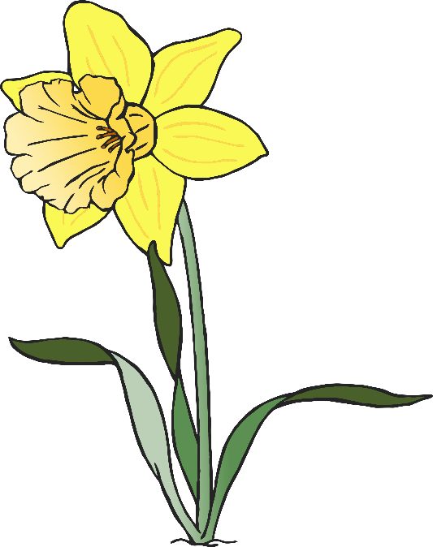



daffodils

bunny rabbit

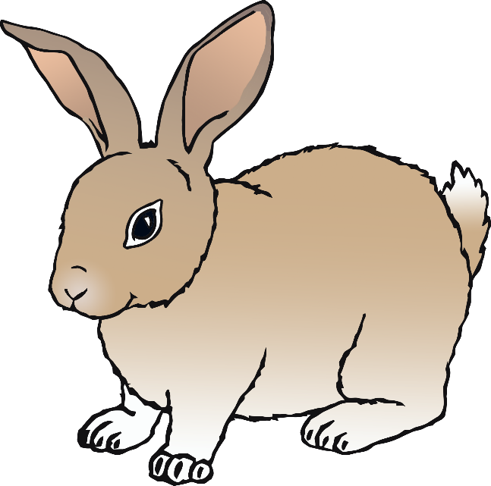

bunny rabbit

bunny rabbit



hot cross bun

hot cross bun

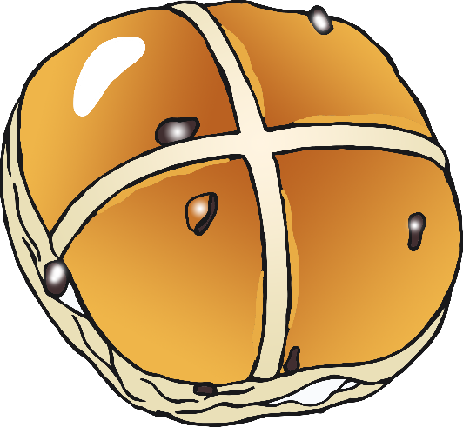



cross

hot cross bun

cross

cross



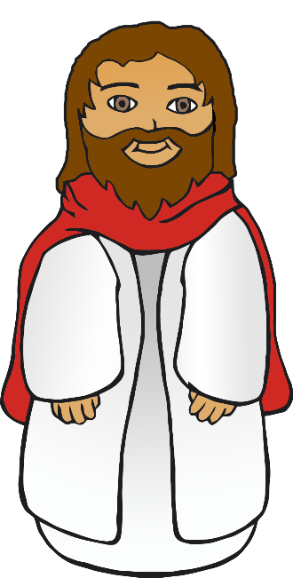

Jesus

Jesus



Jesus