Easter multimat

© 2023 Little Owls Resources

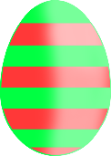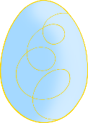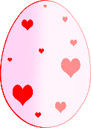

Easter multimat

© 2023 Little Owls Resources



Easter multimat

© 2023 Little Owls Resources

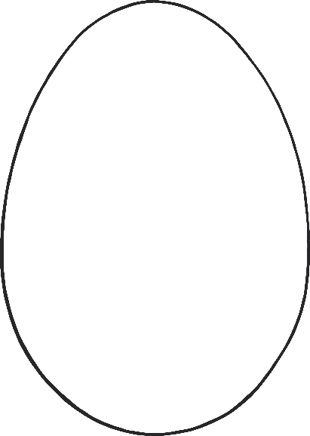

Easter multimat

© 2023 Little Owls Resources



Easter multimat

© 2023 Little Owls Resources



Easter multimat

© 2023 Little Owls Resources

