**Easter Egg Hunt**

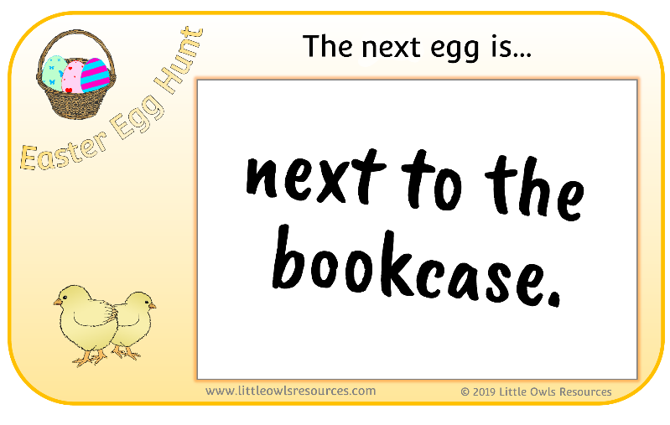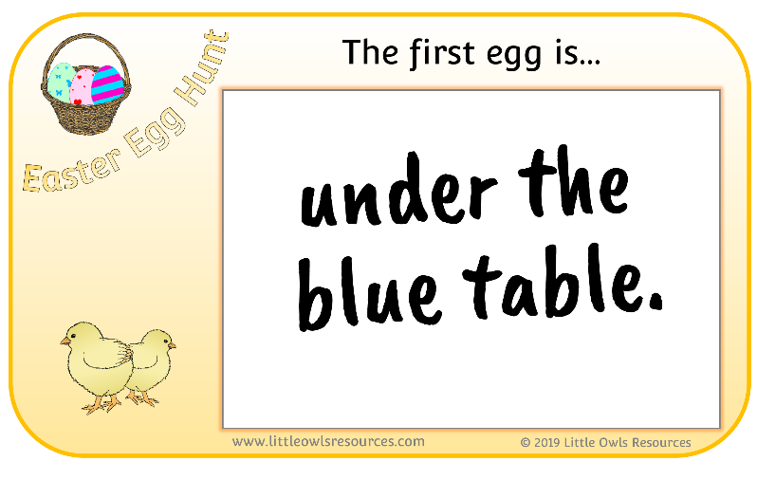

Blank Easter Egg Hunt clues to be filled in before the game. Each clue to be placed with an egg to lead the children to the next one.

Using positional language (on, in, under, behind, etc) to describe the position of the next egg to the children.

Encourage the children to follow your instructions to find the egg.

Have fun!!

**Easter Egg Hunt**

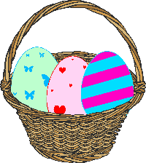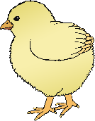

The first egg is…

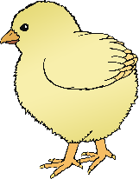

© 2020 Little Owls Resources

www.littleowls-premium.com

**Easter Egg Hunt**



To start, the first egg is…



© 2020 Little Owls Resources

www.littleowls-premium.com

**Easter Egg Hunt**



You will find the next egg…



© 2020 Little Owls Resources

www.littleowls-premium.com

**Easter Egg Hunt**



Look for the next egg…



© 2020 Little Owls Resources

www.littleowls-premium.com

**Easter Egg Hunt**



The next egg is…



© 2020 Little Owls Resources

www.littleowls-premium.com

**Easter Egg Hunt**



The next egg is…



© 2020 Little Owls Resources

www.littleowls-premium.com

**Easter Egg Hunt**



The final egg is…



© 2020 Little Owls Resources

www.littleowls-premium.com

**Easter Egg Hunt**



Finally, look…



© 2020 Little Owls Resources

www.littleowls-premium.com