These card templates have detailed outlines to be used as a starting point for an art activity.

The outlines can be coloured, painted, or collaged to create an individual card design.

Greeting Cards Activity – Easter

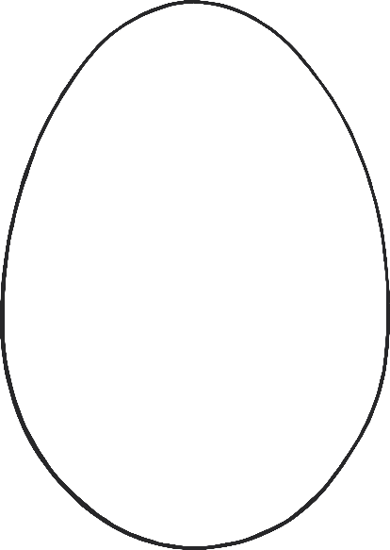

Happy Easter



Happy Easter

©2022 Little Owls Resources

**Happy Easter**

©2022 Little Owls Resources

Happy Easter

©2022 Little Owls Resources

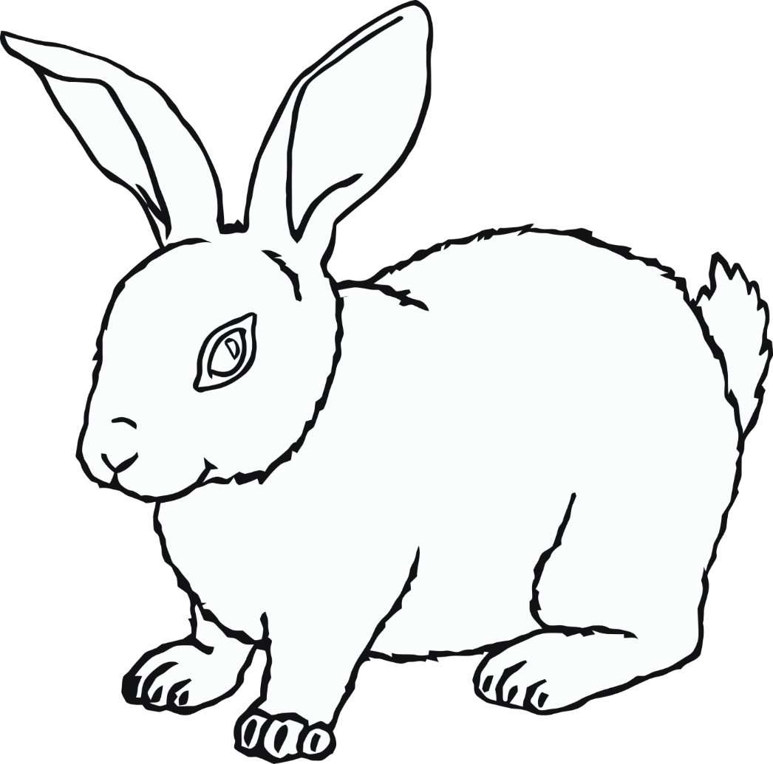

Happy Easter

©2022 Little Owls Resources

Happy Easter

©2022 Little Owls Resources

**Happy**

**Easter**

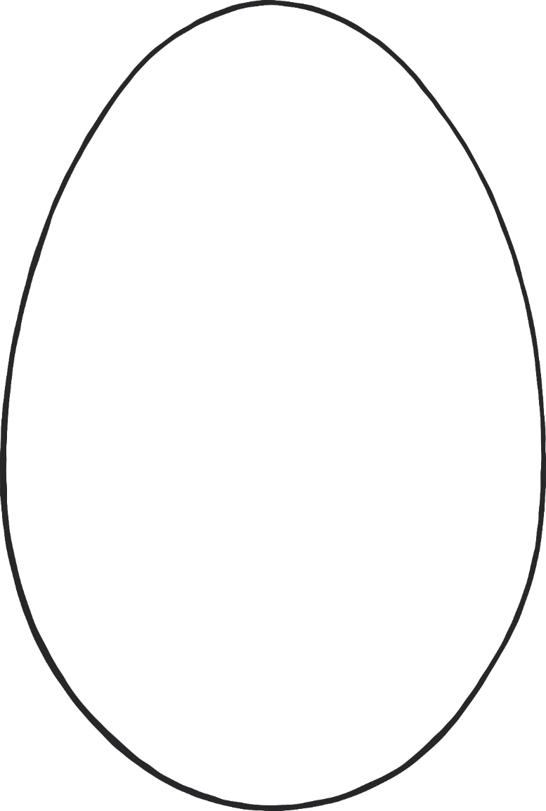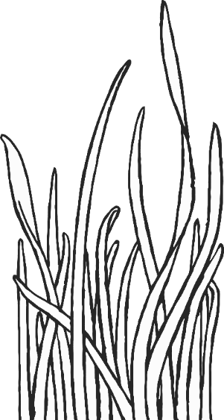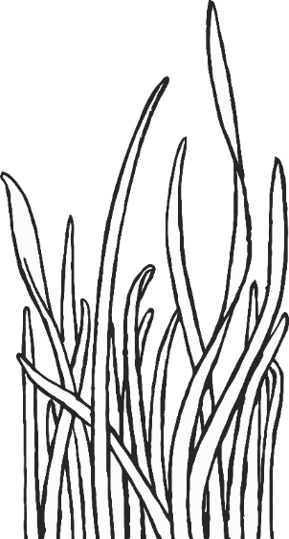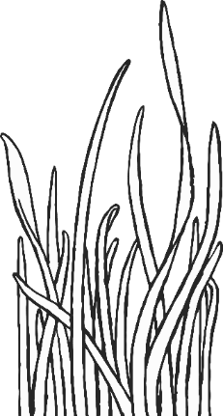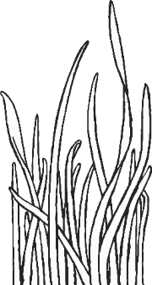

©2022 Little Owls Resources

Happy Easter

©2022 Little Owls Resources

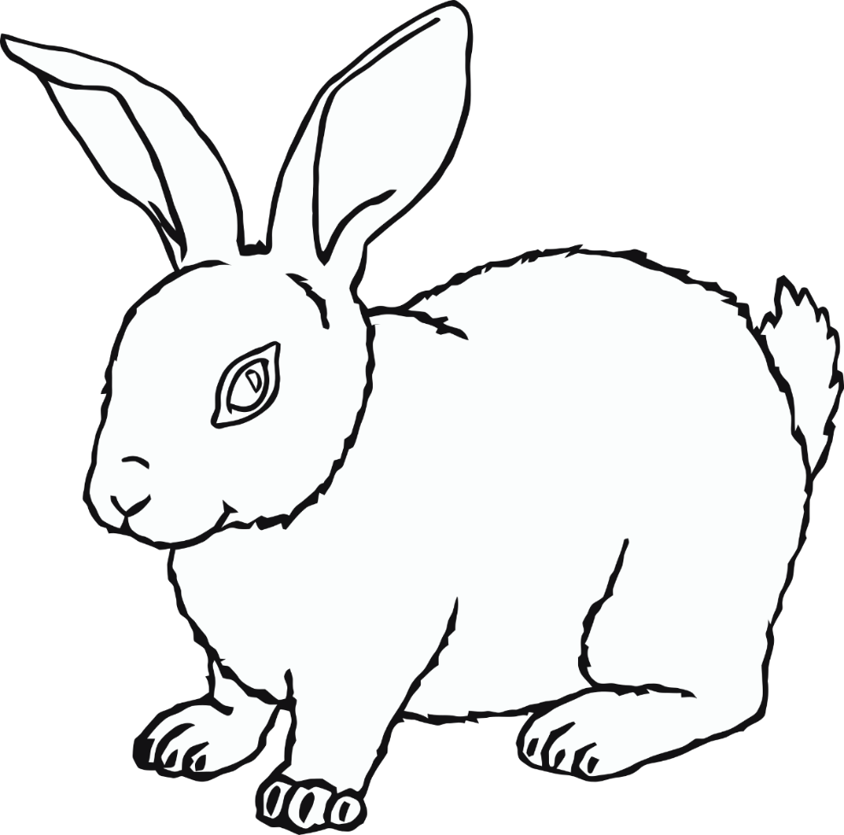

**Happy Easter**

©2022 Little Owls Resources

Happy Easter

©2022 Little Owls Resources

**Happy Easter**

©2022 Little Owls Resources

©2022 Little Owls Resources

**Happy Easter**