Easter A4 templates

©2022 Little Owls Resources

These templates have detailed outlines to be used as a starting point for an art activity.

The outlines can be coloured, painted, or collaged to create an individual poster design.

They could be stuck to a folded piece of A3 card to make a large card!

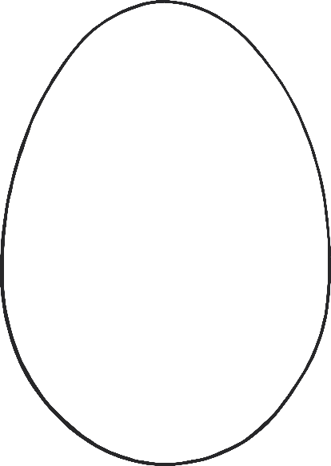

Happy Easter



Happy Easter

Dear Daddy

**Happy Easter**

©2022 Little Owls Resources

Happy Easter

©2022 Little Owls Resources

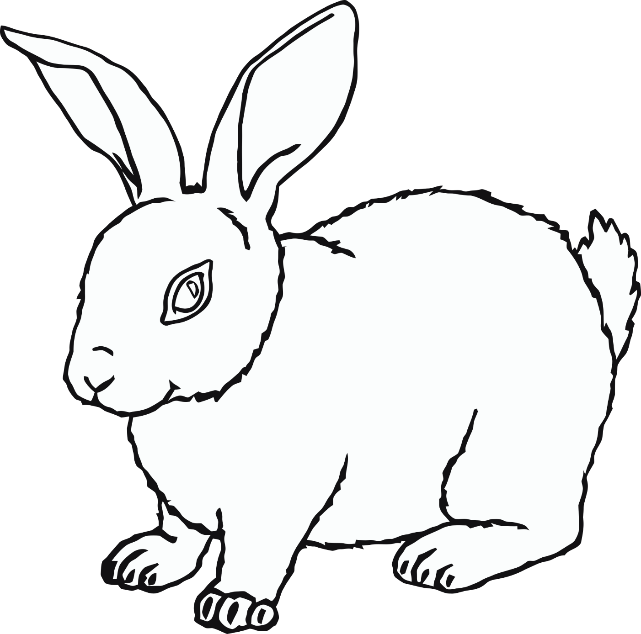

Happy Easter

©2022 Little Owls Resources

Happy Easter

©2022 Little Owls Resources

**Happy**

**Easter**

©2022 Little Owls Resources

Happy Easter

©2022 Little Owls Resources

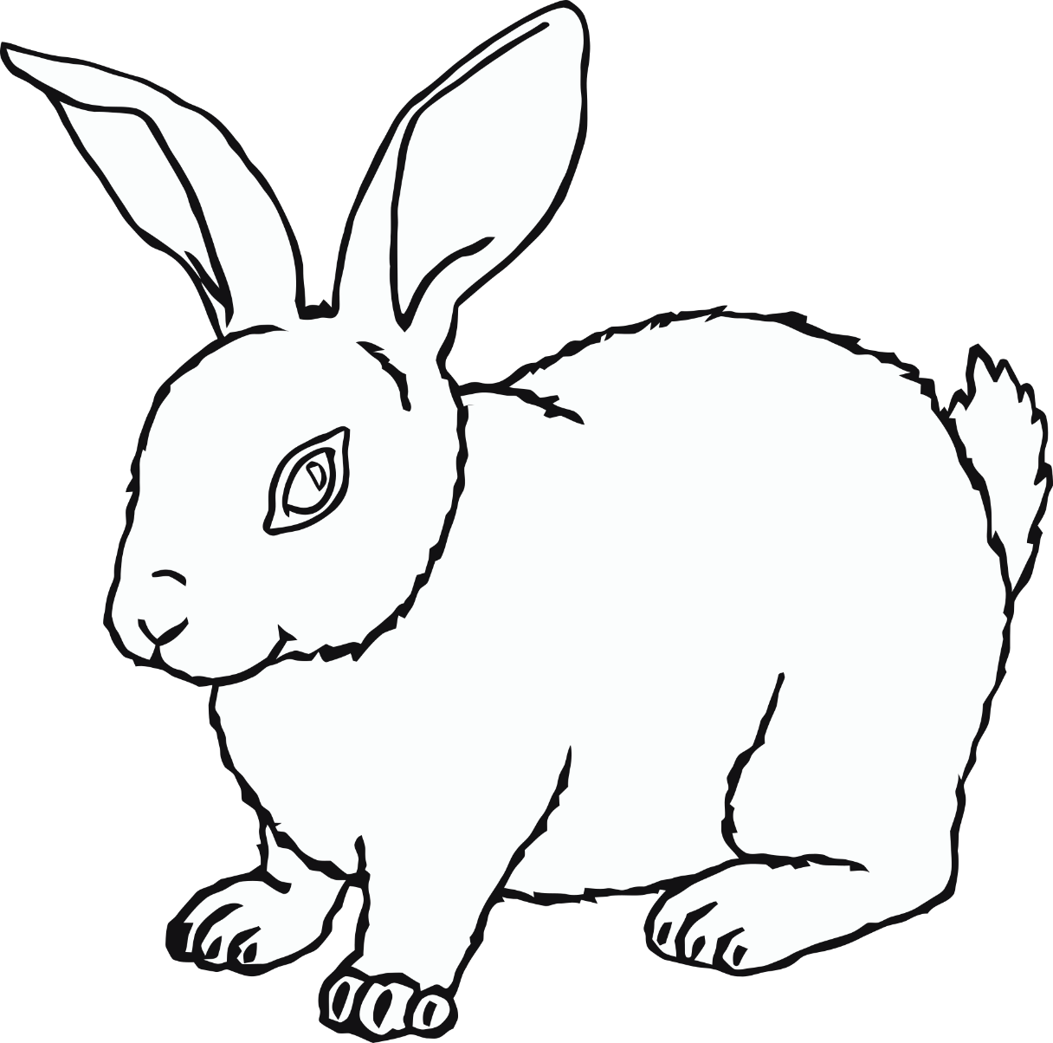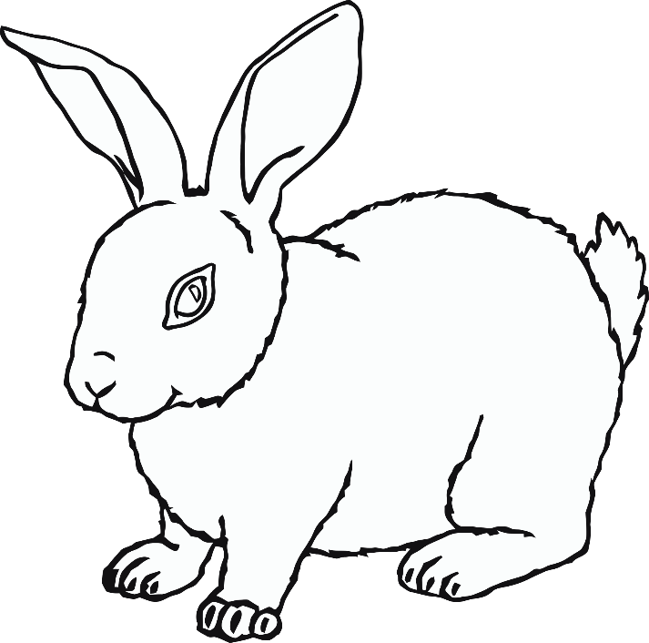

Happy Easter

©2022 Little Owls Resources

Happy Easter

©2022 Little Owls Resources

**Happy Easter**

©2022 Little Owls Resources

**Happy Easter**

©2022 Little Owls Resources