**Duck body parts**

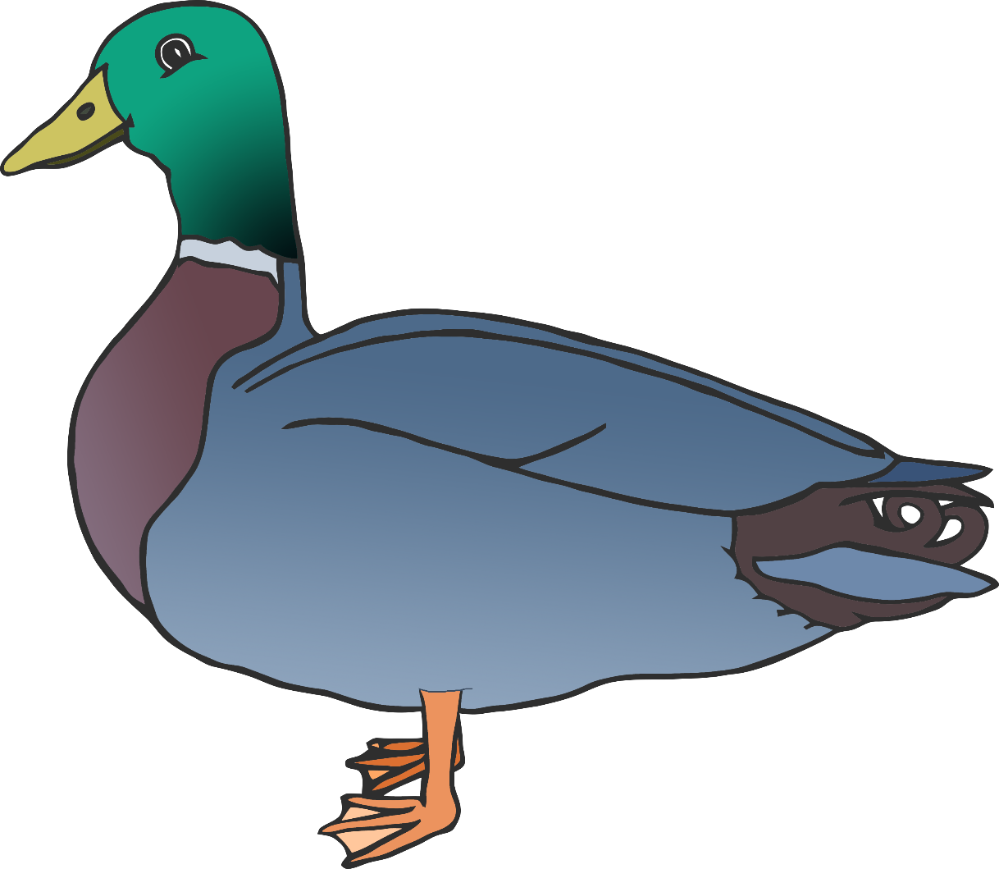

© 2021 Little Owls Resources



e

t

f

w

b

**Duck body parts**

© 2021 Little Owls Resources



eye

tail

foot

wing

bill

**Duck body parts**

© 2021 Little Owls Resources