Water time!

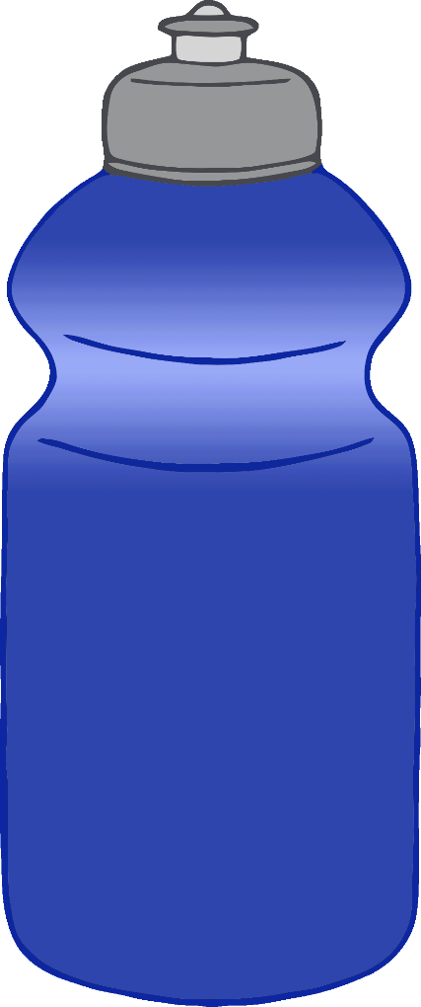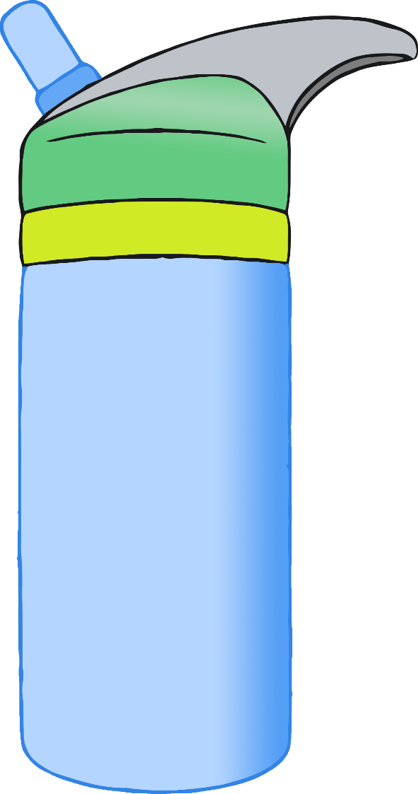

© 2022 Little Owls Resources

Drink some water!