What can you hear?

© 2020 Little Owls Resources

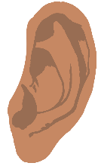

Draw what you heard.

What can you hear?

Close your eyes and listen.

© 2020 Little Owls Resources