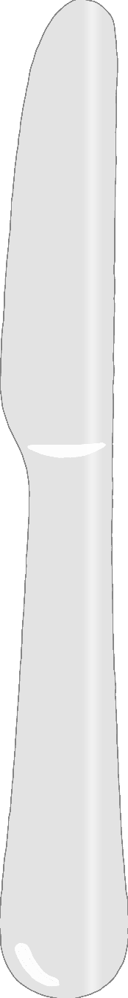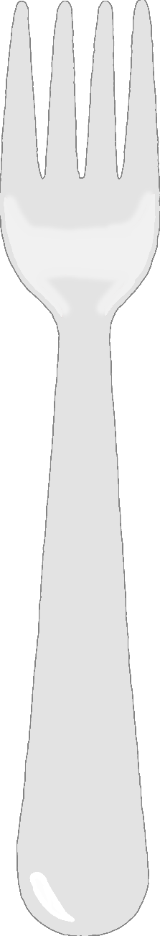

**Draw a healthy meal!**

© 2020 Little Owls Resources