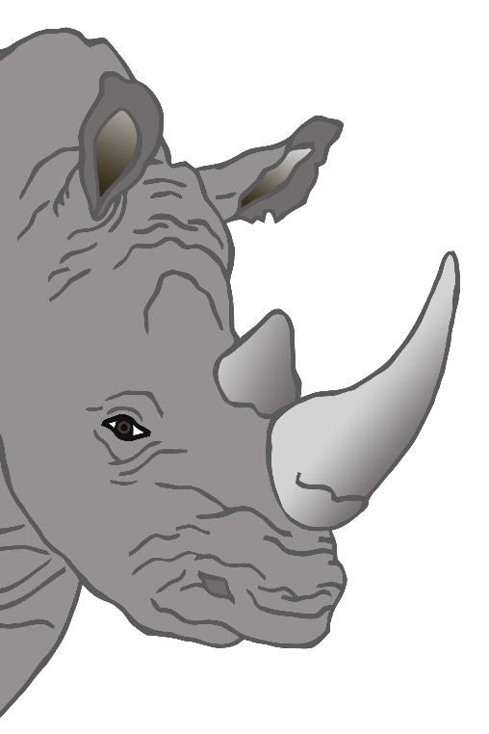

© 2021 Little Owls Resources

Draw some food for the rhino…

**ZOO**

© 2021 Little Owls Resources

Draw some food for the chimpanzee…

**ZOO**

© 2021 Little Owls Resources

Draw some food for the lion…

**ZOO**

© 2021 Little Owls Resources

Draw some food for the giraffe…

**ZOO**

© 2021 Little Owls Resources

Draw some food for the tiger…

**ZOO**

© 2021 Little Owls Resources

Draw some food for the meerkat…

**ZOO**

