

**Draw what you can see through the pirate porthole.**

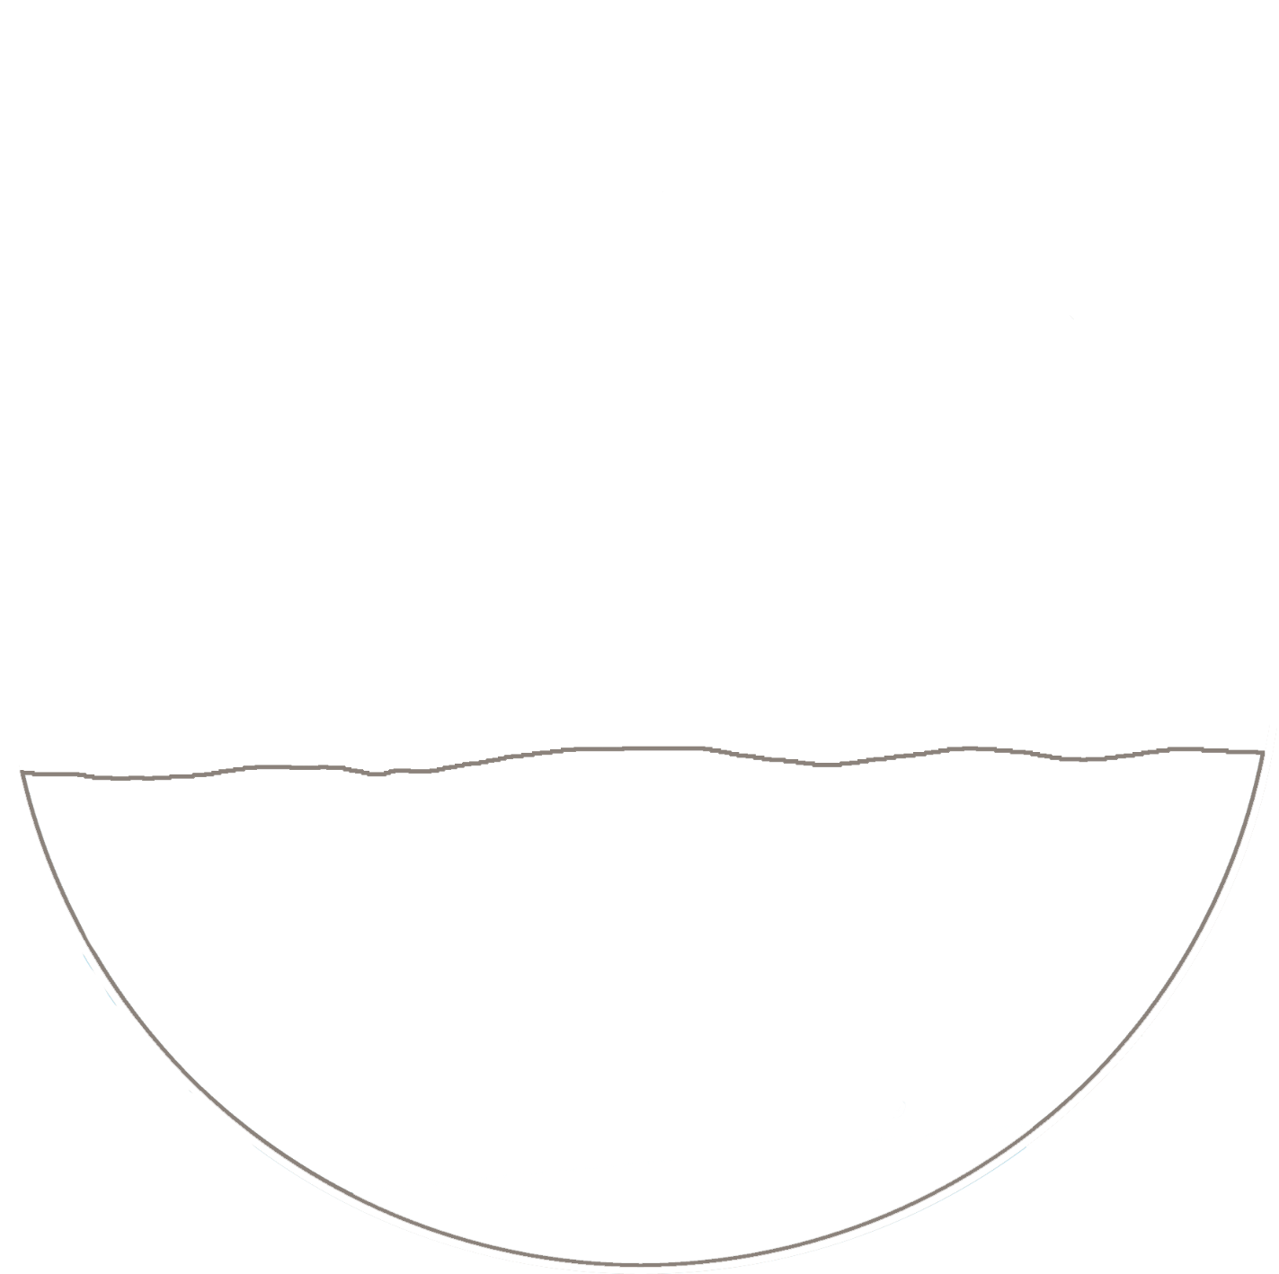

© 2021 Little Owls Resources



Draw what you can see through the pirate porthole.

© 2021 Little Owls Resources