© 2023 Little Owls Resources

Draw a home for this Mermaid!

**Mermaids**

**and Mermen**

© 2023 Little Owls Resources

Draw a home for this Mermaid!

**Mermaids**

**and Mermen**

© 2023 Little Owls Resources

Draw a home for this Mermaid!

**Mermaids**

**and Mermen**

© 2023 Little Owls Resources

Draw a home for this Mermaid!

**Mermaids**

**and Mermen**

© 2023 Little Owls Resources

Draw a home for this Mermaid!

**Mermaids**

**and Mermen**

© 2023 Little Owls Resources

Draw a home for this Merman!

**Mermaids**

**and Mermen**

© 2023 Little Owls Resources

Draw a home for this Merman!

**Mermaids**

**and Mermen**

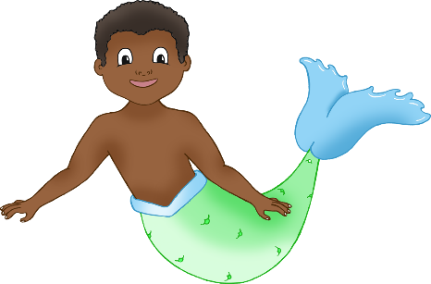

© 2023 Little Owls Resources

Draw a home for this Merman!

**Mermaids**

**and Mermen**

© 2023 Little Owls Resources

Draw a home for this Merman!

**Mermaids**

**and Mermen**