

**Happy**

Can you draw a time when you were happy?

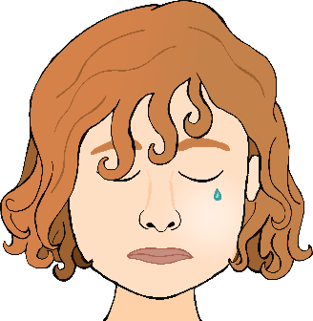

**Sad**

Can you draw a time when you were sad?

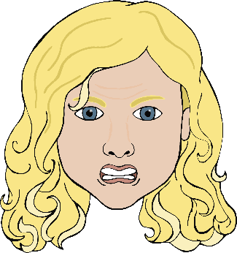

**Angry**

Can you draw a time when you were angry?

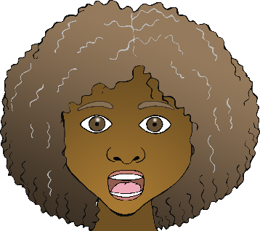

Can you draw a time when you were scared?

**Scared**