If your hands aren’t clean don’t touch your eyes, your nose or your mouth.

© 2020 Little Owls Resources

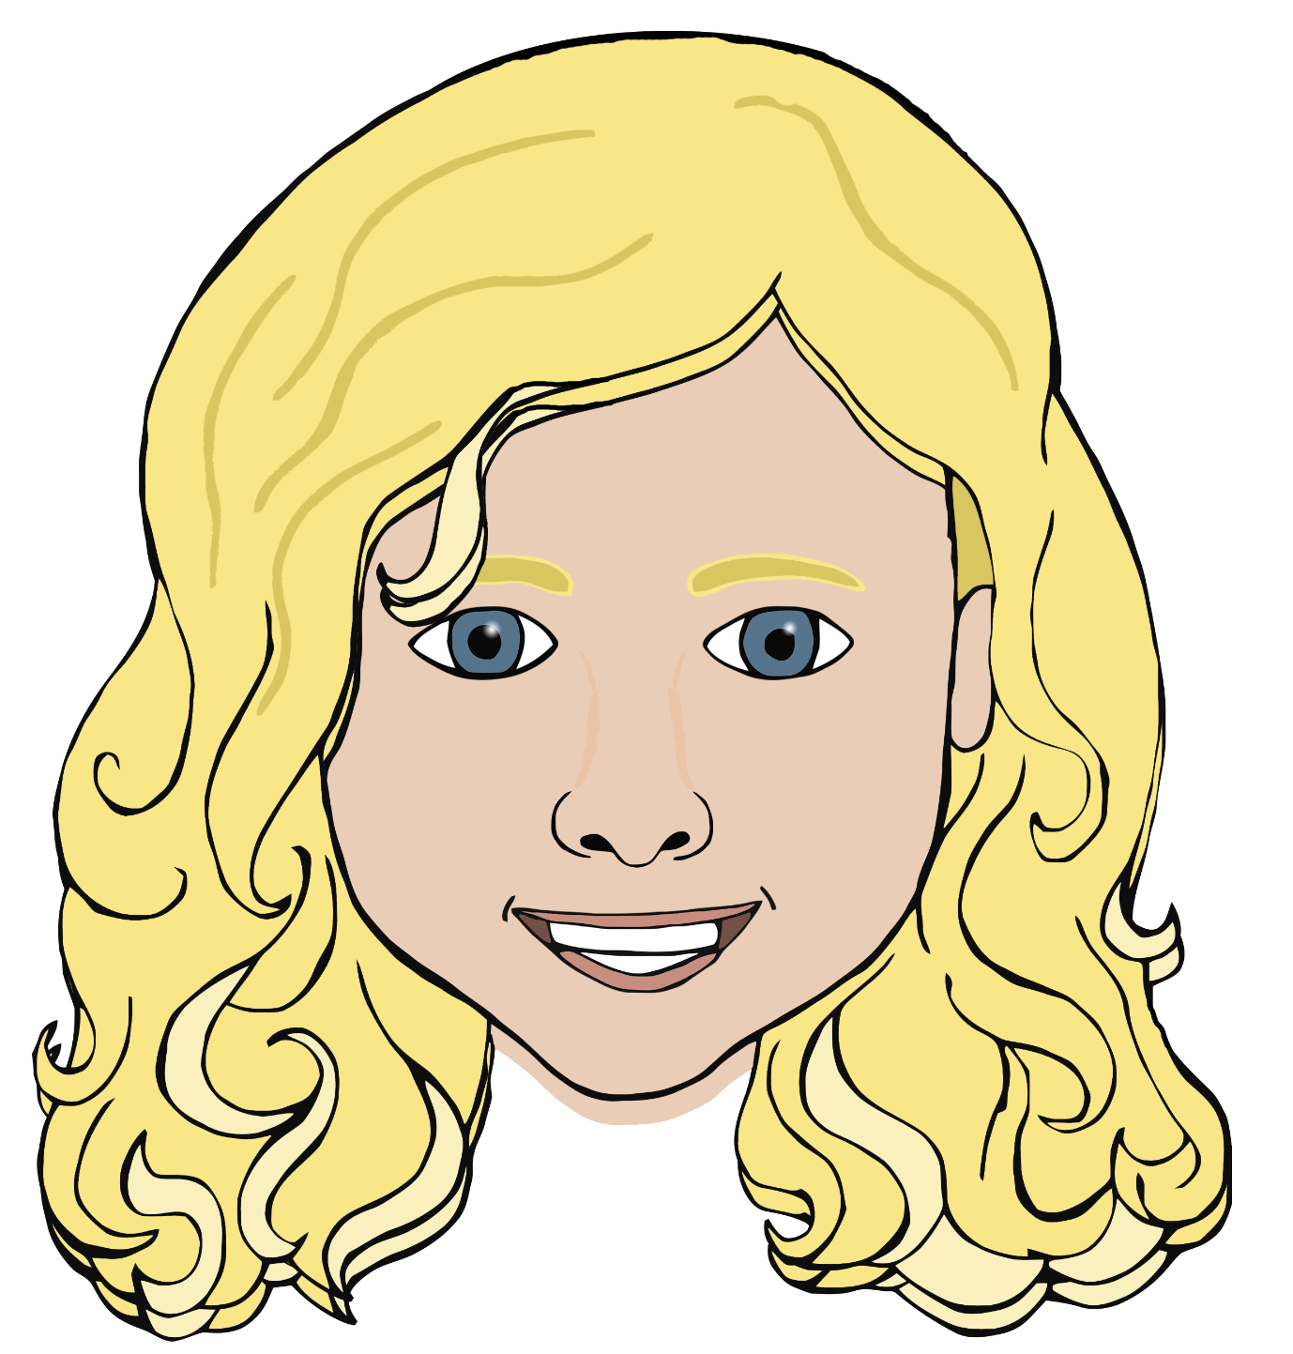

If your hands aren’t clean don’t touch your eyes, your nose or your mouth.

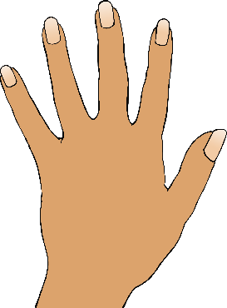

© 2020 Little Owls Resources

If your hands aren’t clean don’t touch your eyes, your nose or your mouth.

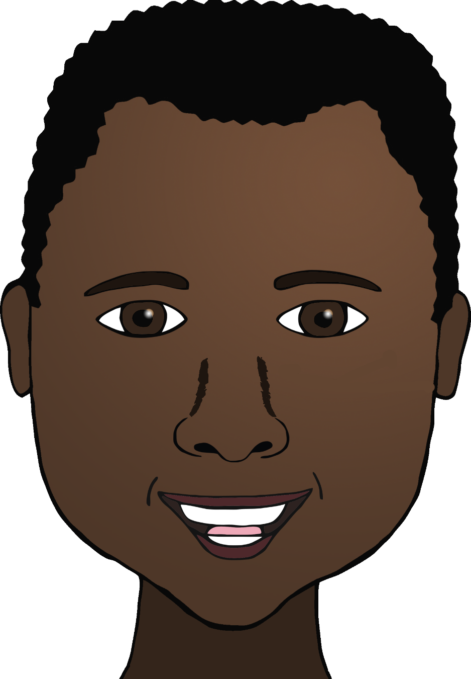

© 2020 Little Owls Resources

If your hands aren’t clean don’t touch your eyes, your nose or your mouth.

© 2020 Little Owls Resources