I ha

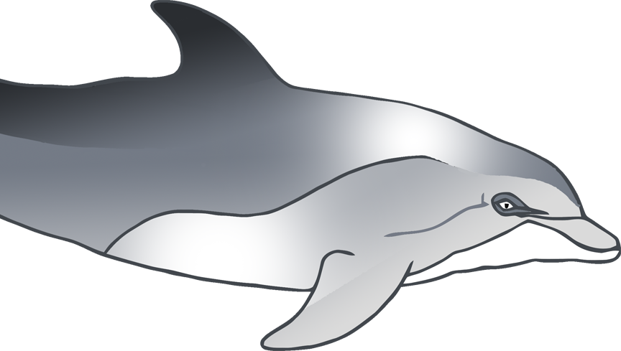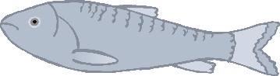

I need **1** fish.

Can you make some fish for the dolphin?

© 2020 Little Owls Resources

I ha



I need **2** fish.

Can you make some fish for the dolphin?

© 2020 Little Owls Resources

I ha



I need **3** fish.

Can you make some fish for the dolphin?

© 2020 Little Owls Resources

© 2020 Little Owls Resources

I ha



I need **4** fish.

Can you make some fish for the dolphin?

© 2020 Little Owls Resources

I ha



I need **5** fish.

Can you make some fish for the dolphin?

© 2020 Little Owls Resources

I ha



I need **6** fish.

Can you make some fish for the dolphin?

© 2020 Little Owls Resources

I ha



I need **7** fish.

Can you make some fish for the dolphin?

© 2020 Little Owls Resources

I ha



I need **8** fish.

Can you make some fish for the dolphin?

© 2020 Little Owls Resources

I ha



I need **9** fish.

Can you make some fish for the dolphin?

© 2020 Little Owls Resources

I ha



I need **10** fish.

Can you make some fish for the dolphin?

© 2020 Little Owls Resources