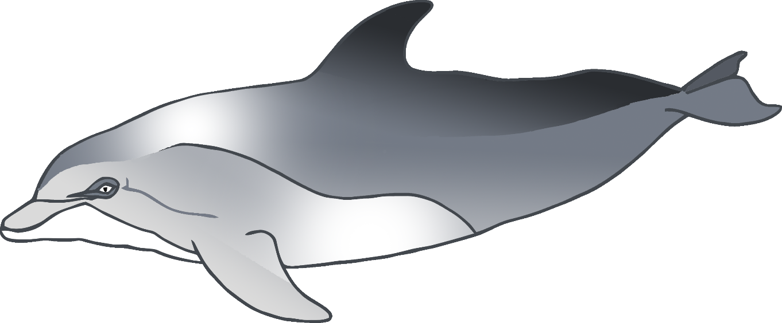

**Dolphin body parts**

© 2020 Little Owls Resources



**Dolphin body parts**

© 2020 Little Owls Resources

b

m

f

f

f



**Dolphin body parts**

© 2020 Little Owls Resources

blowhole

melon

flipper

fin

fluke