**What does a dog need?**

© 2020 Little Owls Resources

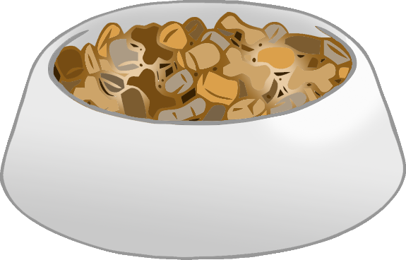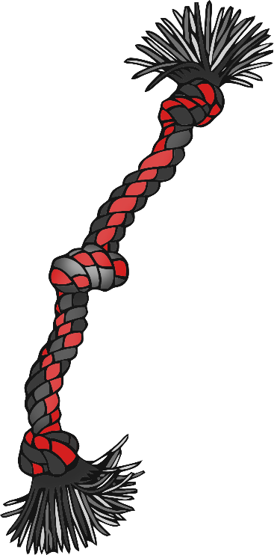

Toys for fun

Healthy food and water

Walking for exercise

Brush for keeping clean