

**What does a dog need?**

© 2020 Little Owls Resources

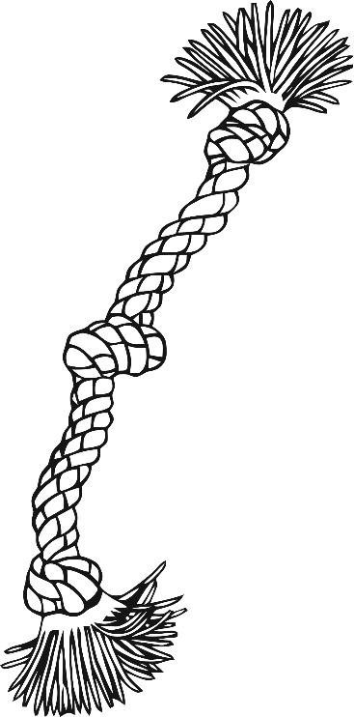

**Toys for fun**

**Healthy food and water**

**Walking for exercise**

**Brush for keeping clean**