**Help the dog get to the food!**

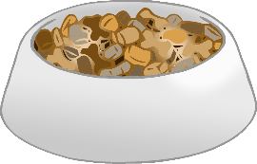

© 2020 Little Owls Resources

© 2020 Little Owls Resources

**Help the dog get to the food!**

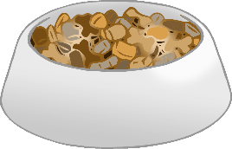

© 2020 Little Owls Resources

**Help the dog get to the food!**

© 2020 Little Owls Resources

**Help the dog get to the food!**