**Help the dog get to the food!** (1)

© 2020 Little Owls Resources

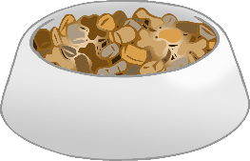

**Help the dog get to the food!** (2)

© 2020 Little Owls Resources