Doctors

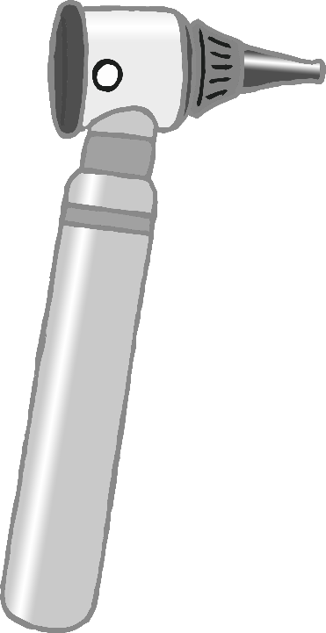

Surgery

© 2021 Little Owls Resources

© 2021 Little Owls Resources

© 2021 Little Owls Resources

© 2021 Little Owls Resources

© 2021 Little Owls Resources

© 2021 Little Owls Resources

© 2021 Little Owls Resources

© 2021 Little Owls Resources

© 2021 Little Owls Resources

Doctor

Doctor

© 2021 Little Owls Resources

Doctor

© 2021 Little Owls Resources

Doctor

© 2021 Little Owls Resources

© 2021 Little Owls Resources

Nurse

Nurse

Nurse

© 2021 Little Owls Resources

© 2021 Little Owls Resources

© 2021 Little Owls Resources

© 2021 Little Owls Resources

Nurse

Not too close!

© 2021 Little Owls Resources

Thank-you!

Feel free to read a book while you wait.

Waiting Area

© 2021 Little Owls Resources

© 2021 Little Owls Resources

© 2021 Little Owls Resources

**Please Wait**

© 2021 Little Owls Resources

medicine

syringe

thermometer

otoscope

fob watch

Medical Word Mat

stethoscope

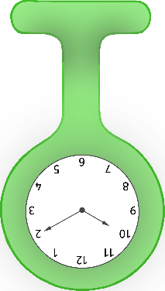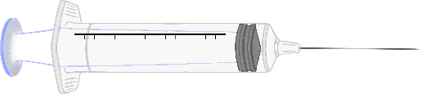

medical gloves

plasters

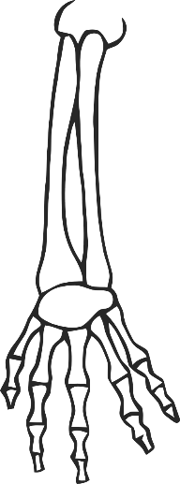

doctor’s bag

clipboard

x-ray

bandage

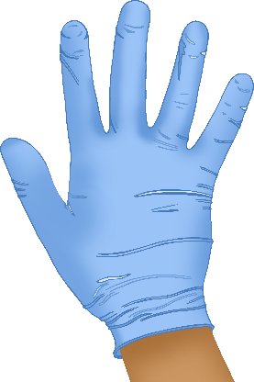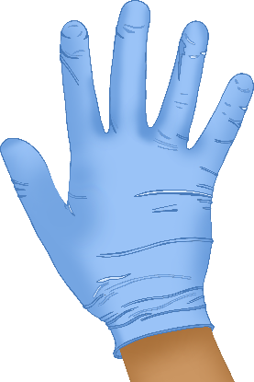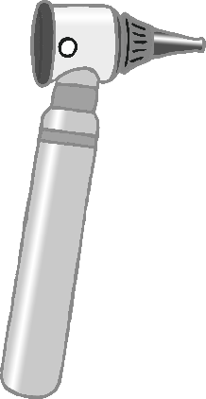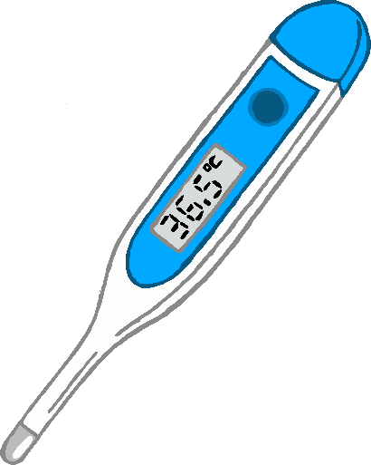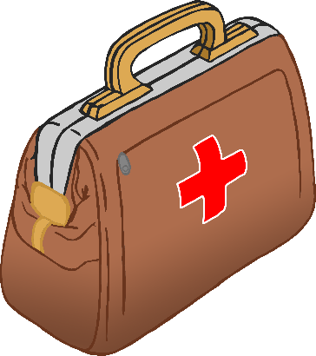

© 2021 Little Owls Resources

Please sign in for your appointment.

Welcome!

**Open**

© 2021 Little Owls Resources

© 2021 Little Owls Resources

**Closed**

|  |  |
| --- | --- |
| Monday |  |
| Tuesday |  |
| Wednesday |  |
| Thursday |  |
| Friday |  |
| Saturday |  |
| Sunday |  |

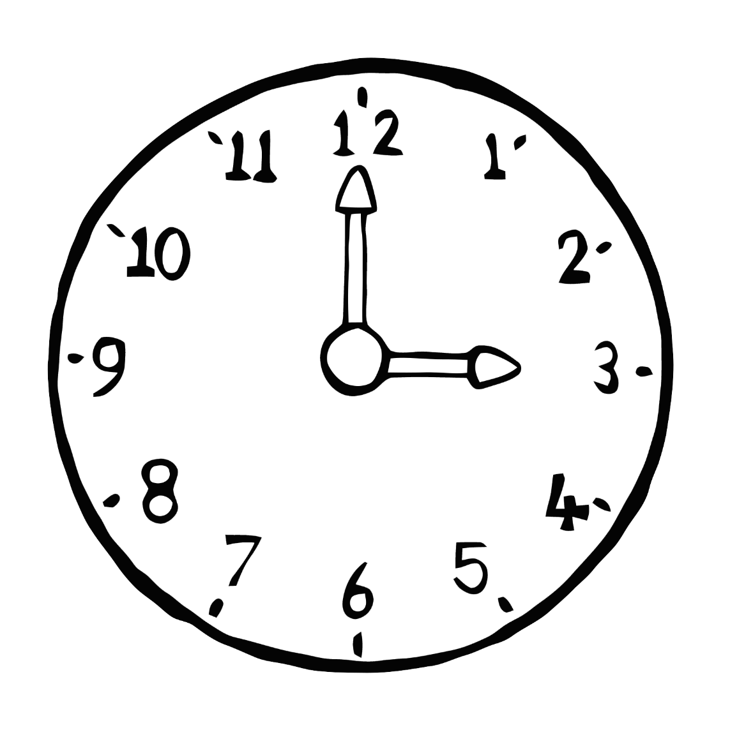

Surgery Opening Times

12

8

7

1

5

4

2

10

11

9

3

6

© 2021 Little Owls Resources

Eat healthy foods!

© 2021 Little Owls Resources

Doctor

© 2021 Little Owls Resources

Doctor

Notes

© 2021 Little Owls Resources

Notes

Nurse

Notes

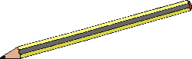

© 2021 Little Owls Resources

Nurse

Notes



© 2021 Little Owls Resources

Opens at

o’clock

12

6

3

9

1

2

4

5

7

8

10

11

Closes at

o’clock

© 2021 Little Owls Resources

© 2021 Little Owls Resources

© 2021 Little Owls Resources

12

6

3

9

1

2

4

5

7

8

10

11

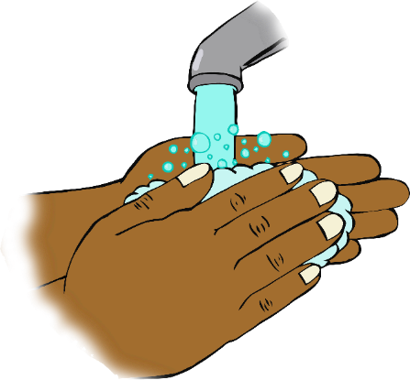

Don’t forget!

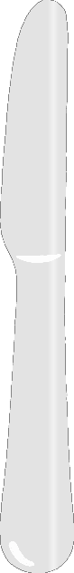

**Wash your hands!**

© 2021 Little Owls Resources

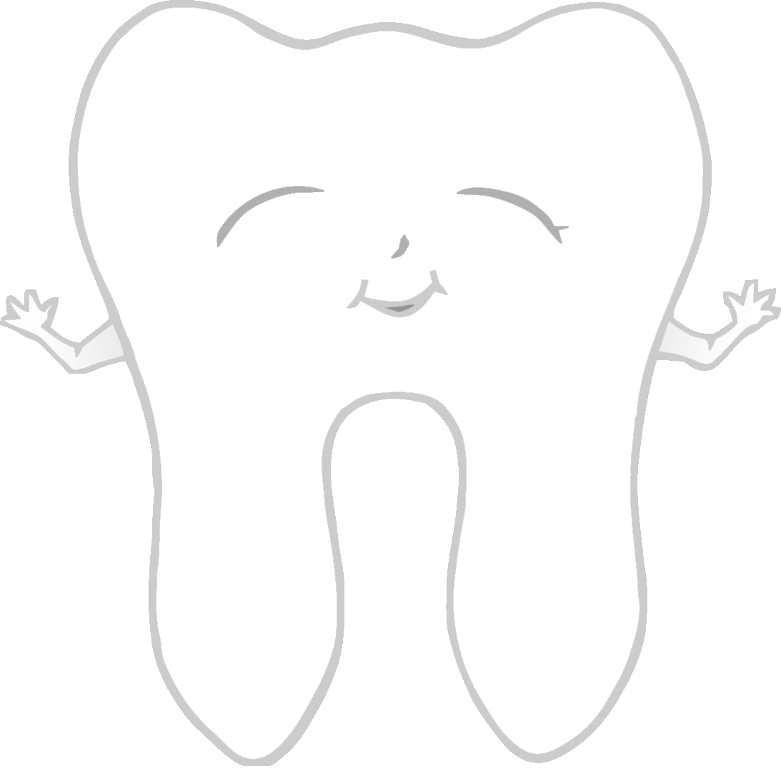

Keep me clean!

Brush your teeth!

© 2021 Little Owls Resources

…talk to a friend!

If you are feeling sad…

© 2021 Little Owls Resources

Appointments

© 2021 Little Owls Resources



Patient Details

© 2021 Little Owls Resources

Name:

Age:

What seems to be the problem?

Patient Details

© 2021 Little Owls Resources

Name:

Age:

What seems to be the problem?

_________________________________________________________

Patient Details

© 2021 Little Owls Resources

Name:

Age:

What seems to be the problem?

____________________________________________________________________________________________________________

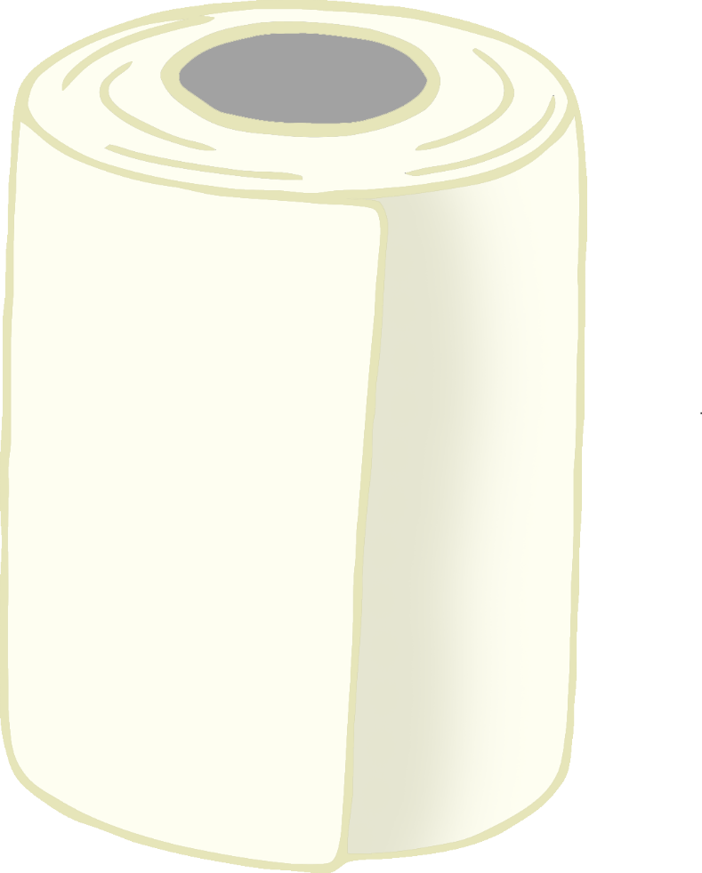

© 2021 Little Owls Resources

© 2021 Little Owls Resources

© 2021 Little Owls Resources

© 2021 Little Owls Resources

© 2021 Little Owls Resources

© 2021 Little Owls Resources

© 2021 Little Owls Resources

© 2021 Little Owls Resources

© 2021 Little Owls Resources

© 2021 Little Owls Resources

© 2021 Little Owls Resources

© 2021 Little Owls Resources

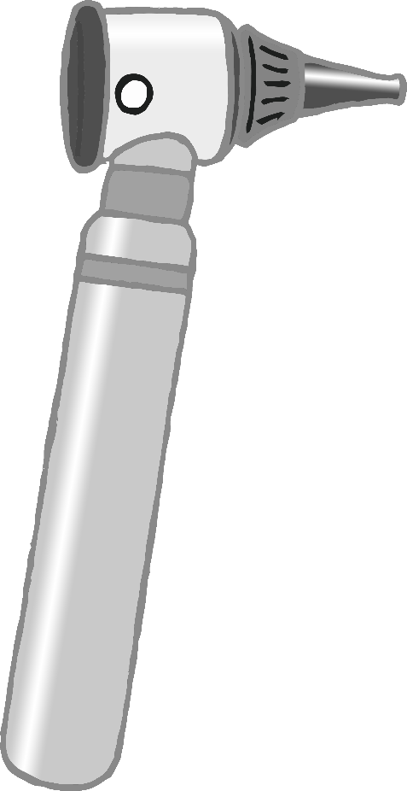

© 2021 Little Owls Resources

© 2021 Little Owls Resources

© 2021 Little Owls Resources

© 2021 Little Owls Resources



© 2021 Little Owls Resources

© 2021 Little Owls Resources

© 2021 Little Owls Resources

© 2021 Little Owls Resources

© 2021 Little Owls Resources

© 2021 Little Owls Resources

© 2021 Little Owls Resources

© 2021 Little Owls Resources

© 2021 Little Owls Resources

© 2021 Little Owls Resources

© 2021 Little Owls Resources

syringe

stethoscope

medicine

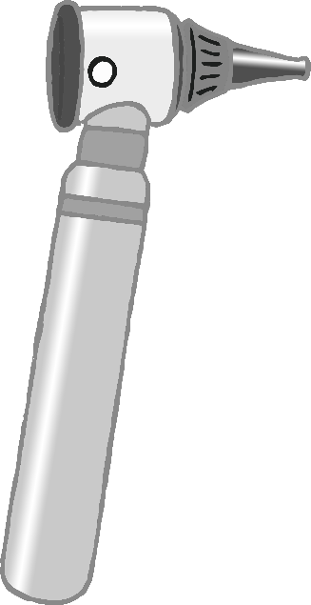

© 2021 Little Owls Resources

© 2021 Little Owls Resources

© 2021 Little Owls Resources

plasters

otoscope

thermometer

© 2021 Little Owls Resources

© 2021 Little Owls Resources

© 2021 Little Owls Resources

medical gloves

fob watch

doctor’s bag

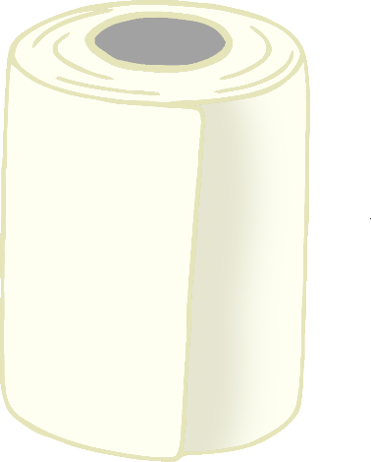



bandage

x-ray

clipboard

© 2021 Little Owls Resources

© 2021 Little Owls Resources

© 2021 Little Owls Resources