People Who Help Us

Doctor

© 2021 Little Owls Resources

* Information Posters
* Information Posters (Colouring)
* Drawing/Writing Sheets
* Draw items Sheet
* Draw items Sheet (Colouring)
* Item Poster
* Item Poster (Colouring)
* Multimats for Art & Craft/Loose Parts/Playdough
* 5x 2-Piece individual items puzzles
* 1x 4-Piece all items puzzle

This pack includes:

The pages of this pack give some general information about the role of a doctor and some fun and engaging activities to foster and develop children’s interest in this role in society.

© 2021 Little Owls Resources

Doctor

I’m a **doctor.**

If someone is sick, I will do my best to find out what is causing it and offer medicine to make them feel better.

If someone is injured, I will choose the right treatment for them to heal quickly.

I use a stethoscope to listen closely to someone’s heartbeat and breathing.

Doctor

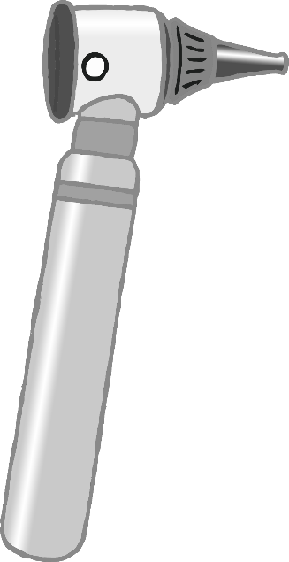

If someone is ill, I might choose some medicine to give them.

I use medical gloves when I am helping people.

I sometimes use an otoscope to look into someone’s ears.

© 2021 Little Owls Resources

© 2021 Little Owls Resources

**Doctor**

**I’m a doctor.**

**If someone is sick, I will do my best to find out what is causing it and offer medicine to make them feel better.**

**If someone is injured, I will choose the right treatment for them to heal quickly.**

**I use a stethoscope to listen closely to someone’s heartbeat and breathing.**

**Doctor**

**I use medical gloves when I am helping people.**

**I sometimes use an otoscope to look into someone’s ears.**

**If someone is ill, I might choose some medicine to give them.**

© 2021 Little Owls Resources

© 2021 Little Owls Resources

Draw a Doctor!

© 2021 Little Owls Resources

Draw and write about a Doctor!

_________________________________________________________

© 2021 Little Owls Resources

Draw and write about a Doctor!

________________________________________________________________________________________________________________________________________________

**Can you draw the items a doctor needs?**

© 2021 Little Owls Resources

**Can you draw the items a doctor needs?**

© 2021 Little Owls Resources

Doctor

© 2021 Little Owls Resources

Otoscope

Medical Gloves

Stethoscope

Medicine

**Doctor**

© 2021 Little Owls Resources

**Otoscope**

**Stethoscope**

**Medicine**

**Medical Gloves**

Doctor Multimat - Stethoscope

© 2021 Little Owls Resources

Doctor Multimat - Otoscope

© 2021 Little Owls Resources

Doctor Multimat – Medical Gloves

© 2021 Little Owls Resources

Doctor Multimat – Medicine

© 2021 Little Owls Resources

© 2021 Little Owls Resources

© 2021 Little Owls Resources

© 2021 Little Owls Resources

© 2021 Little Owls Resources

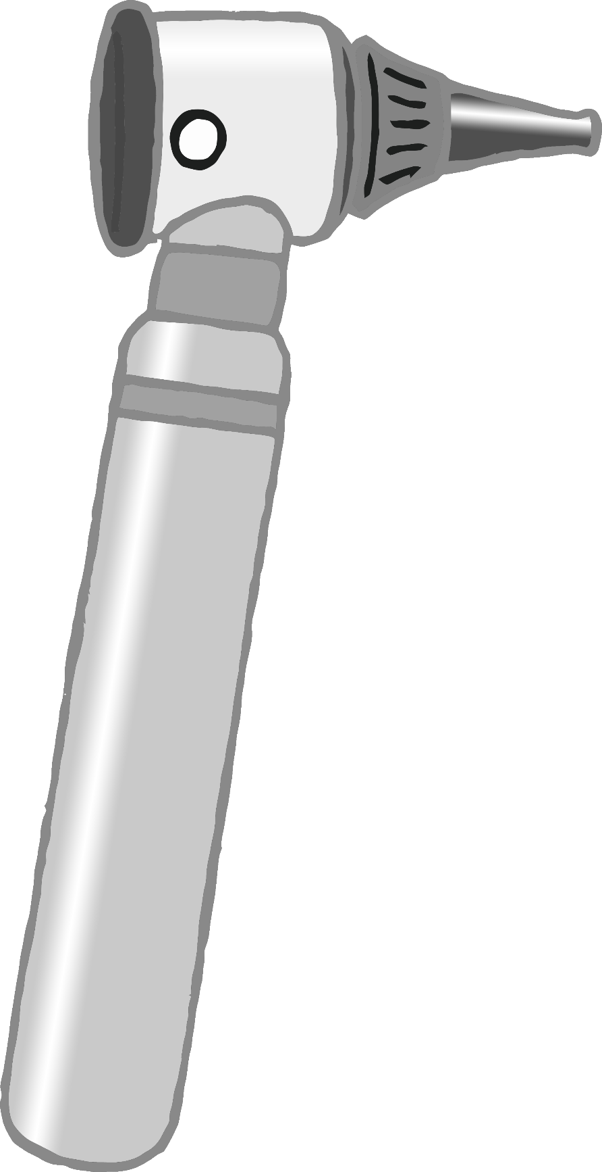

© 2021 Little Owls Resources

**Doctor**

© 2021 Little Owls Resources

Medicine

Medical Gloves

Stethoscope

Otoscope