www.littleowls-premium.com

**Diwali**

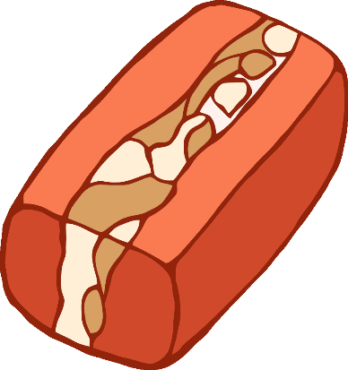

**Sweet**

© 2019 Little Owls Resources

**Shop**

Diwali Sweet Shop

Order Form

www.littleowls-premium.com © 2019 Little Owls Resources



Diwali Sweet Shop

Order Form

www.littleowls-premium.com © 2019 Little Owls Resources



**Diwali Sweet Shop**

© 2019 Little Owls Resources

www.littleowls-premium.com

© 2019 Little Owls Resources

www.littleowls-premium.com

w.littleowlsresources.com

**Diwali Sweet Shop**

Closed

Open

Opening Times

|  |  |
| --- | --- |
| **Monday** |  |
| **Tuesday** |  |
| **Wednesday** |  |
| **Thursday** |  |
| **Friday** |  |
| **Saturday** |  |
| **Sunday** |  |

12

www.littleowls-premium.com

© 2019 Little Owls Resources

6

3

9

10

11

1

2

5

4

7

8

**Delicious Sweets!**

www.littleowls-premium.com

© 2019 Little Owls Resources

**Celebrate Diwali!**







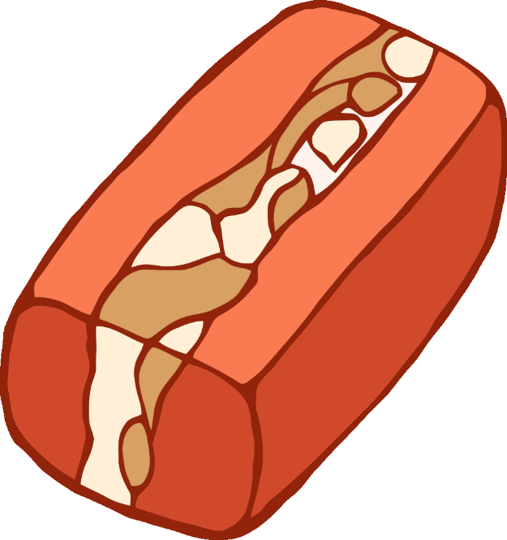

www.littleowls-premium.com

© 2019 Little Owls Resources



**Diwali Sweets**



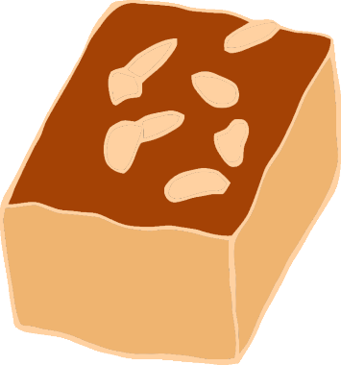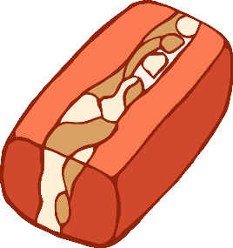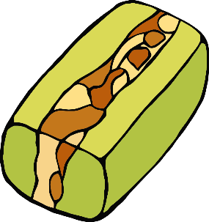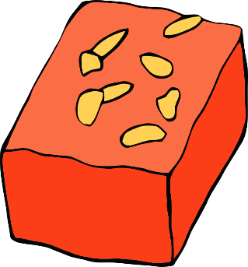

www.littleowls-premium.com

**10p**

**15p**

**20p**

**10p**

**20p**

**15p**

**Diwali Sweets**





www.littleowls-premium.com

© 2019 Little Owls Resources

www.littleowls-premium.com



www.littleowls-premium.com

© 2019 Little Owls Resources

www.littleowls-premium.com

© 2019 Little Owls Resources

© 2019 Little Owls Resources

www.littleowls-premium.com

© 2019 Little Owls Resources

© 2019 Little Owls Resources

www.littleowls-premium.com

© 2019 Little Owls Resources

www.littleowls-premium.com





www.littleowls-premium.com

© 2019 Little Owls Resources

www.littleowls-premium.com

© 2019 Little Owls Resources



© 2019 Little Owls Resources

www.littleowls-premium.com

© 2019 Little Owls Resources

www.littleowls-premium.com

© 2019 Little Owls Resources

www.littleowls-premium.com

© 2019 Little Owls Resources

www.littleowls-premium.com

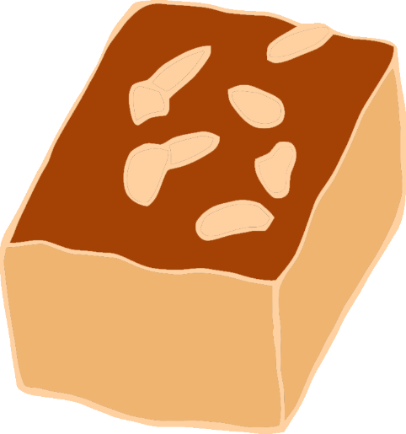

© 2019 Little Owls Resources

www.littleowls-premium.com

© 2019 Little Owls Resources

www.littleowls-premium.com

© 2019 Little Owls Resources

www.littleowls-premium.com

© 2019 Little Owls Resources

www.littleowls-premium.com

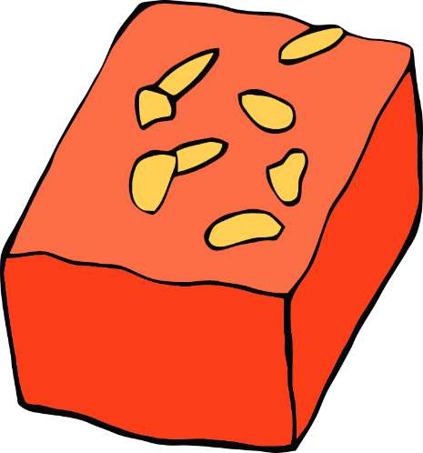

www.littleowls-premium.com

© 2019 Little Owls Resources

www.littleowls-premium.com

© 2019 Little Owls Resources

www.littleowls-premium.com

© 2019 Little Owls Resources

www.littleowls-premium.com

© 2019 Little Owls Resources

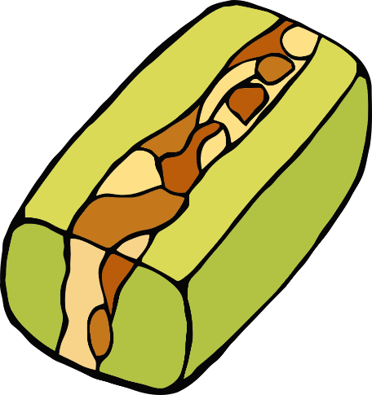

© 2019 Little Owls Resources

www.littleowls-premium.com

© 2019 Little Owls Resources

www.littleowls-premium.com

© 2019 Little Owls Resources

www.littleowls-premium.com

© 2019 Little Owls Resources

www.littleowls-premium.com

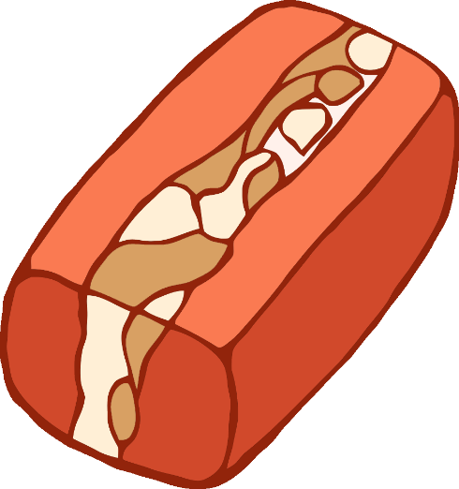

© 2019 Little Owls Resources

www.littleowls-premium.com

© 2019 Little Owls Resources

www.littleowls-premium.com

© 2019 Little Owls Resources

www.littleowls-premium.com

© 2019 Little Owls Resources

www.littleowls-premium.com



www.littleowls-premium.com

rces.com

© 2019 Little Owls Resources

www.littleowls-premium.com

© 2019 Little Owls Resources

www.littleowls-premium.com

© 2019 Little Owls Resources

www.littleowls-premium.com

© 2019 Little Owls Resources



www.littleowls-premium.com

© 2019 Little Owls Resources

www.littleowls-premium.com

© 2019 Little Owls Resources

www.littleowls-premium.com

© 2019 Little Owls Resources

www.littleowls-premium.com

© 2019 Little Owls Resources

www.littleowls-premium.com

© 2019 Little Owls Resources

www.littleowls-premium.com

© 2019 Little Owls Resources

www.littleowls-premium.com

.com

© 2019 Little Owls Resources

www.littleowls-premium.com

© 2019 Little Owls Resources

