Rama

Ravana

© 2019 Little Owls Resources

© 2019 Little Owls Resources

© 2019 Little Owls Resources

Sita

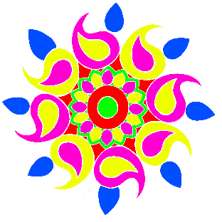

© 2019 Little Owls Resources

© 2019 Little Owls Resources

© 2019 Little Owls Resources

Hanuman

Rangoli Patterns

Diva Lamp

Lanterns

Fireworks

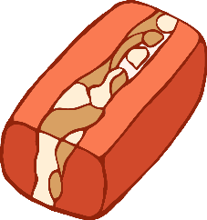

© 2019 Little Owls Resources

© 2019 Little Owls Resources

Diwali

Sweets

© 2019 Little Owls Resources