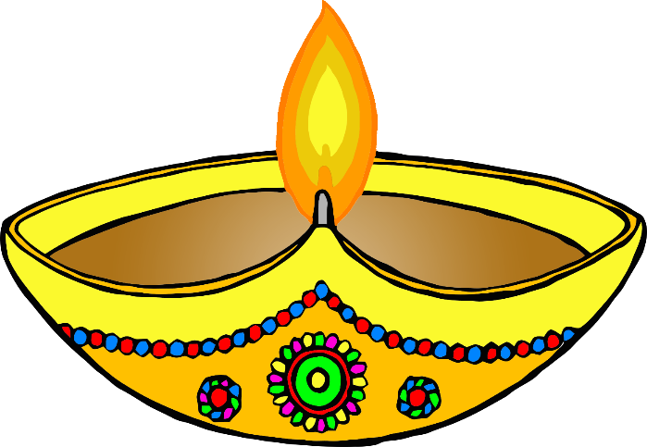

Diva Lamp



Diva Lamp

© 2019 Little Owls Resources

© 2019 Little Owls Resources



Diva Lamp



Diva Lamp

© 2019 Little Owls Resources

© 2019 Little Owls Resources

Rangoli



Rangoli



© 2019 Little Owls Resources

© 2019 Little Owls Resources

Rangoli



Rangoli



© 2019 Little Owls Resources

© 2019 Little Owls Resources

Rangoli

Rangoli



© 2019 Little Owls Resources

© 2019 Little Owls Resources

Rangoli

Rangoli



© 2019 Little Owls Resources

© 2019 Little Owls Resources

Mehndi

Mehndi

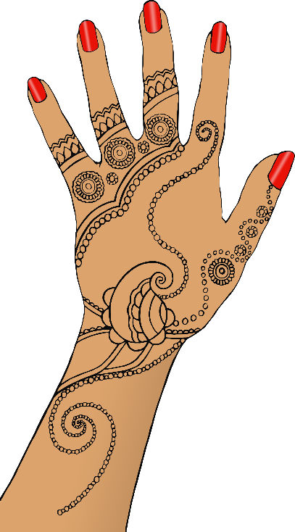

© 2019 Little Owls Resources

© 2019 Little Owls Resources

Mehndi

Mehndi



© 2019 Little Owls Resources

© 2019 Little Owls Resources

Lantern

Lantern

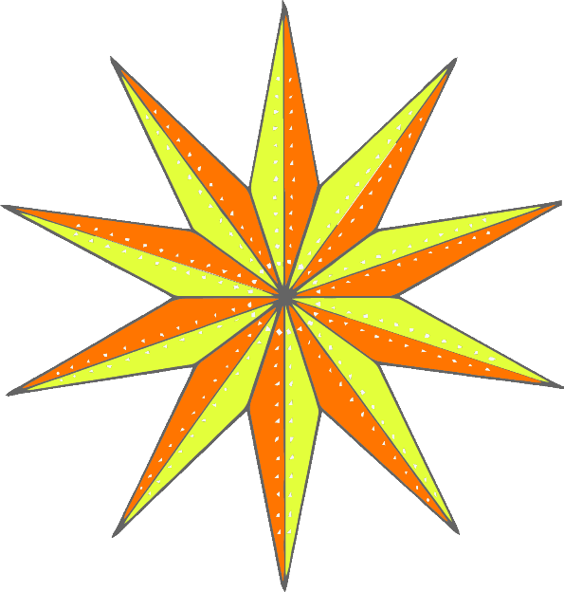

© 2019 Little Owls Resources

© 2019 Little Owls Resources

Lantern

Lantern



© 2019 Little Owls Resources

© 2019 Little Owls Resources

Lanterns

Lanterns

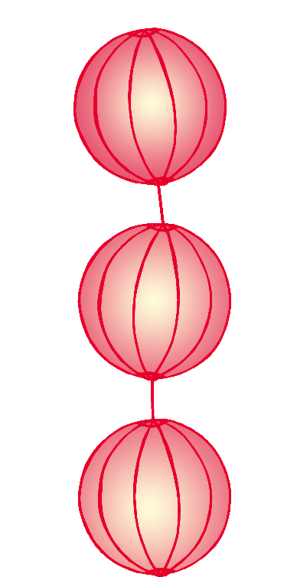

© 2019 Little Owls Resources

© 2019 Little Owls Resources

© 2019 Little Owls Resources

© 2019 Little Owls Resources

Lanterns

Lanterns



Sweet

Sweet



© 2019 Little Owls Resources

© 2019 Little Owls Resources

Sweet

Sweet



© 2019 Little Owls Resources

© 2019 Little Owls Resources

Sweet

Sweet

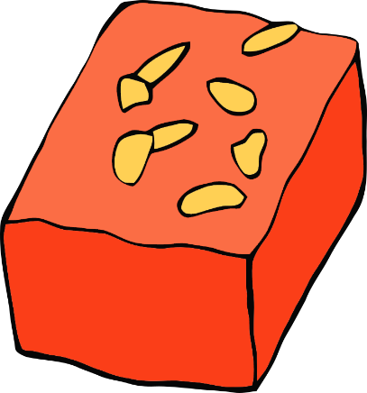

© 2019 Little Owls Resources

© 2019 Little Owls Resources

© 2019 Little Owls Resources

© 2019 Little Owls Resources

Sweet

Sweet

