**Diwali Lollipop Puppets**

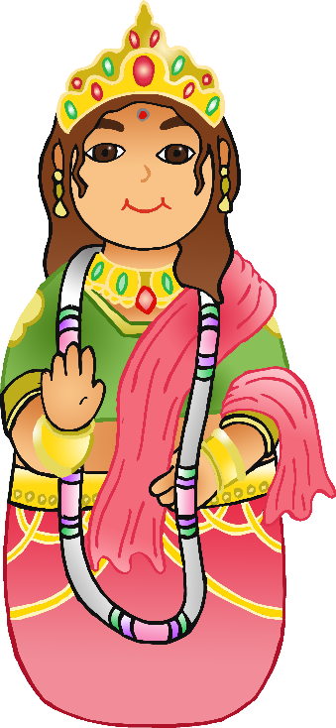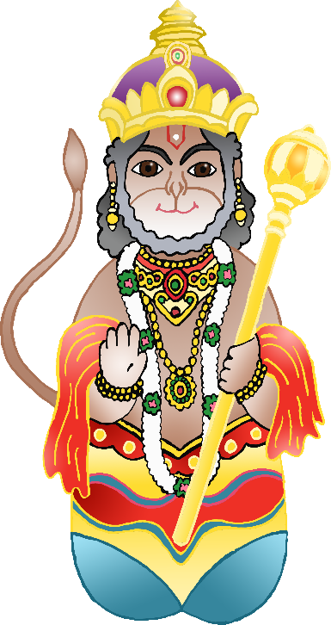

Diwali puppets to be cut out to stick on lolly sticks.

There are two background images included.

© 2021 Little Owls Resources

© 2021 Little Owls Resources

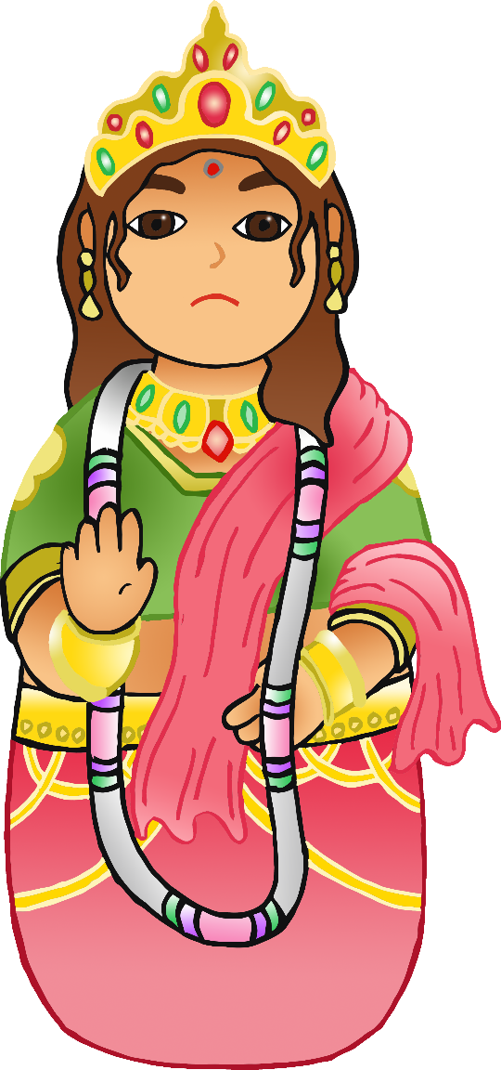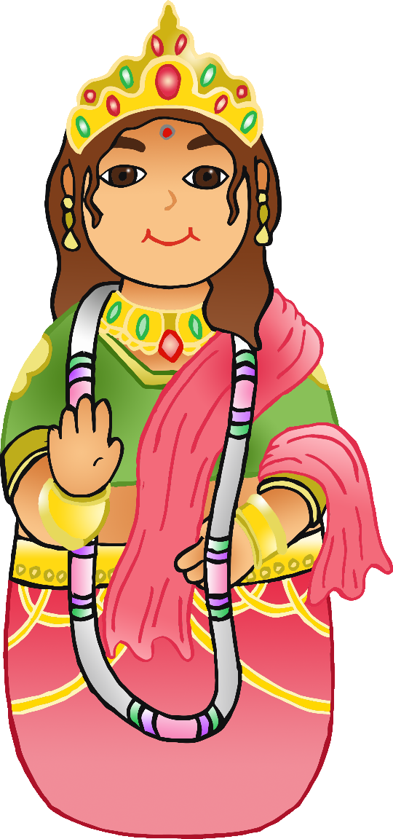

© 2021 Little Owls Resources

© 2021 Little Owls Resources

© 2021 Little Owls Resources

© 2021 Little Owls Resources

© 2021 Little Owls Resources