**Diwali** A4 templates

These templates have detailed outlines to be used as a starting point for an art activity.

The children must think about which card they think their friend/family member will like best before colouring it for them

The outlines can be coloured, painted, or collaged to create an individual poster design.

They could be stuck to a folded piece of A3 card to make a large card!

©2022 Little Owls Resources

Happy

Diwali!

Happy

Diwali!

Dear Mr Smith

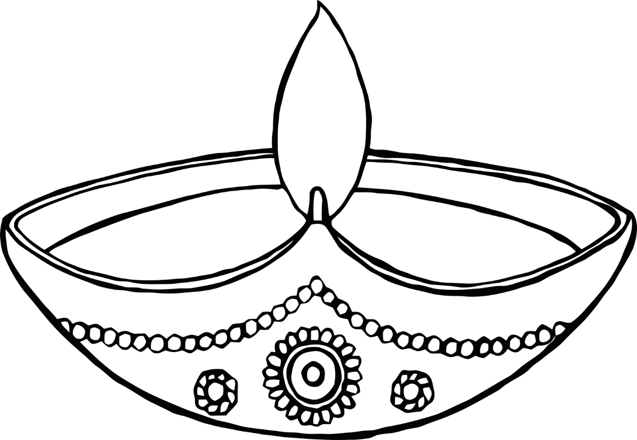

**Happy Diwali!**

©2022 Little Owls Resources

Happy

Diwali!

©2022 Little Owls Resources

Diwali Greetings!

©2022 Little Owls Resources

Diwali!

©2022 Little Owls Resources

**Wishing you a**

**Happy Diwali!**

©2022 Little Owls Resources

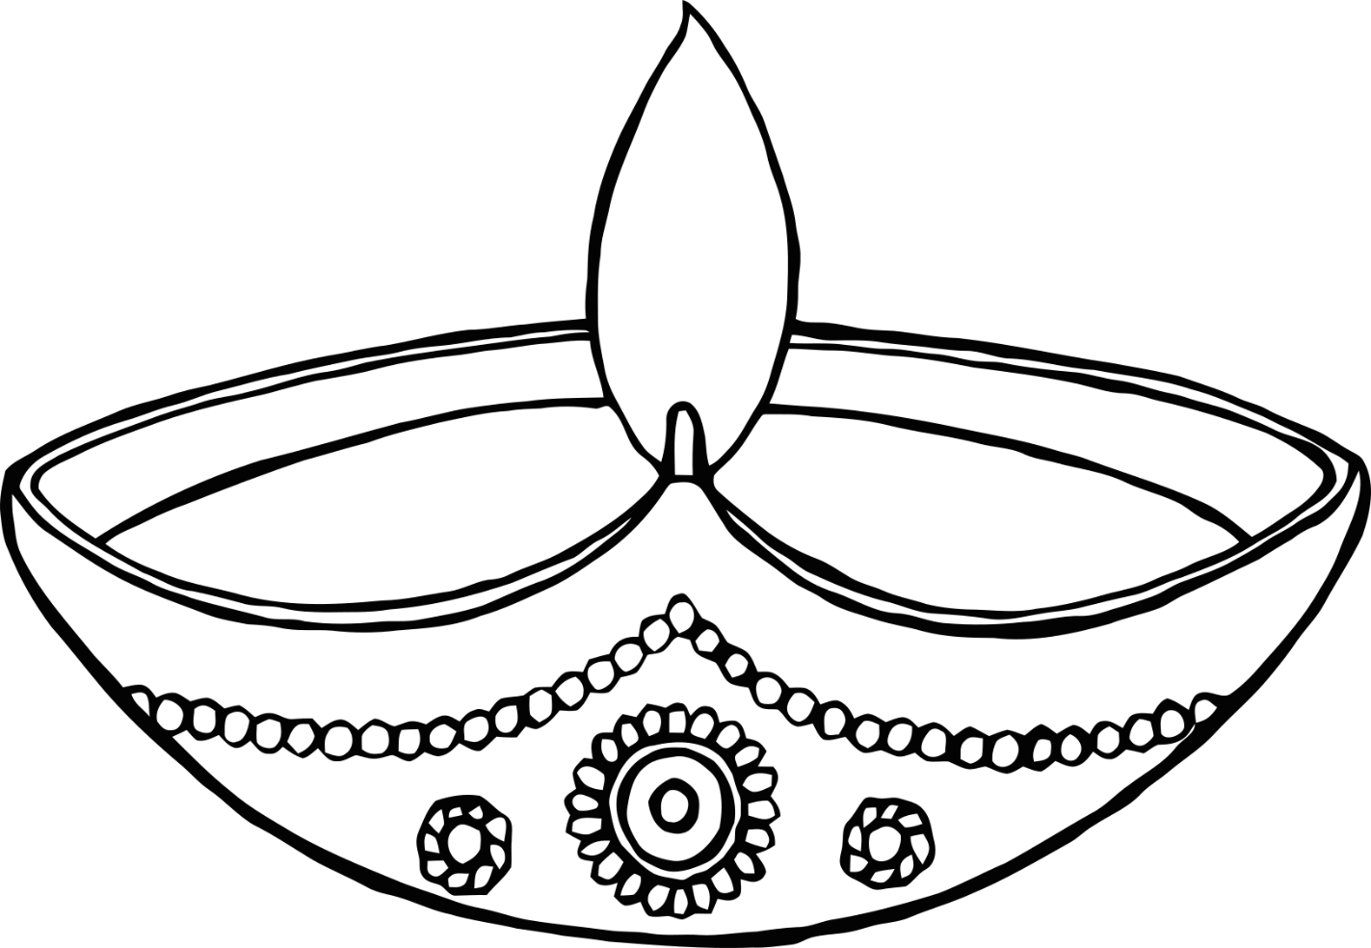

Happy Diwali!

**Festival of Lights**

©2022 Little Owls Resources

Diwali!

©2022 Little Owls Resources

Happy Diwali!

©2022 Little Owls Resources

©2022 Little Owls Resources

**Diwali!**

©2022 Little Owls Resources

**Diwali Greetings!**