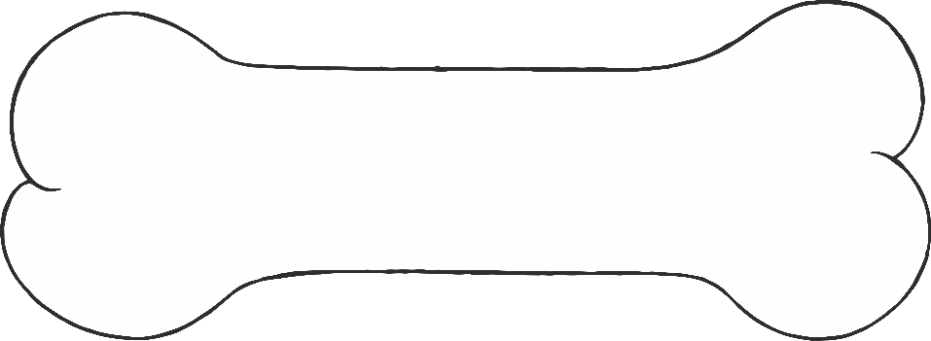

© 2022 Little Owls Resources

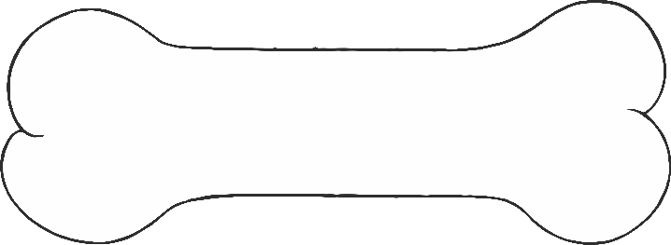

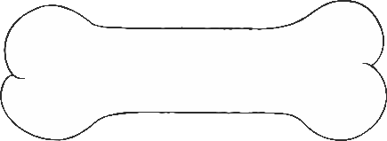

DINOSAURS

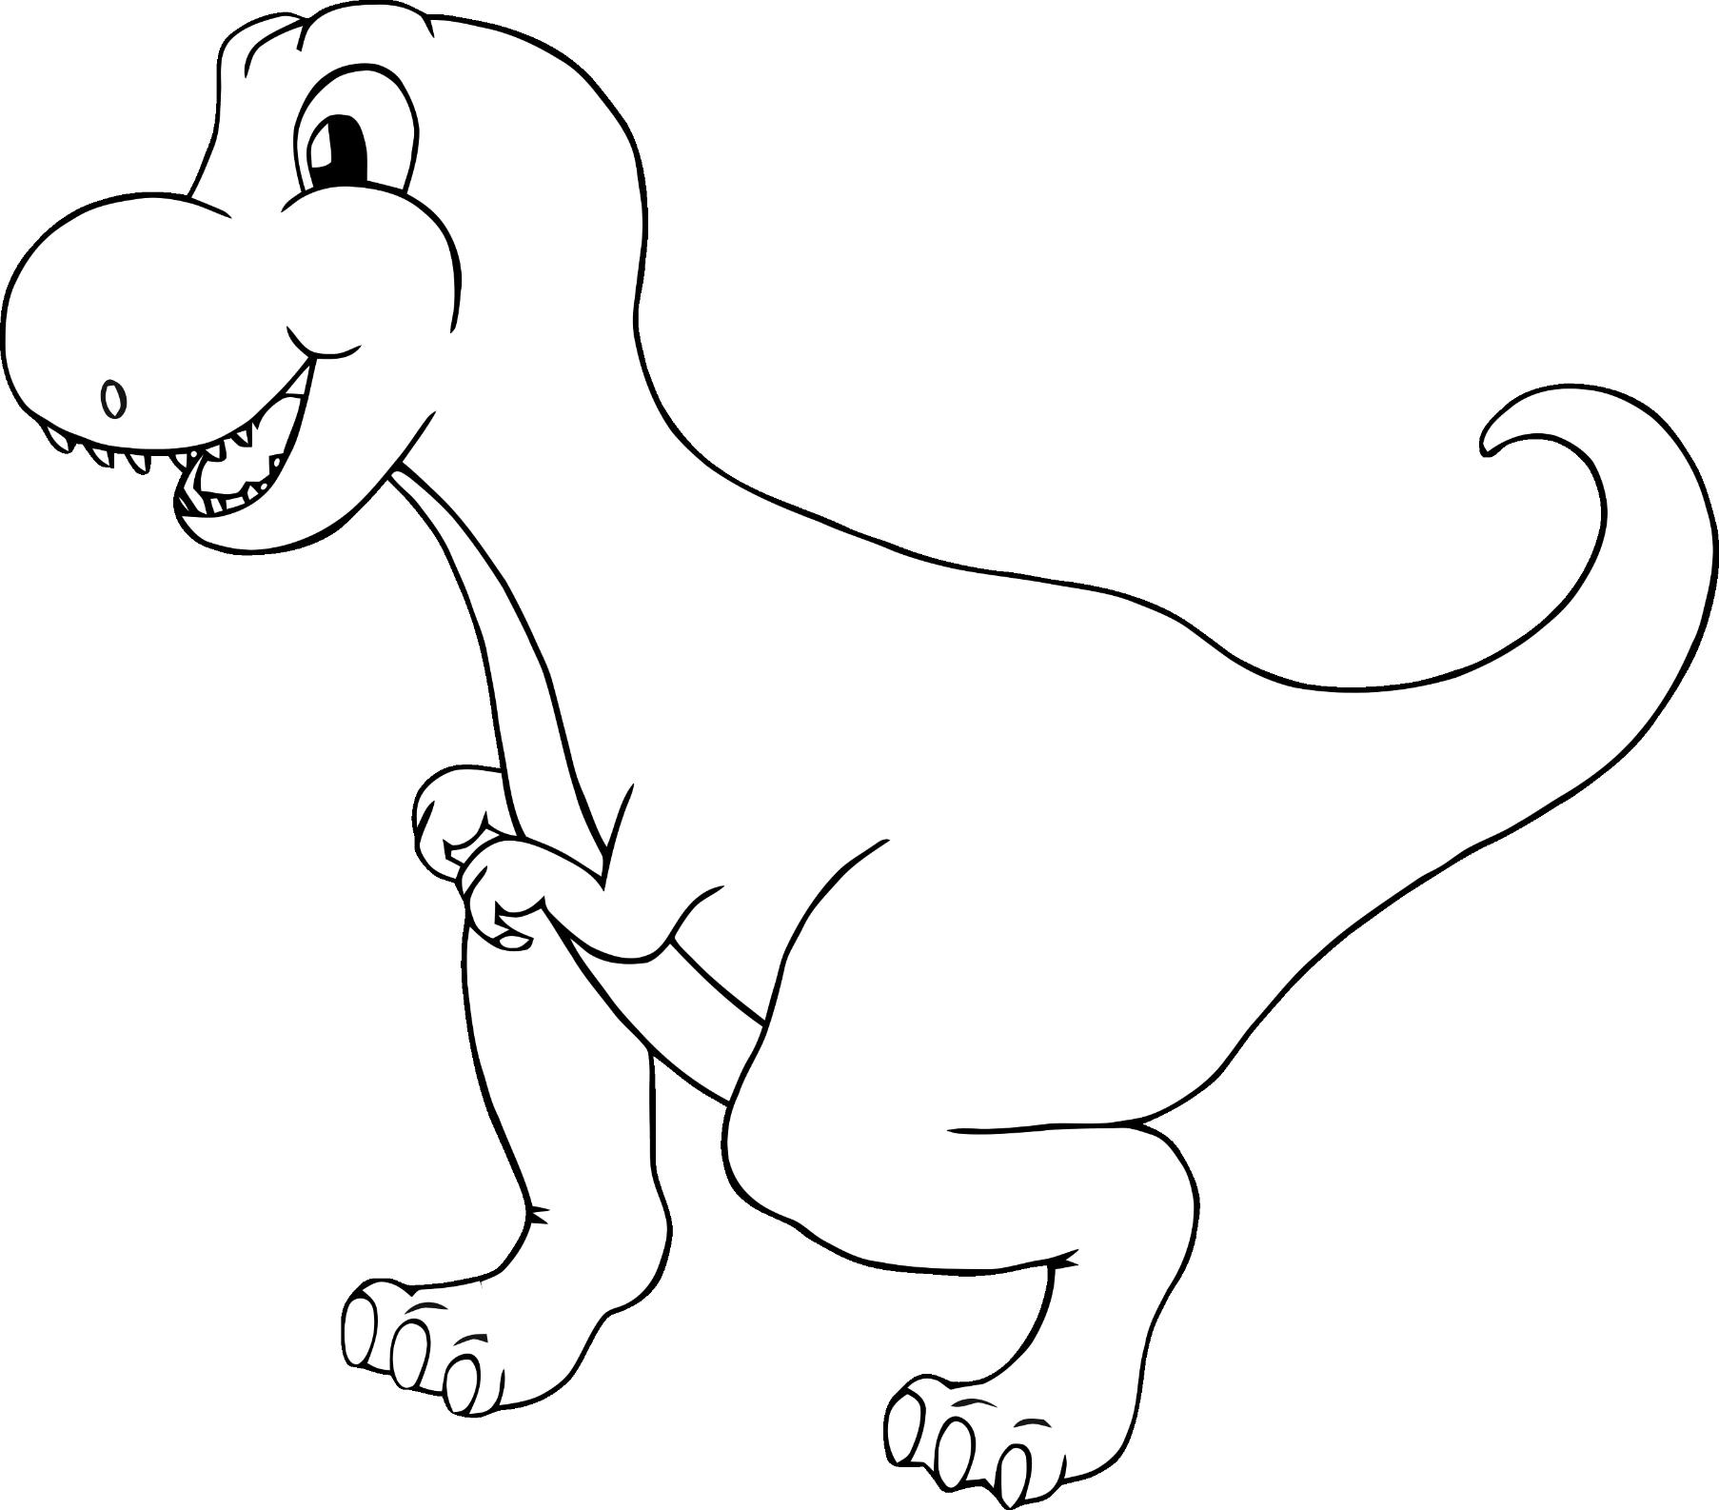

Tyrannosaurus Rex

© 2022 Little Owls Resources

Brachiosaurus

© 2022 Little Owls Resources

Stegosaurus

© 2022 Little Owls Resources

© 2022 Little Owls Resources

Parasaurolophus

Plesiosaurus

© 2022 Little Owls Resources

Pterodactyl

© 2022 Little Owls Resources

Pachycephalosaurus

© 2022 Little Owls Resources

Triceratops

© 2022 Little Owls Resources

Ankylosaurus

© 2022 Little Owls Resources

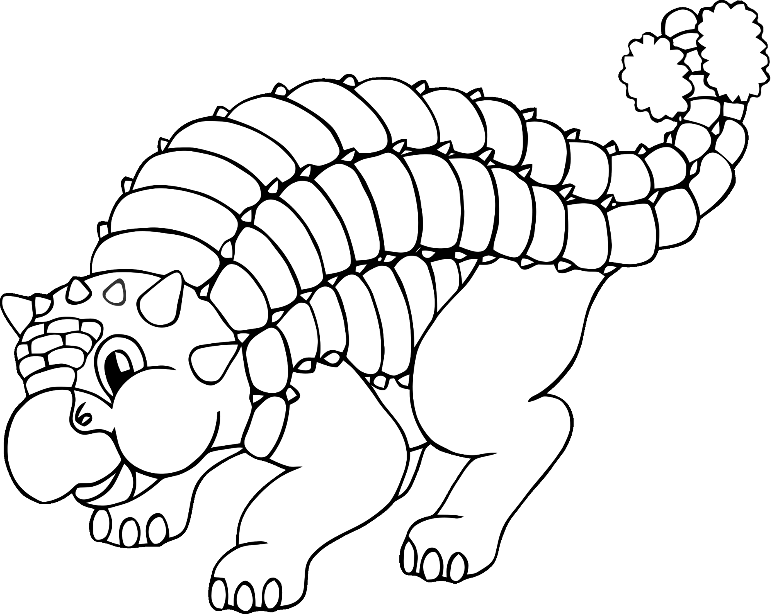

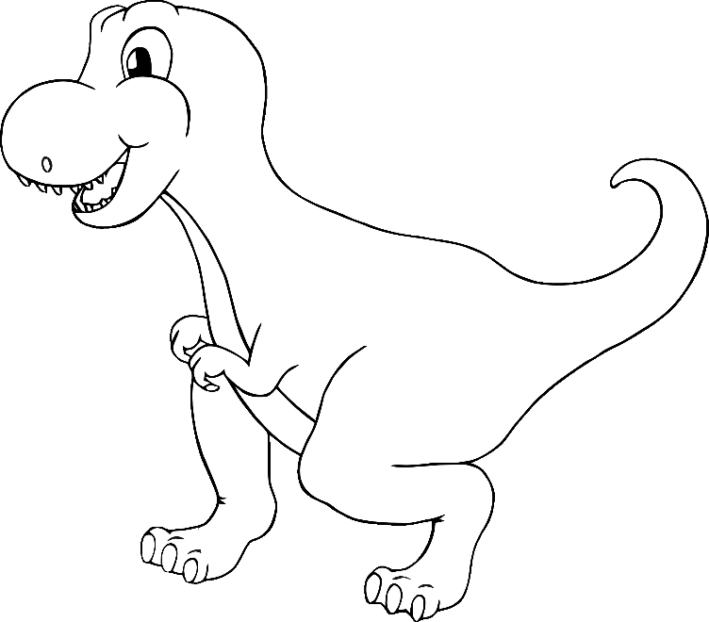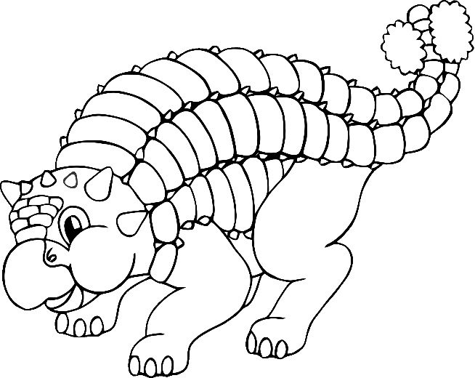

© 2022 Little Owls Resources