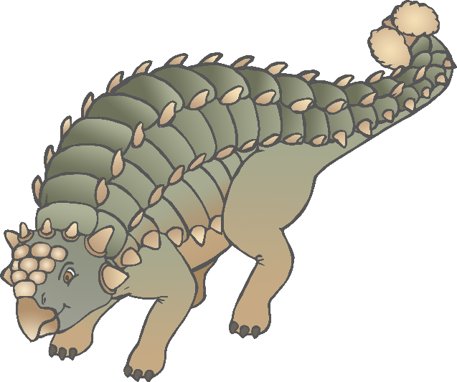

Herbivore

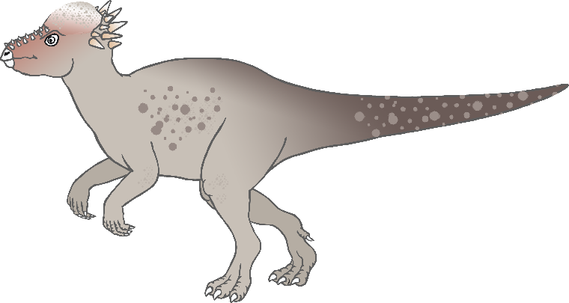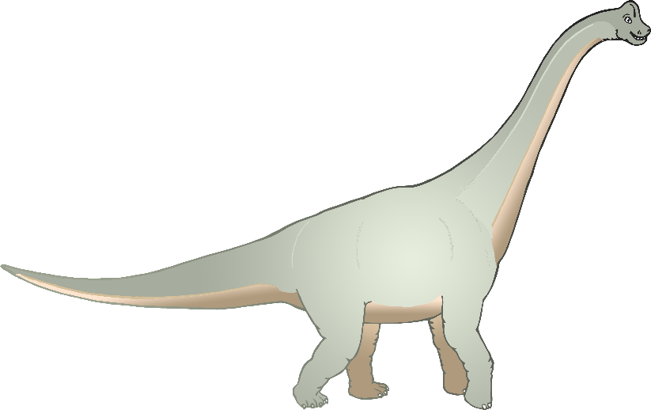

Herbivore

Herbivore

Pachycephalosaurus

Brachiosaurus

Ankylosaurus

© 2019 Little Owls Resources

© 2019 Little Owls Resources

© 2019 Little Owls Resources

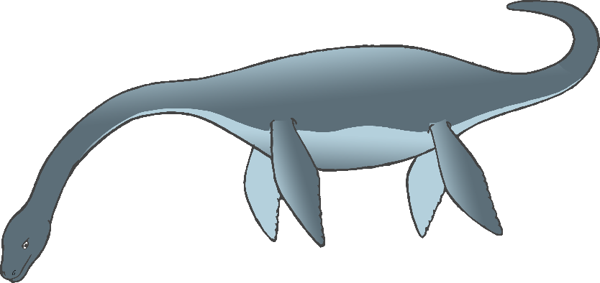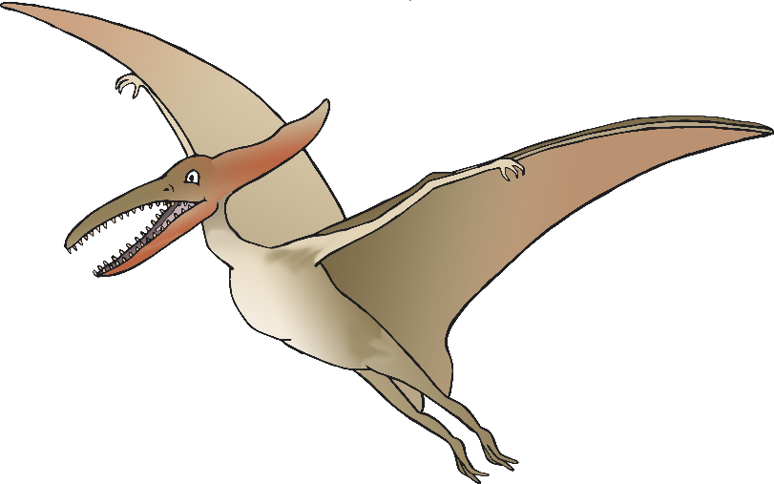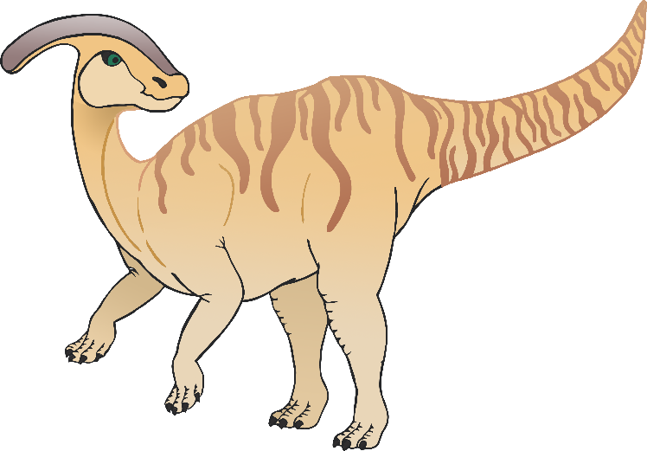

Carnivore 

Carnivore

Herbivore

Plesiosaur

Pterodactyl

Parasaurolophus

© 2019 Little Owls Resources

© 2019 Little Owls Resources

© 2019 Little Owls Resources

© 2019 Little Owls Resources

© 2019 Little Owls Resources

© 2019 Little Owls Resources

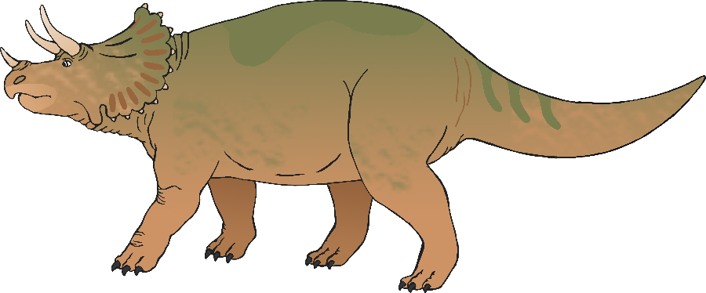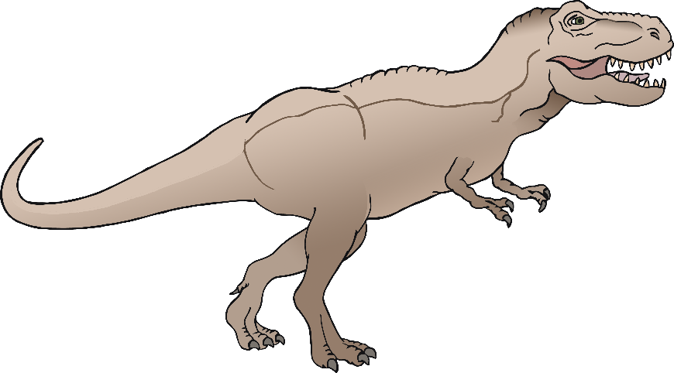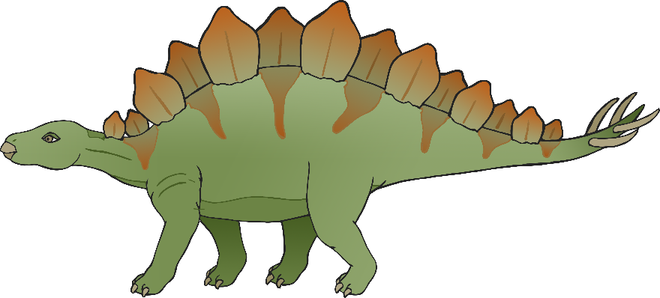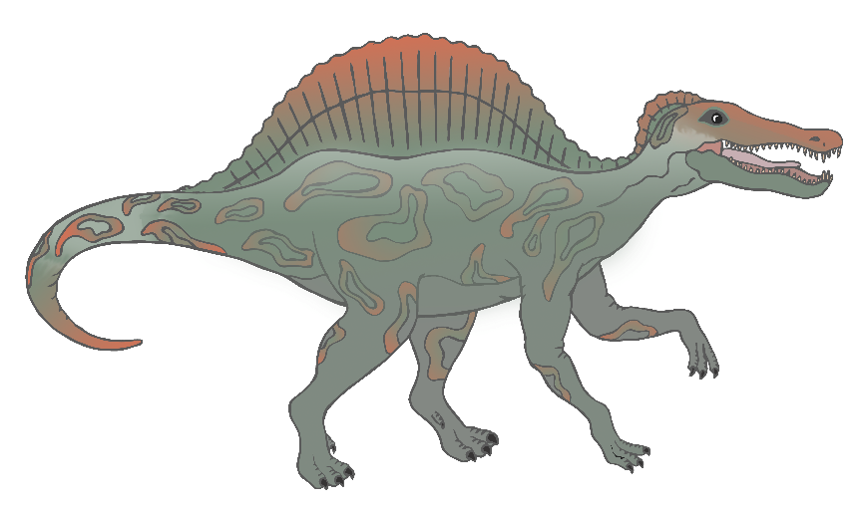

Carnivore 

Carnivore 

Herbivore

Herbivore

Triceratops

Tyrannosaurus Rex

Stegosaurus

Spinosaurus

Carnivore

© 2019 Little Owls Resources