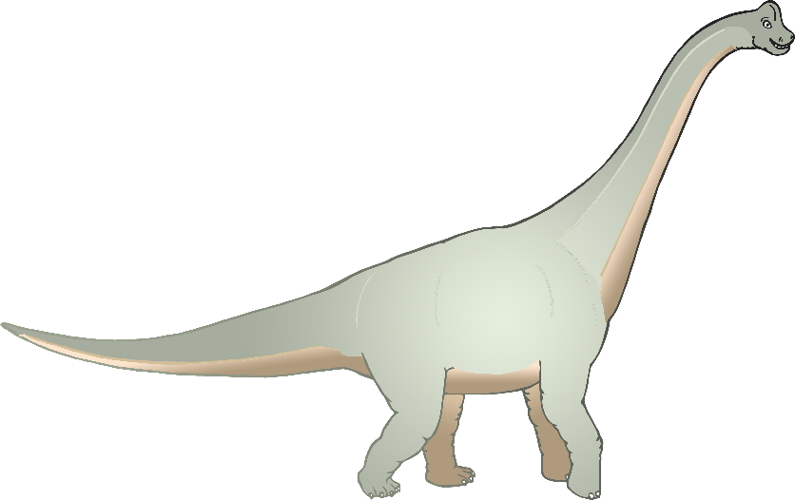

Brachiosaurus

Brachiosaurus



© 2019 Little Owls Resources

© 2019 Little Owls Resources

Brachiosaurus



Brachiosaurus



© 2019 Little Owls Resources

© 2019 Little Owls Resources

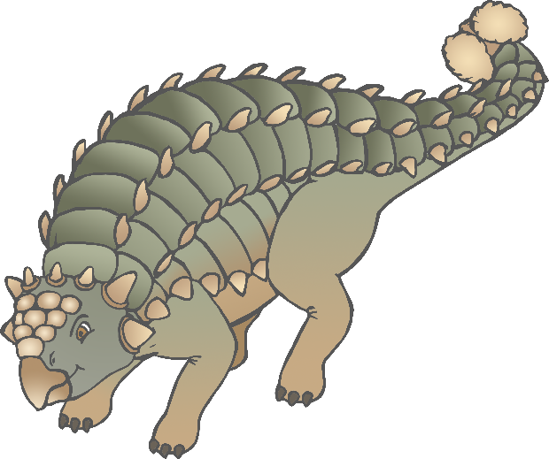

Ankylosaurus

Ankylosaurus

© 2019 Little Owls Resources

© 2019 Little Owls Resources



Ankylosaurus

Ankylosaurus

© 2019 Little Owls Resources

© 2019 Little Owls Resources

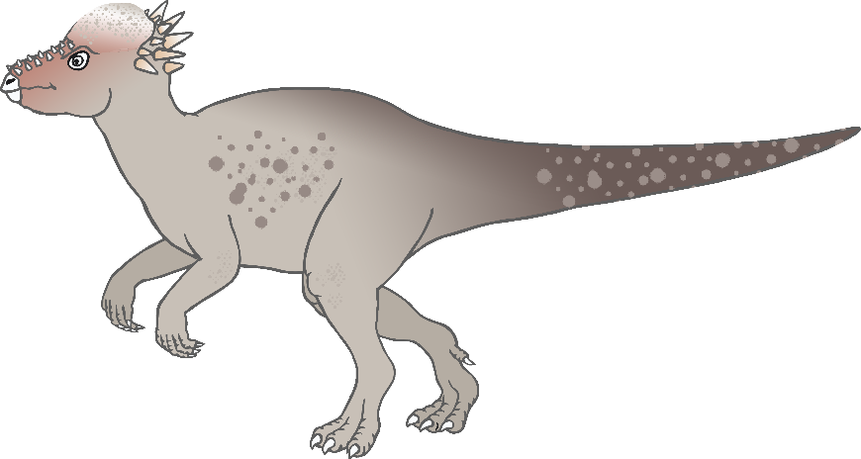

Pachycephalosaurus

Pachycephalosaurus

© 2019 Little Owls Resources

© 2019 Little Owls Resources



Pachycephalosaurus

Pachycephalosaurus

© 2019 Little Owls Resources

© 2019 Little Owls Resources

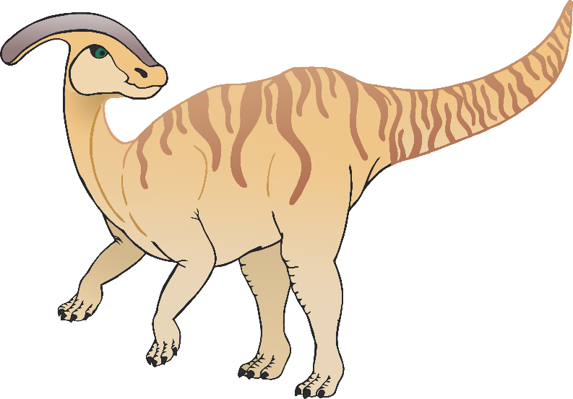

Parasaurolophus

Parasaurolophus

© 2019 Little Owls Resources

© 2019 Little Owls Resources



Parasaurolophus

Parasaurolophus

© 2019 Little Owls Resources

© 2019 Little Owls Resources

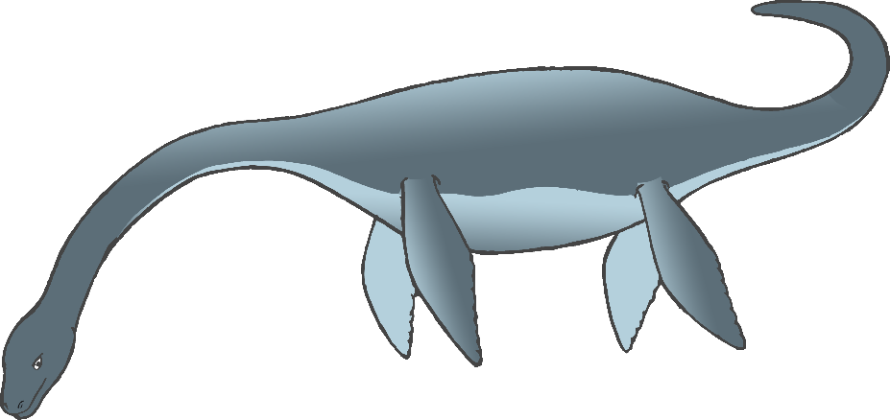

Plesiosaur

Plesiosaur

© 2019 Little Owls Resources

© 2019 Little Owls Resources



Plesiosaur

Plesiosaur

© 2019 Little Owls Resources

© 2019 Little Owls Resources

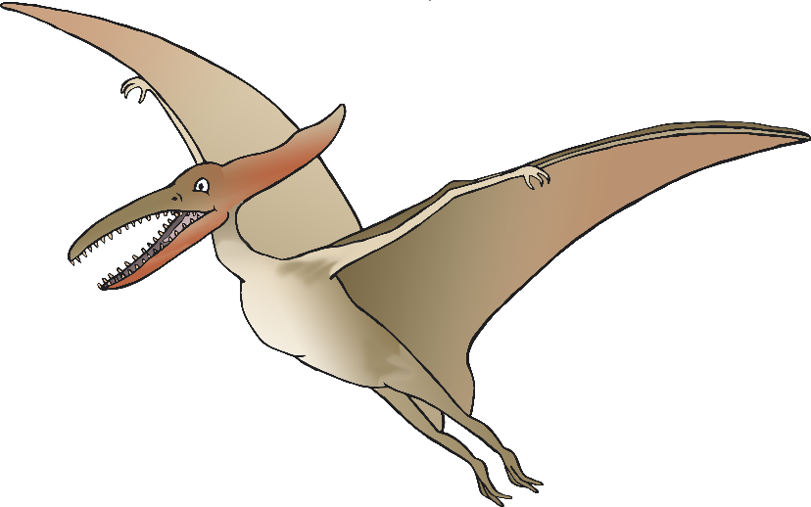

Pterodactyl

Pterodactyl

© 2019 Little Owls Resources

© 2019 Little Owls Resources

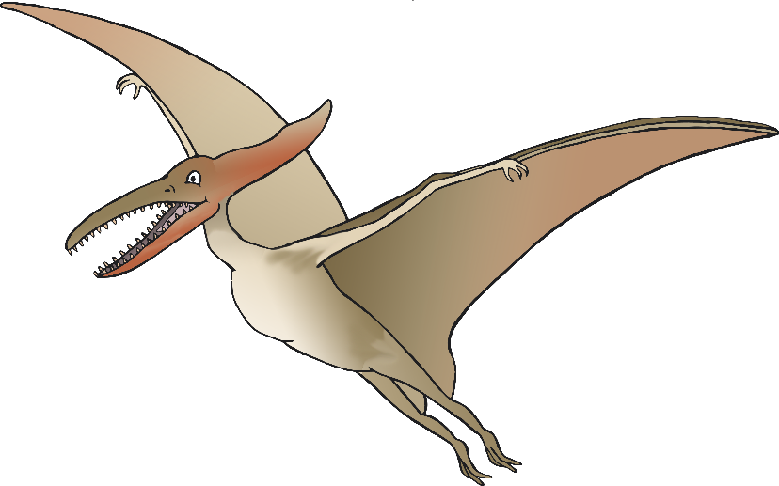

Pterodactyl

Pterodactyl

© 2019 Little Owls Resources

© 2019 Little Owls Resources

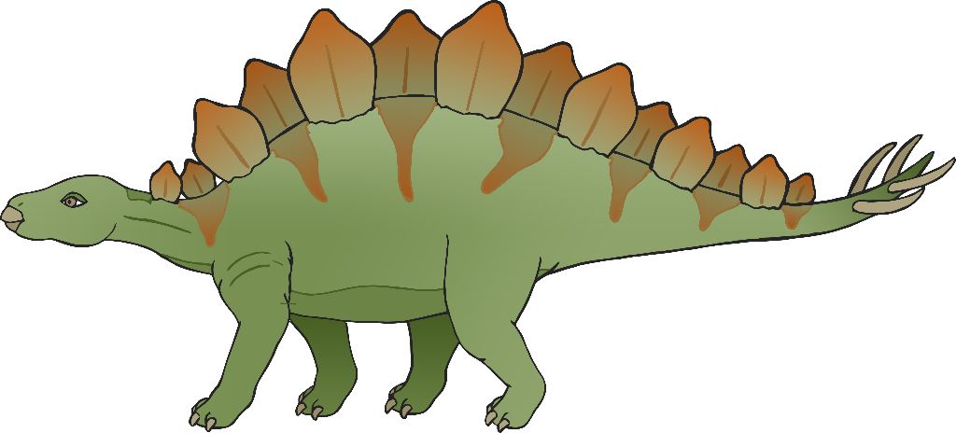

Stegosaurus

Stegosaurus

© 2019 Little Owls Resources

© 2019 Little Owls Resources

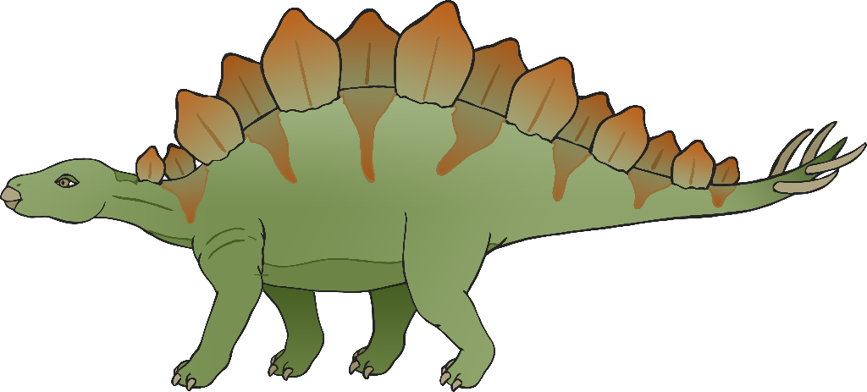

Stegosaurus

Stegosaurus

© 2019 Little Owls Resources

© 2019 Little Owls Resources

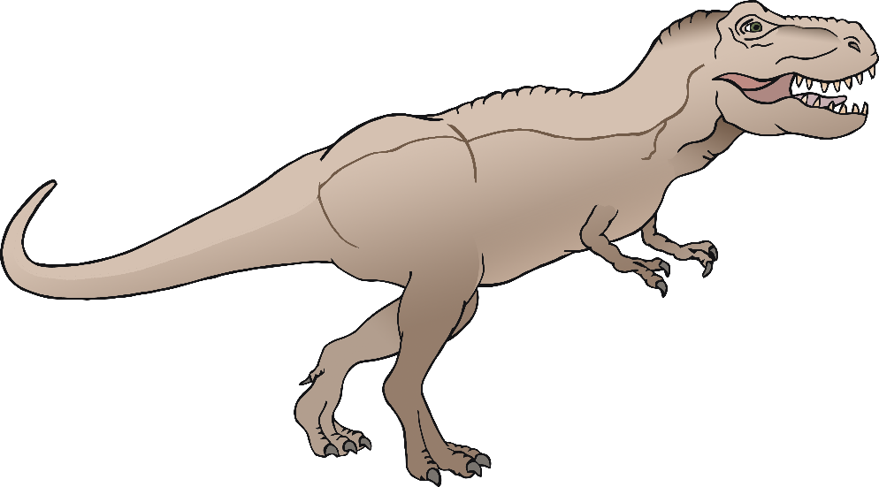

Tyrannosaurus Rex

Tyrannosaurus Rex

© 2019 Little Owls Resources

© 2019 Little Owls Resources



Tyrannosaurus Rex

Tyrannosaurus Rex

© 2019 Little Owls Resources

© 2019 Little Owls Resources

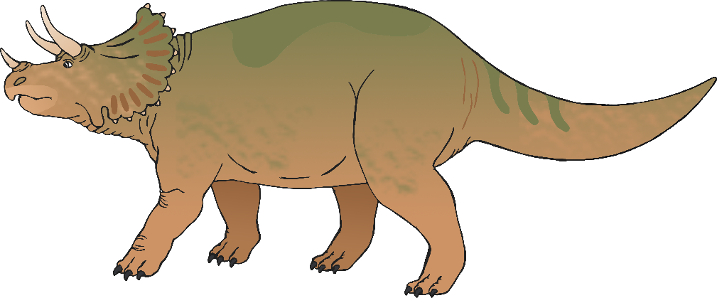

Triceratops

Triceratops

© 2019 Little Owls Resources

© 2019 Little Owls Resources



Triceratops

Triceratops

© 2019 Little Owls Resources

© 2019 Little Owls Resources

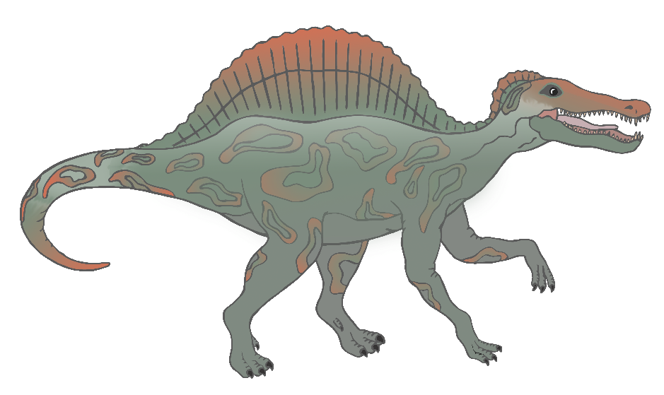

Spinosaurus

Spinosaurus

© 2019 Little Owls Resources

© 2019 Little Owls Resources



Spinosaurus

Spinosaurus

© 2019 Little Owls Resources

© 2019 Little Owls Resources