**Design a Stegosaurus!**

© 2020 Little Owls Resources

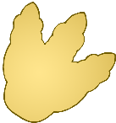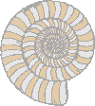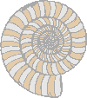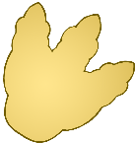

**Design a Parasaurolophus!**

© 2020 Little Owls Resources



**Design a Spinosaurus!**

© 2020 Little Owls Resources



**Design a T-Rex!**

© 2020 Little Owls Resources



