**Dinosaur Multimat**

© 2022 Little Owls Resources

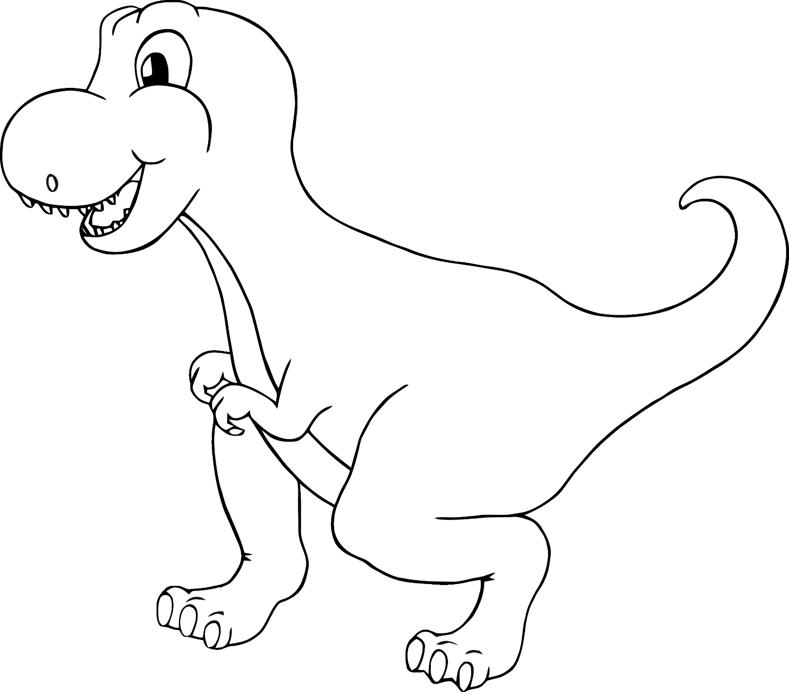

**Dinosaur Multimat**

© 2022 Little Owls Resources

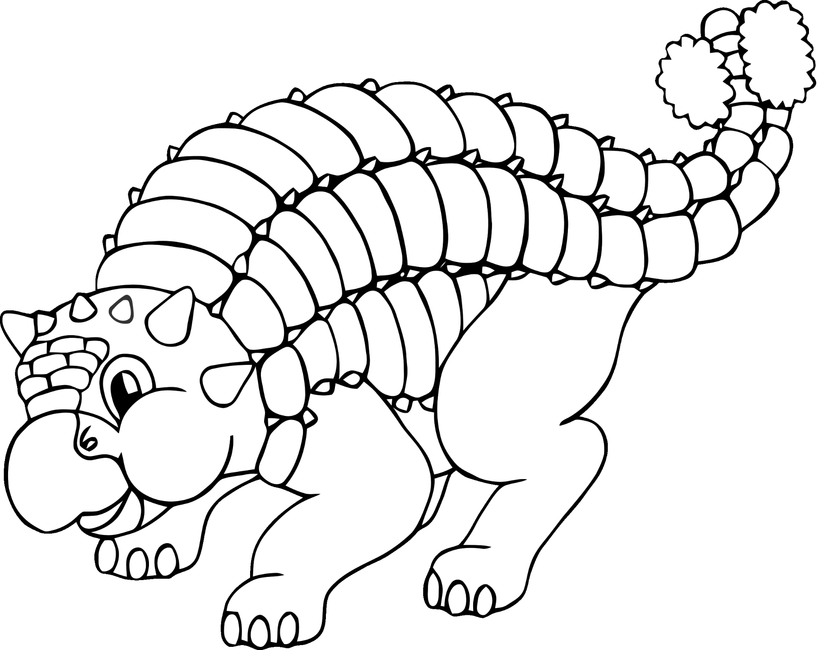

**Dinosaur Multimat**

© 2022 Little Owls Resources

**Dinosaur Multimat**

© 2022 Little Owls Resources

**Dinosaur Multimat**

© 2022 Little Owls Resources

**Dinosaur Multimat**

© 2022 Little Owls Resources

**Dinosaur Multimat**

© 2022 Little Owls Resources

**Dinosaur Multimat**

© 2022 Little Owls Resources

**Dinosaur Multimat**

© 2022 Little Owls Resources