Dino Maths

Challenge

**1**

© 2022 Little Owls Resources

Can you make a dinosaur using 2D shapes?

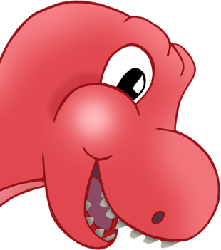

**2**

© 2022 Little Owls Resources

Can you make a block tower as tall as a toy dinosaur?

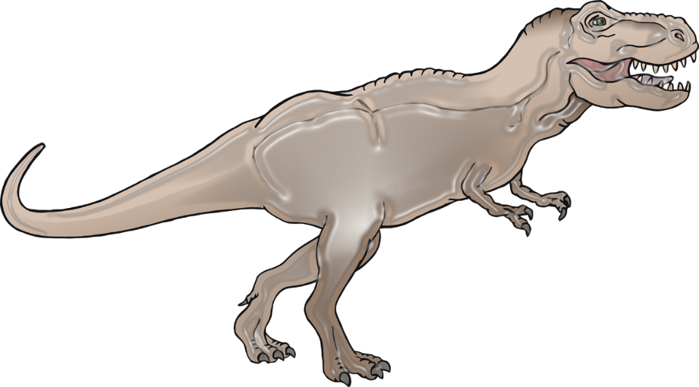

Dino Maths

Challenge

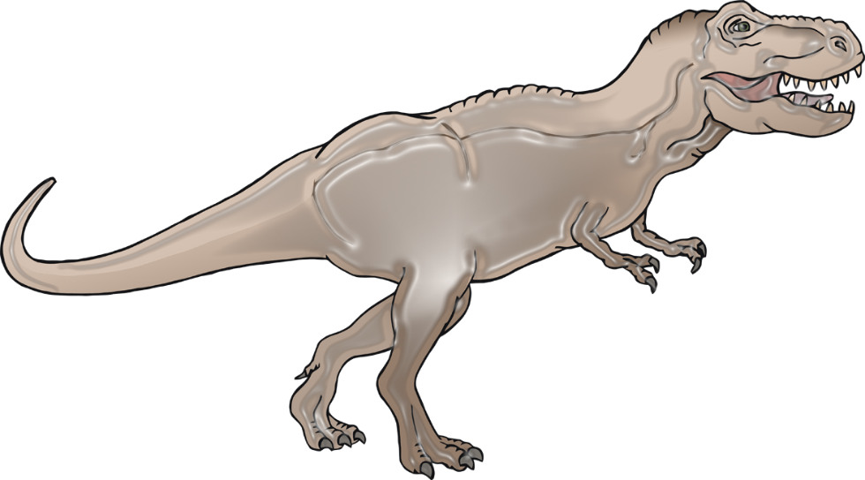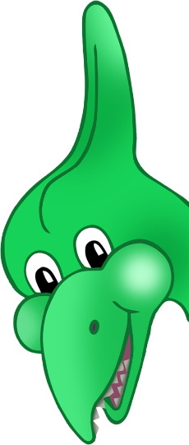

Dino Maths

Challenge

**3**

© 2022 Little Owls Resources

Can you put the dinosaur toys in size order?

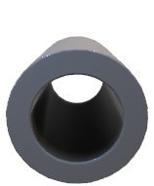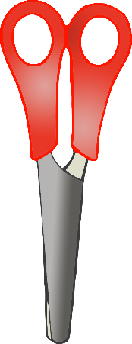

**4**

© 2022 Little Owls Resources

Can you make a model of a dinosaur using junk modelling materials?

Dino Maths

Challenge

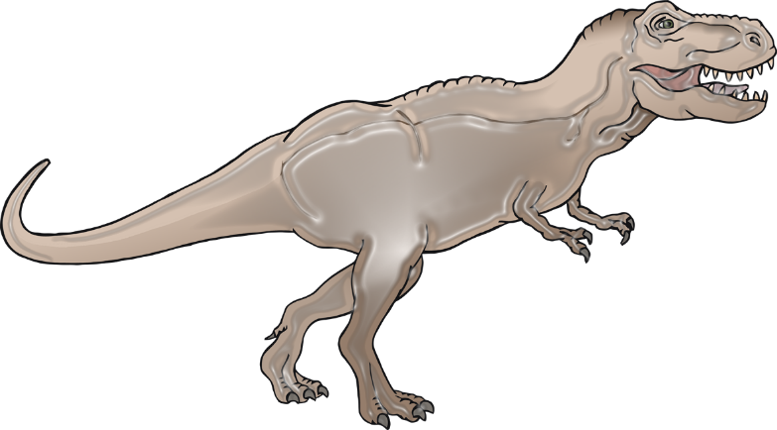

**5**

© 2022 Little Owls Resources

Can you compare dinosaur toys to find which is heavier or lighter?

Dino Maths

Challenge

**6**

© 2022 Little Owls Resources

Roll a die or dice and then find that many dinosaurs. How many legs do they have altogether?

Dino Maths

Challenge

**7**

© 2022 Little Owls Resources

Make a trail of dinosaur footprints in playdough. How many did you make?

Dino Maths

Challenge

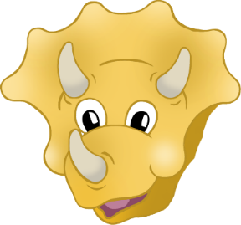

**8**

© 2022 Little Owls Resources

Take turns with a friend to challenge them to put a dinosaur under/over/inside/behind/in front of an object.

Dino Maths

Challenge