**Dinosaur Lollipop Puppets**

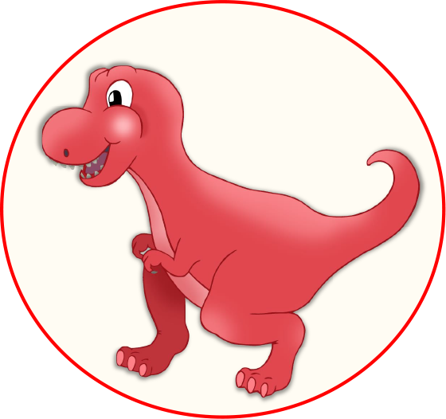

Dinosaur puppets to be cut out to stick on lolly sticks.

There are two background images included.

© 2022 Little Owls Resources

© 2022 Little Owls Resources

© 2022 Little Owls Resources

© 2022 Little Owls Resources

© 2022 Little Owls Resources

© 2022 Little Owls Resources

“Grrrr!”

“Roar!”

Chomp!

Crash!

© 2022 Little Owls Resources

© 2022 Little Owls Resources

© 2022 Little Owls Resources