Food

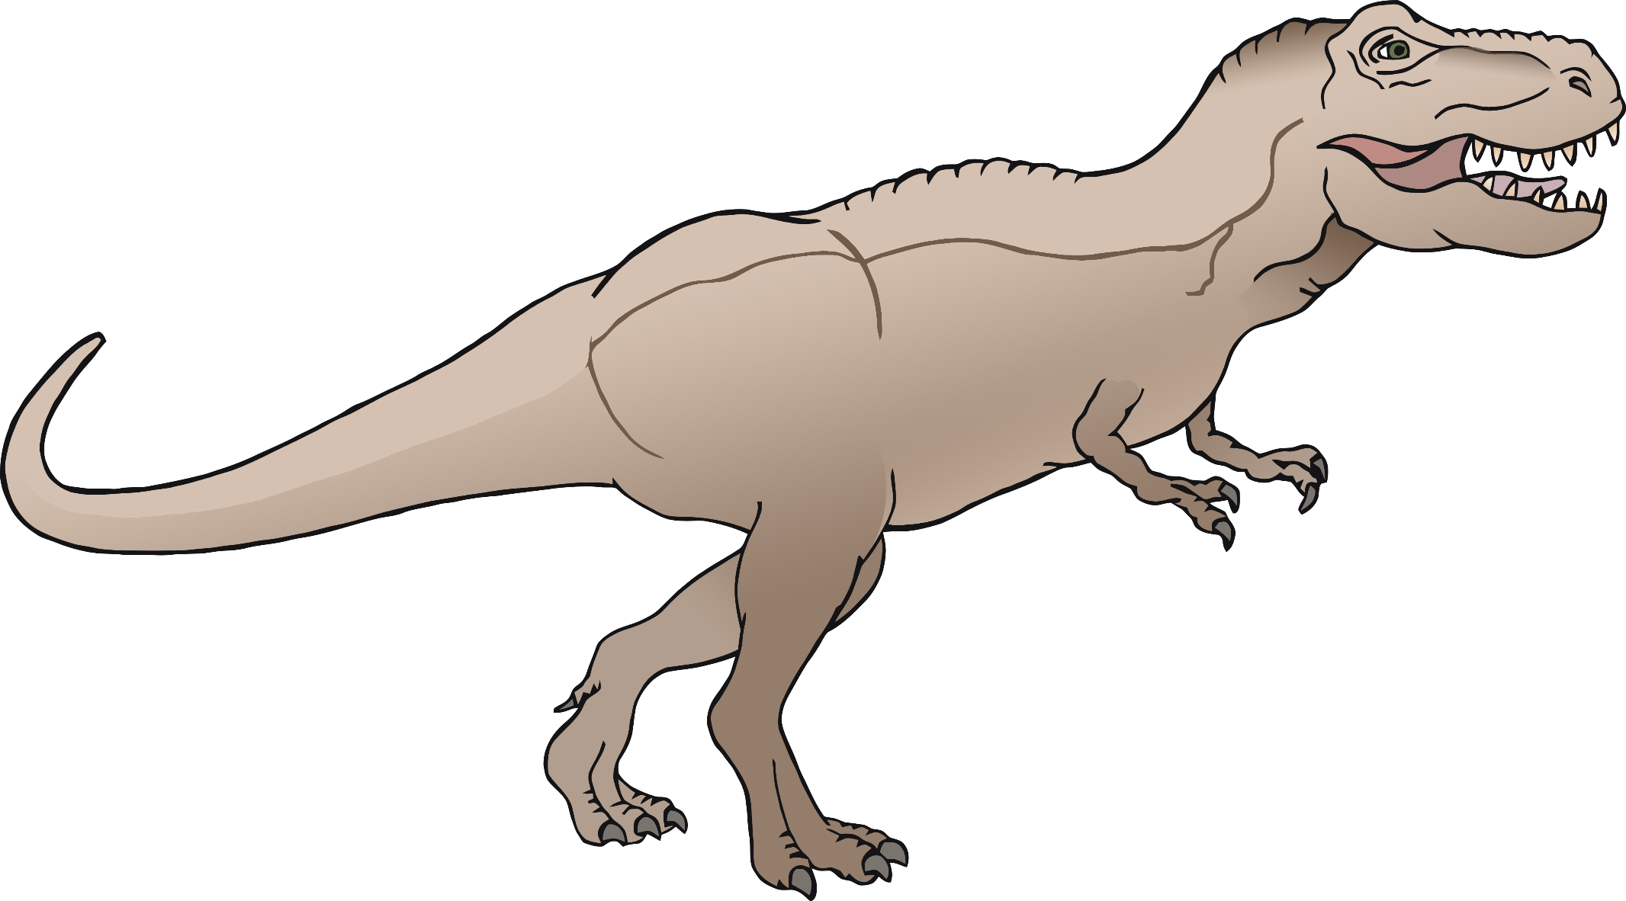

**Tyrannosaurus Rex**

© 2019 Little Owls Resources

Diet

Lived

Carnivore

80-65 Million Years Ago

Height

Weight

Up to 6.1m

Up to 15000kg

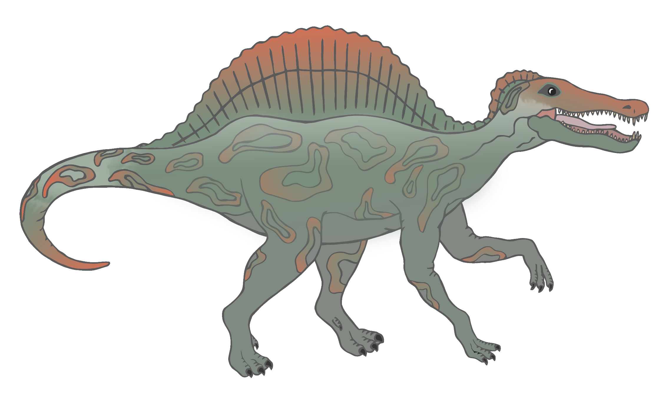

**Spinosaurus**



© 2019 Little Owls Resources

Diet

Lived

Carnivore

112-72 Million Years Ago

Height

Weight

Up to 7m

Up to 21000kg

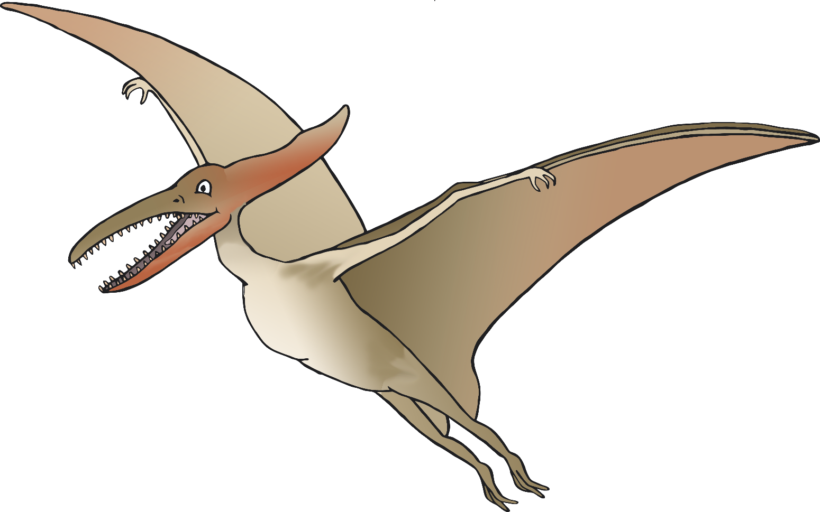

**Pterodactyl**

© 2019 Little Owls Resources

Diet

Lived

Carnivore

200-136 Million Years Ago

Height

Weight

Approx 2-3m

Approx 20-90kg

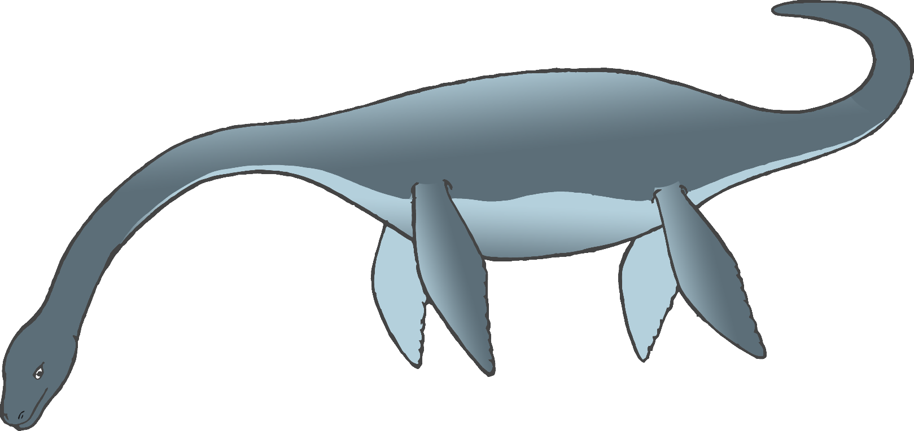

**Plesiosaur**

© 2019 Little Owls Resources

Diet

Lived

Carnivore

205-66 Million Years Ago

Length

Weight

Up to 3.5m

Up to 450kg

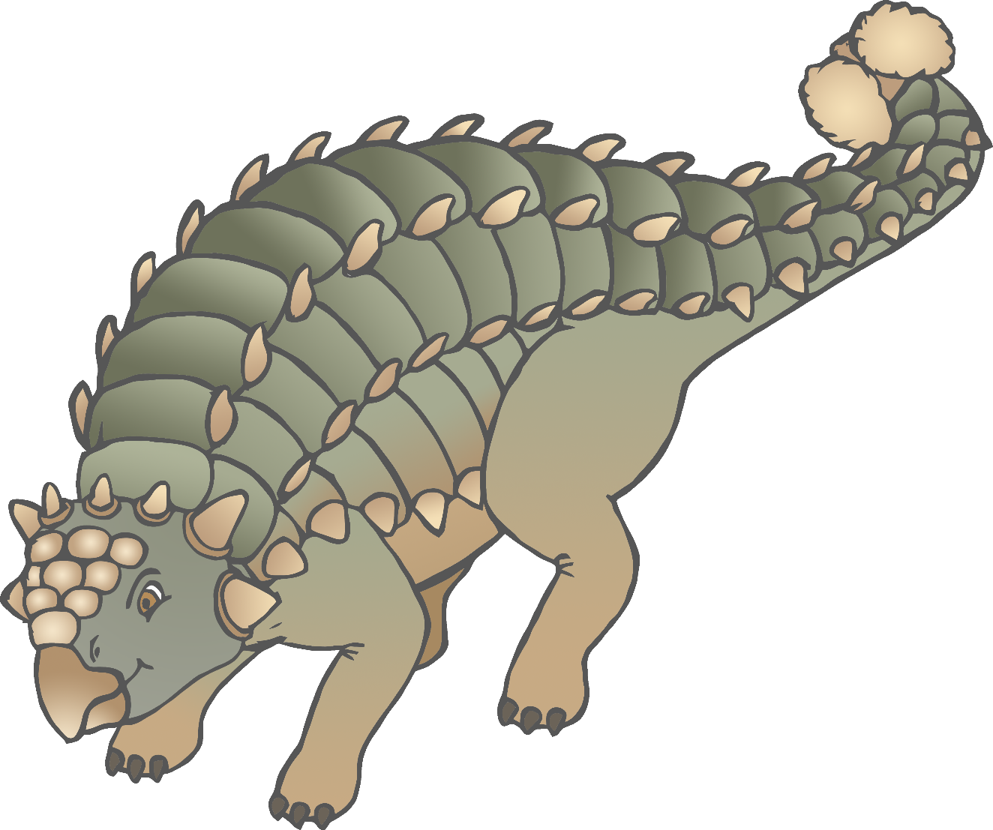

**Ankylosaurus**

© 2019 Little Owls Resources

Diet

Lived

Herbivore

83-66 Million Years Ago

Height

Weight

Up to 1.7m

Up to 7000kg

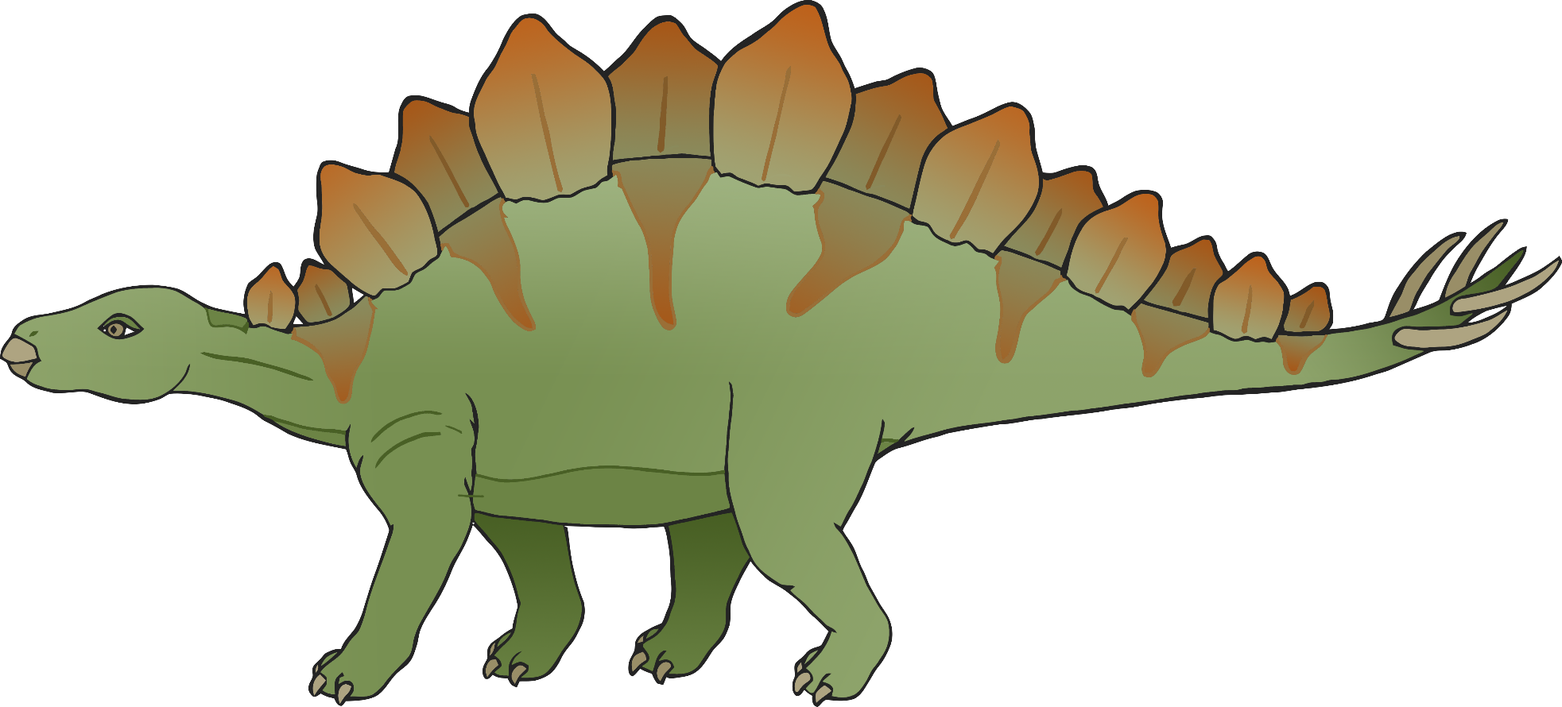

**Stegosaurus**

© 2019 Little Owls Resources

Diet

Lived

Herbivore

155-150 Million Years Ago

Height

Weight

Up to 2.75m

Up to 3100kg

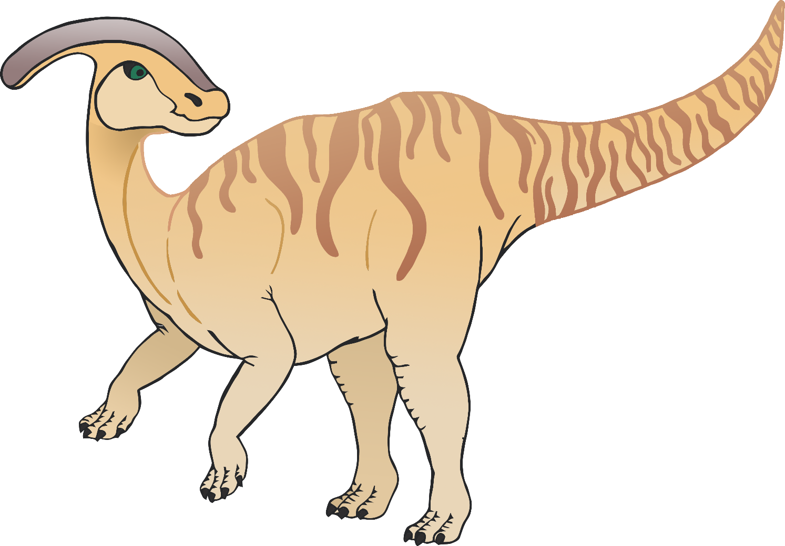

**Parasaurolophus**

© 2019 Little Owls Resources

Diet

Lived

Herbivore

76-73 Million Years Ago

Height

Weight

Up to 4.9m

Up to 3600kg

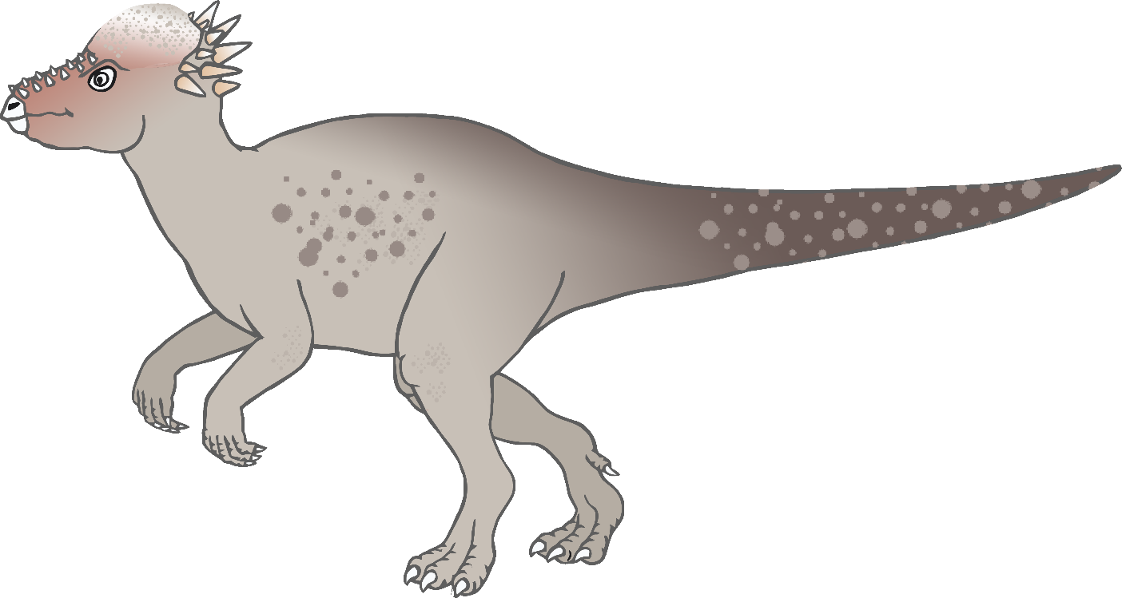

**Pachycephalosaurus**

© 2019 Little Owls Resources

Diet

Lived

Herbivore

72-66 Million Years Ago

Height

Weight

Up to 1.5m

Up to 1000kg

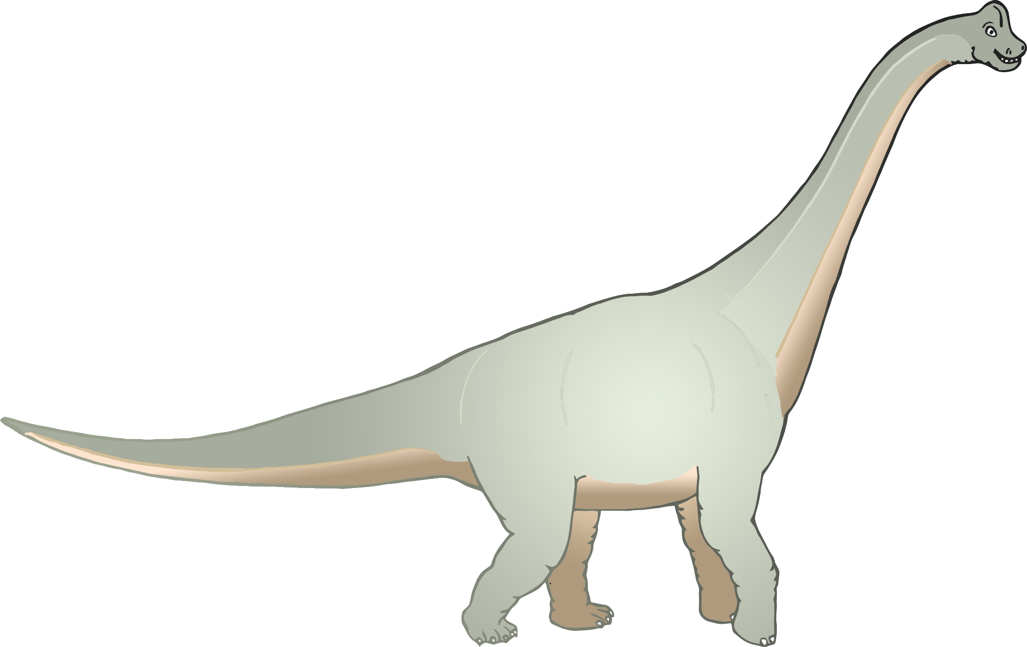

**Brachiosaurus**

© 2019 Little Owls Resources

Diet

Lived

Herbivore

161-145 Million Years Ago

Height

Weight

Up to 13m

Up to 58000kg

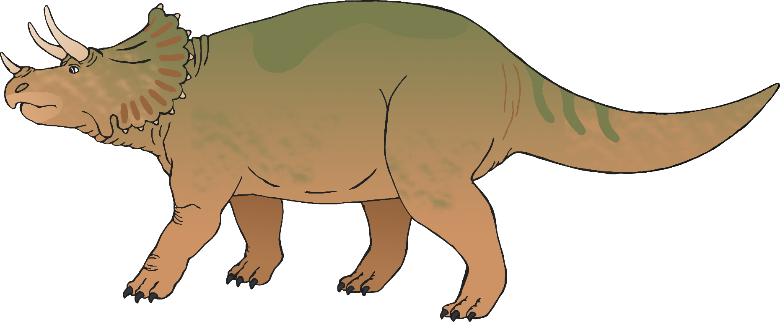

**Triceratops**

© 2019 Little Owls Resources

Diet

Lived

Herbivore

83-66 Million Years Ago

Height

Weight

Up to 3m

Up to 12000kg