**Dinosaur Egg Colour Sorting**

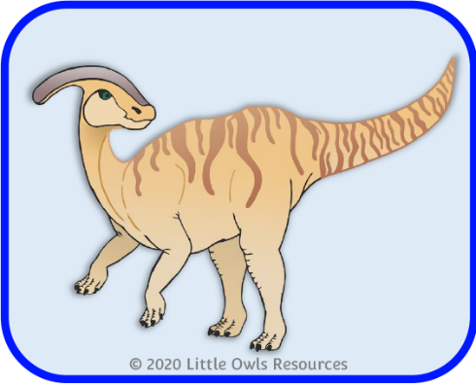

© 2020 Little Owls Resources

Children to match the coloured dinosaur cards with the correct egg.

**blue**

© 2020 Little Owls Resources

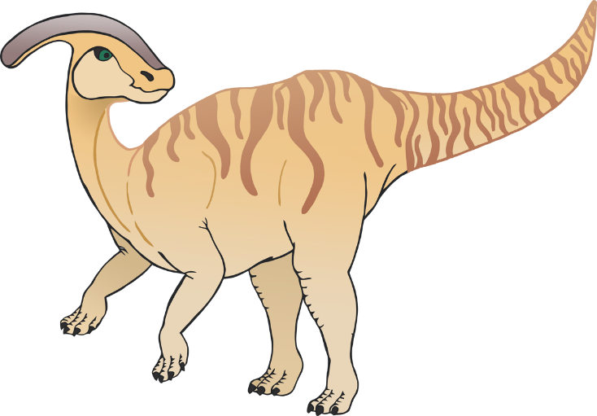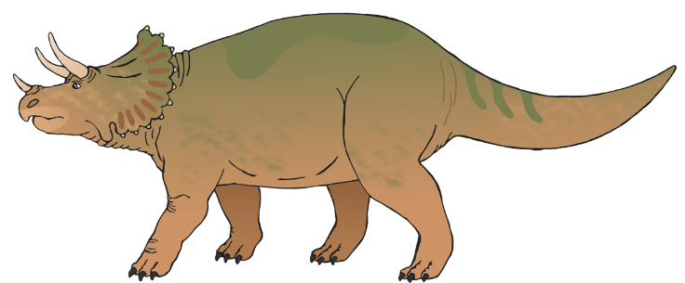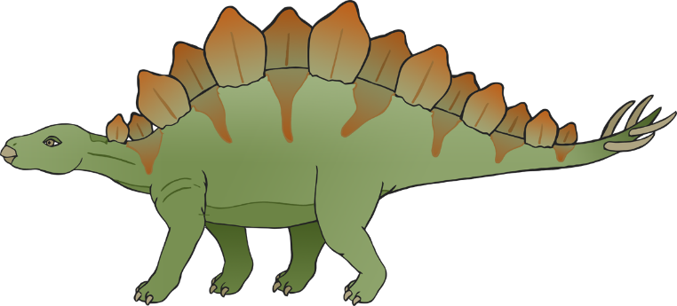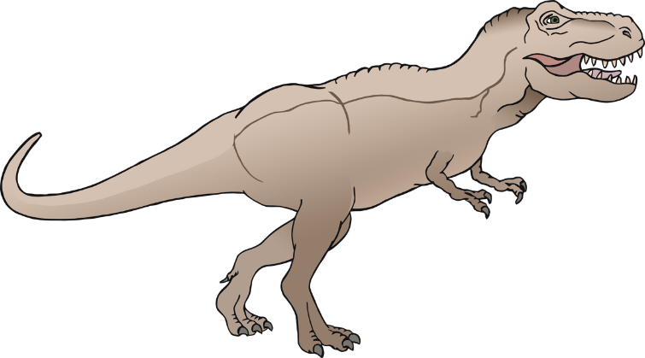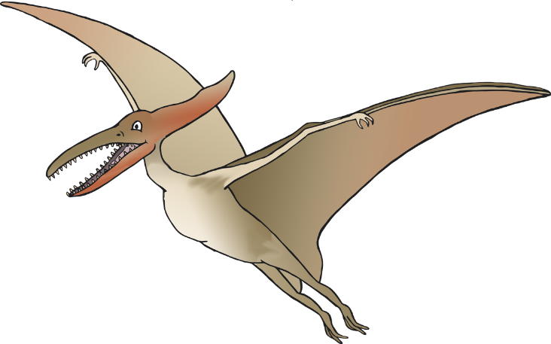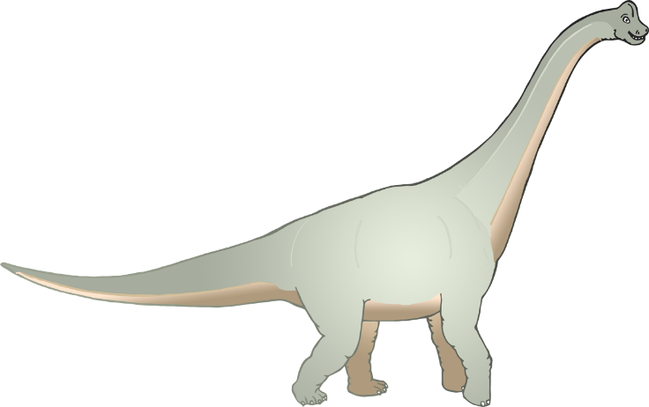

© 2020 Little Owls Resources

© 2020 Little Owls Resources

© 2020 Little Owls Resources

© 2020 Little Owls Resources

© 2020 Little Owls Resources

© 2020 Little Owls Resources

© 2020 Little Owls Resources

**green**



© 2020 Little Owls Resources

© 2020 Little Owls Resources

© 2020 Little Owls Resources

© 2020 Little Owls Resources

© 2020 Little Owls Resources

© 2020 Little Owls Resources

© 2020 Little Owls Resources

**yellow**



© 2020 Little Owls Resources

© 2020 Little Owls Resources

© 2020 Little Owls Resources

© 2020 Little Owls Resources

© 2020 Little Owls Resources

© 2020 Little Owls Resources

© 2020 Little Owls Resources

**red**



© 2020 Little Owls Resources

© 2020 Little Owls Resources

© 2020 Little Owls Resources

© 2020 Little Owls Resources

© 2020 Little Owls Resources

© 2020 Little Owls Resources